How to Register for a tournament on Trackwrestling

FIRST you need to register for a trackwrestling membership. This is FREE. This only needs to be once. If you have a trackwrestling number from previous years you do not need a new number.
- Select REGISTER
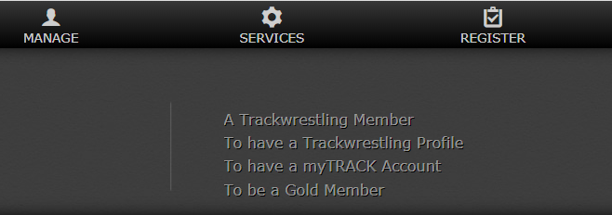
- Select A Trackwrestling Member
- Fill in the Registration Form
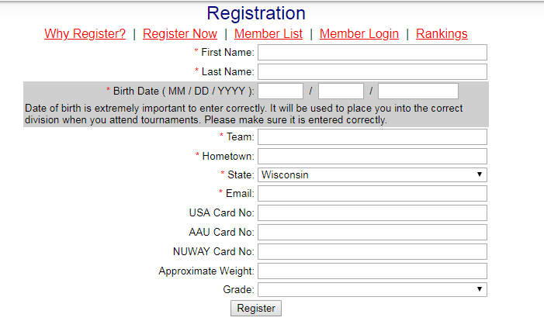
- You will receive a trackwrestling number for your wrestler.

REGISTER for a TOURNAMENT
- Go to www.trackwrestling.com
- Select BROWSE
- Select Tournaments

- Select Search Events


- Enter the State where the tournament is held
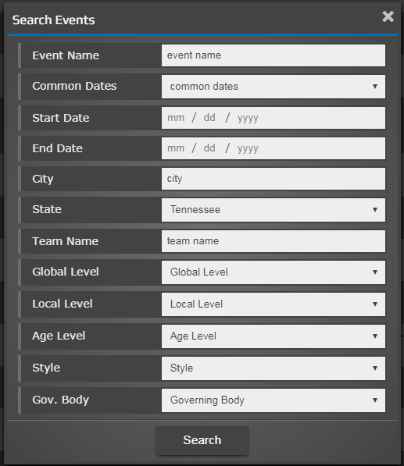
- Select the tournament you want to register for
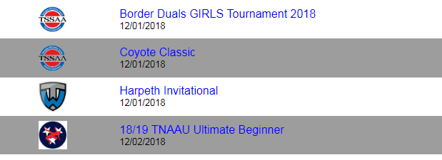
- Enter Event
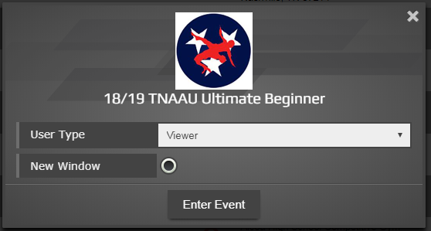
- Select Registration
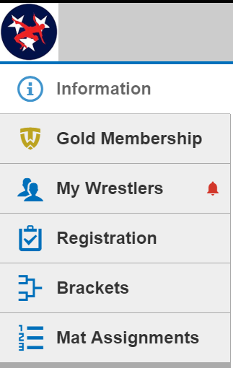
- Register Now

