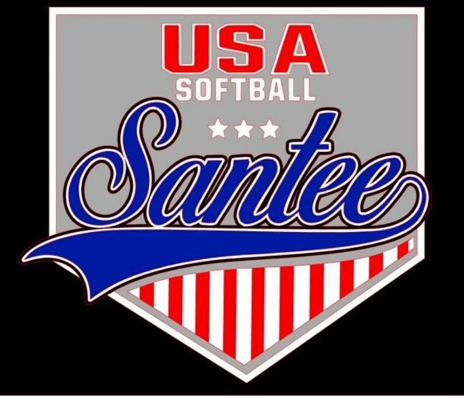
MINUTES TO BE APPROVED AT THE NEXT BOARD MEETING. THESE MINUTES ARE NOT CURRENTLY POSTED AND SHOULD NOT BE DISTRIBUTED UNTIL APPROVED BY USASSCS BOARD.
Board Meeting Minutes September 9, 2024
Location: Santee City Hall
Attendees Shown with Marked Box
Guests: None
President | Jay Strandberg | x | Field Prep | Kevin Hopkins
1st VP/ Field Prep | Erik Ruiz | x | Field Prep | Trevor Henton
2nd VP | Kelli Timanus | x | Field Prep/Uniforms | James Timanus | x
Treasurer | Tiffany Lynch | x | Field Prep
Secretary/Safety Coordinator/Head Scorekeeper | Bryan Scholar | x | Field Prep | Brad Allen | x
Tax Advisor | Lori Britt |  | Field Prep/Equipment | Shane Frary | x
Player Agent | Lance Craw | x | Field Prep
UIC/Parliamentarian | Felicia Leca | x | Head Team Parent Coordinator | Dana Hisaw | x
Field Scheduler/Fall Ball Coordinator | Chris Klima | x
Webmaster/Social Media/All-Star Coordinator | Alexis Ruiz
BOTH Tournament Coordinator/Picnic Coodinator | Kayleigh Ponciano-Ahue | x | Snackbar #1 | Katja Moskowicz | x
Sponsorships | Kylee Scholar |  | Snackbar #2
Awards | Janis Aiello | x | Social Media Coordinator | Sophia Vigil | x

Meeting called to order: 7:05 PM
Meeting Minutes
Brad Allen motioned to approve minutes from August 2024. Katja Moszkowicz seconded the motion.
Meeting rule – One Topic at a Time
Financial Update (Tiffany L)
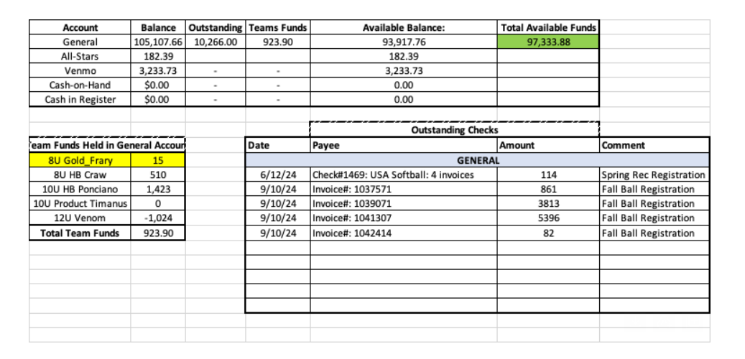
Fields
- Backstop pads to be ordered and installed before January
Logo
- New logo will be under consideration this fall
- Goal of keeping logo uniformity
League Pictures
- Board voted to get rid of spring rec pictures
Spring Rec Uniforms
- Board voted to keep team names on jerseys and to continue providing each team with 2 coaches jerseys at no additional cost

Board Positions Updates
- Adding Shane Hanson and Eric Dechant to the board as field prep members

Snack Bar Security
- Jay to look into motion lights for the snack bar
- Brad Allen will add weather stripping to roll up doors

Fall Season

- Erik Ruiz having a discussion with a manager who has had written complaints about her

Fall Rules
- Bryan and Felicia to handle communication
- To be posted in Manager GroupMe
“1904 Managers, this MUST be posted in your team's group chat or sent to each family individually. The USA Softball of Santee Board met on Monday, Sept 9th. At the meeting, questions were posed regarding the playing rules for Santee Teams VS all teams playing in the 1904 League. Prior to the vote: All Santee registered teams, no matter what Fall Ball League they were playing in, had to follow Santee's Rule Exception that during the entire season including TOC all players present must bat and play a minimum of 2 innings in a 4 inning game or 1 inning in a game with less than 4 innings. The Proposal: Teams playing in the 1904 League have the option to utilize the USA Softball rule, which is what 1904 has as their rules: Managers can either bat straight 9 with substitutes, bat 10 with a EP, bat 9 with DP/FLEX, or bat 10 with an EP and DP/FLEX. The Vote: After discussion and pros/cons the majority on the Board voted that ONLY in 1904 TOC Managers in age Groups 10U, 12U, 14U will have the option to Bat Around or use the USA Softball Rule for line ups. 8U- All players must be in the line up (USA Softball Rules) but will have no minimum for defensive playing time. The Board wants to be sure that all participants, coaches, managers, and parents are aware of the alterations to the Fall 2024 playing rules.”

Meeting Adjourned: 9:18 pm
Next Meeting: October 14

