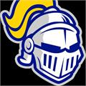
STMA Youth Baseball 2024 Coaching Requirements
All coaches in the dugout (head coach, assistant coaches, bookkeeper, and/or team manager) must complete a concussion training course and an abuse awareness course. The concussion certificate is good for 3 years after completion and the abuse awareness is good for 2 years after completion. These are required for both MYAS and MBT. Both trainings are free and available on the STMA youth baseball website in the coach’s corner section. All certificates (head coaches and assistants) must be submitted to Ron Wetzel (ronwetzel75@gmail.com) prior to any scheduled practices. Below are instructions on how to access both courses and print your certificates. If you have any questions, you can reach out to Ron Wetzel at ronwetzel75@gmail.com or 763-442-9999.
Concussion Training Instructions
- Go to https://www.stmayouthbaseball.org/coachescorner
- Click on Concussion Awareness Training from NFHS Learning 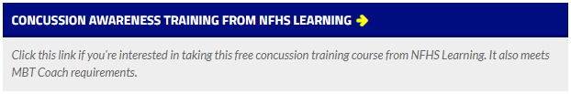
- Click on Concussion in Sports 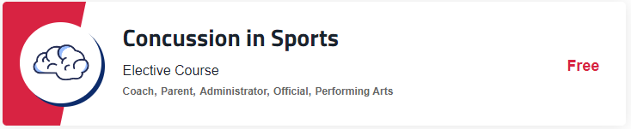
- Select State (Minnesota) and click Order Course 
- If this is your first-time completing training with NFHS, you will need to register before completing the course. If you have previously registered, you will be able to log in with your email and password.
- Once completed with the course, download and save a copy of your certificate and email to Ron Wetzel (ronwetzel75@gmail.com)
Abuse Awareness Instructions
- Go to https://www.stmayouthbaseball.org/coachescorner
- Click on Abuse Awareness Training from USA Baseball 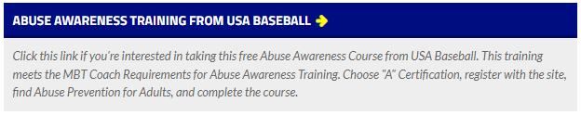
- Click on Education 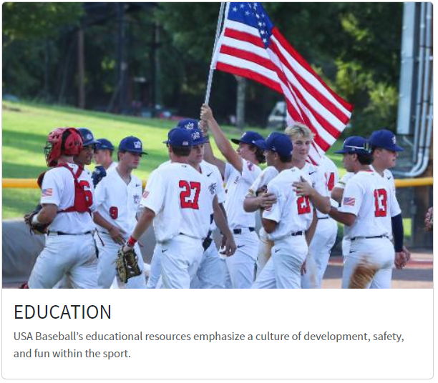
- Click on Courses and it will bring you to a login page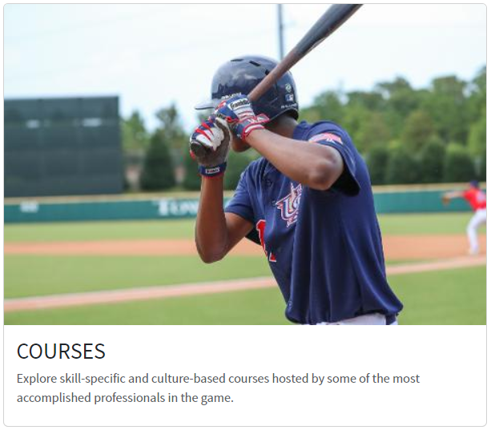
- If this is your first-time completing training with USA Baseball, you will need to register before enrolling in a course. If you have previously registered, you will be able to log in with your email and password.
- Once logged in, scroll down, and click on Abuse Awareness for Adults 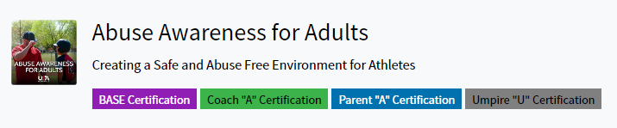
- Once you have completed the course, exit and click on your name (top right) and select My Account from the drop down list. Click on courses on the left and then download certificate. Save a copy of your certificate and email to Ron Wetzel (ronwetzel75@gmail.com)

