SportsEngine App: Set Up Instructions
The SportsEngine app is used for team specific information. Rosters, schedules, and ability to send team specific communication. Please make sure to follow the below steps to set up your access to the SportsEngine app.
Download the SportsEngine App:
On an iOS Device:
- On your device, open the App Store.
- Search for SportsEngine.
- Tap the Get button to begin installing the app.
- Open the app on your device.
- On the Settings tab, tap Account and tap the Sign In button to sign into your SportsEngine account.

On an Android Device:
- On your device, open Google Play.
- Search for SportsEngine.
- Tap the Install button to begin installing the app.
- Open the app on your device.
- On the Settings tab, tap Account and tap the Sign In button to sign into your SportsEngine account.

Teams that you/your player are a member of will appear in the Teams tab by default when you log in.

If your team does not appear, please follow the below steps to search for your team.

- Open the SportsEngine App and log in (ensure you use the correct log in that you registered your player with – some families have multiple log ins).
- Tap the Teams tab
- Tap the Search icon in the top right
- Enter the Team Name and tap Search
- Click on the Star icon to save your team as a favorite

To Add Additional Guardians to Player Profile:
SportsEngine grants permission to only one primary guardian initially, this primary guardian is the person who completed the online registration for the season. If permission to the app needs to be set up for additional parties, please follow the below steps.
- Go to Account in the bottom menu bar
- Click on the appropriate player
- Click on Pencil at the bottom right of the screen
- Click on +(Add Guardian) at the bottom right of the screen
- Enter the Email Address for Guardian being added & hit Save
  - An invite email will be sent to the email address entered. They will have to set up a Sports Engine account if they do not already have one.
  - Once the invite is accepted they can download the app & access will be granted.
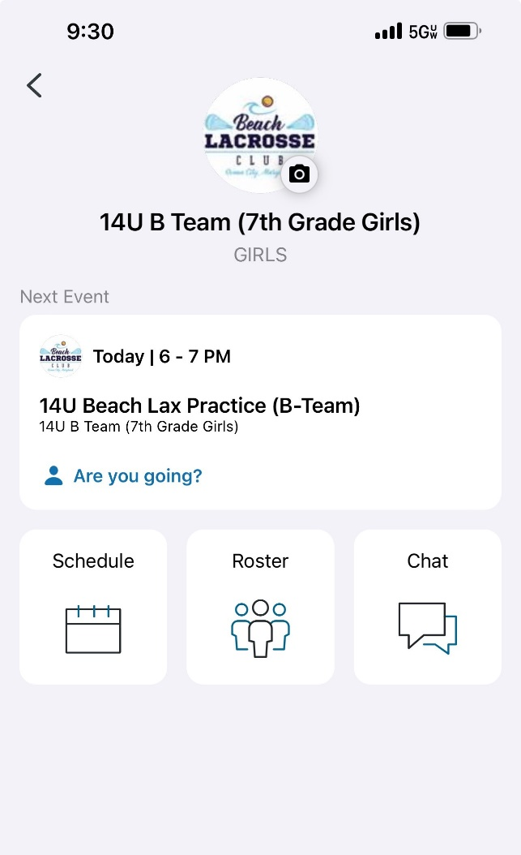
Schedule:
Once game schedules are finalized, details are posted here.

Roster:
Once players are rostered by the league, parents can upload photos, stats & RSVP for practices & games.

Chat & Messages:
Keep everyone up-to-date and connected with free team text, chat, messages and notifications.

