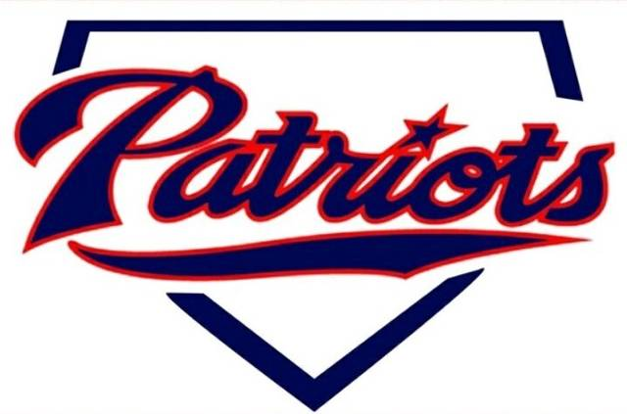
Donation Form

MPCG Baseball & Softball Boosters

Donor Information (please print or type)

Name

Billing address

City, St, Zip Code

Phone

Email

Donation Information
I (we) donate a total of $____________________ Upon donation you will be recognized as one of the following:
Team Maker $1000+ Home Run Club $500-$999 Triple Play Club $499-$251 Double Play Club $250/below
I (we) would like the donation to be used for:
☐General Funds ☐Player Scholarship ☐Special project ☐other.
If you checked special project or other please specify below.

Special Project

Other

Acknowledgement Information
Donations of $500 or more received by April 20th, 2025 will be recognized on T-ball and rookie jerseys. If you do not want to be publicly recognized, please check box below.
☐ I (we) wish to have our gift remain anonymous.
Please make checks, corporate matches,  or other gifts payable to: |  | MPCG Baseball & Softball Boosters  900 Main Street West  Mayville ND, 58257

