Instructions for Ordering Jimmy John’s for Sports Teams
**DUE TO QUANITY OF ORDERS, ORDERS MUST BE PLACED AT LEAST 24 HOURS IN ADVANCE**
**NO EXCEPTIONS, THE ORDERS MUST BE PLACED 24+ HOURS IN ADVANCE**

- Go to jimmyjohns.com
  - Choose Pickup – 55901
    - Select the 2986 41st St NW location
  - Create Account – YOU MUST CREATE A NEW ACCOUNT AND FOLLOW INSTRUCTIONS FOR TEAM ORDERS. (EVEN IF YOU ALREADY HAVE AN EXISTING ACCOUNT) *If you have more than one student attending the event, you must make separate accounts for each student!
    - First Name Box – Type student’s FIRST AND LAST name into box.
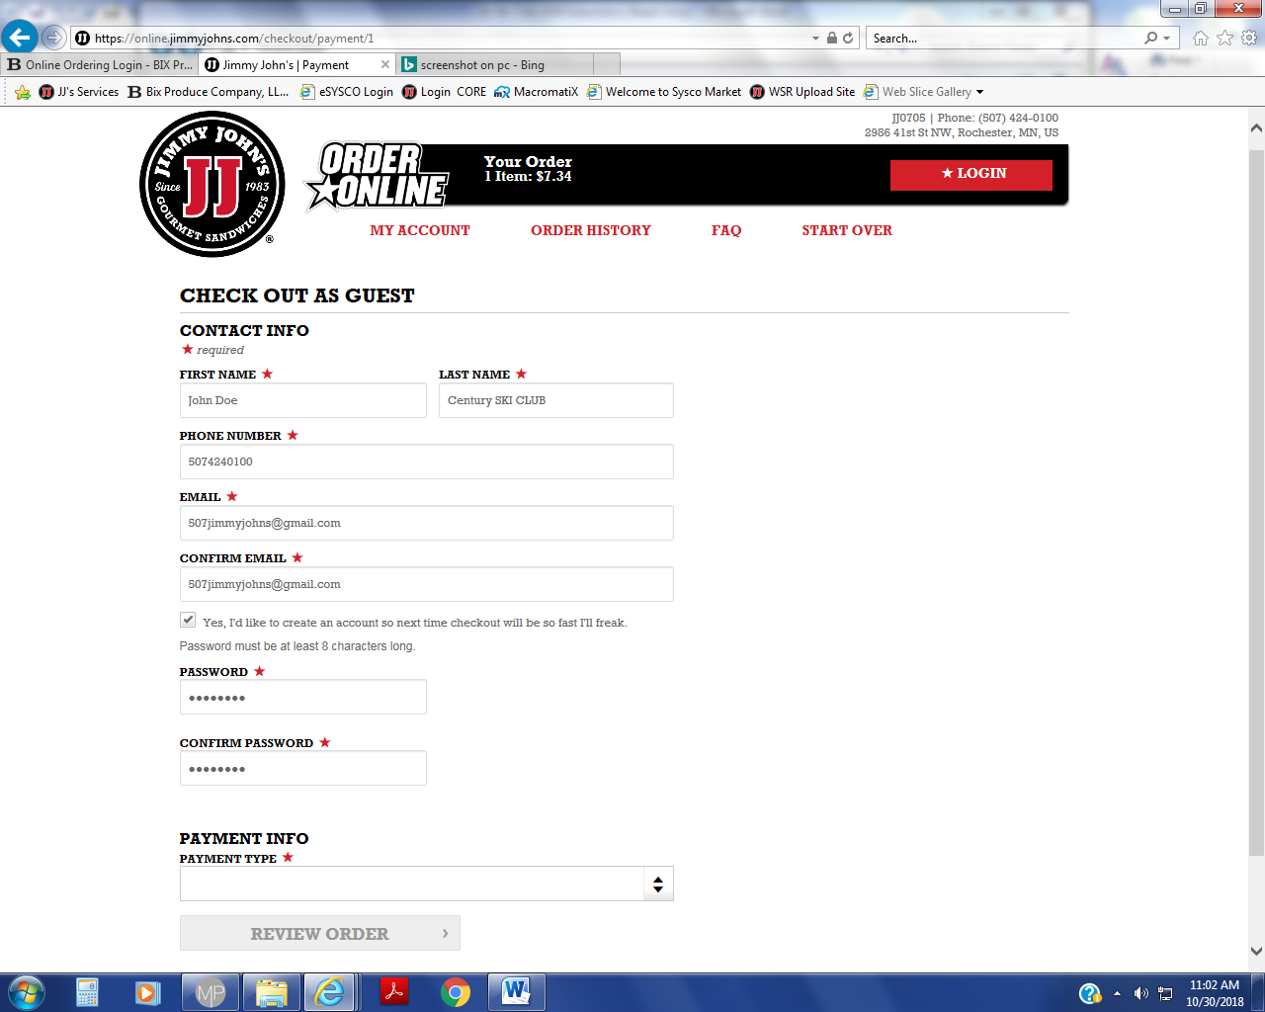
    - Last Name Box – Type student’s SCHOOL AND SPORT into box.
    - Please re-read and follow these instructions accordingly, this step is very important.
    - You can order up to 30 days in advance.
    - If you make a mistake while ordering, you will need to call the store to fix any errors.
  - ORDER
- Choose Sandwich and sides of choice
- To prolong the freshness of sandwiches we recommend you order NO mayo on the sandwiches and add it on the side.
      - Customize Sandwich > Mayonnaise “NO”
      - Customize Sandwich > Add Mayo/ Mustard Packets
- Order Only WATER to drink, as it’s the only beverage in a bottle.
  - Checkout – Choose date and choose time of 2 PM under WHEN:
    - All orders that are specified with school and team name will go together regardless of pickup time specified on the order.
    - With your new account, you will be able to save your order and payment information for easy re-ordering.
    - Double check the phone number is correct on the checkout page to ensure we can contact you if we have any questions about your order.

