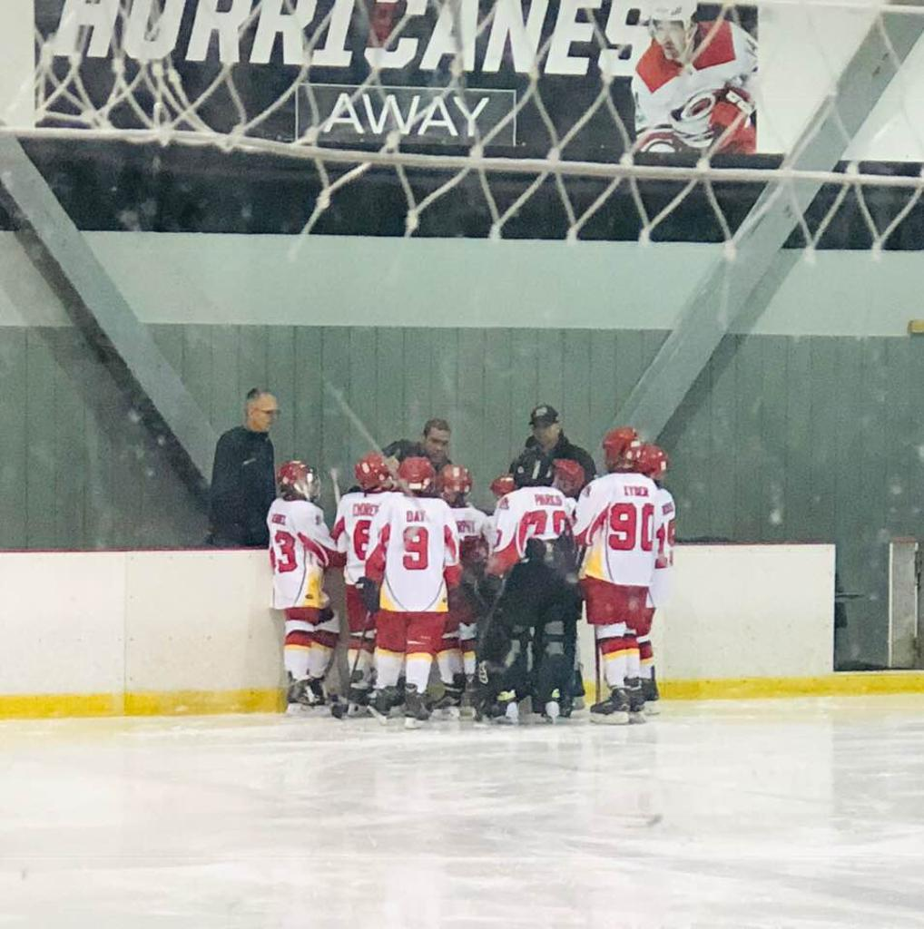STARS SHINE BRIGHT IN RALEIGH
10-28-18 - After a hot start, the Storm have now found themselves in the midst of a 6 game losing streak. Coming into the weekend games with the Stars, coaches and players were looking to get back on track with at worst, a split, to bring their overall record to .500, but by Sunday afternoon they would be traveling back to the Boro with a 3-6 record.
A shaky 1st period in game 1 would doom the team. Raleigh scored on their very first shot, and 3 of their first 5, to put them up 3-0 only 5 minutes into the game. By the end of the 1st the score would be 6-0. The final two periods would be played out to a tie, with each team potting 3 goals, but the damage had been done and the Stars would win by the 6 goal margin they gained in the 1st.
The Storm would come back with a vengeance in game 2, dominating the first 15 minutes to take a 2-0 lead into the start of the 2nd. However, playing their second game in a four hour span with only 9 skaters proved to be too much. Raleigh rolled three full lines (17 skaters and 3 goalies) and simply out lasted the Storm. The players never gave up but by the end of the 3rd it was just too much. Final score would be 2-8.
Players hung their heads after the game but the coaches saw it differently. "These kids came out and matched up with a team twice their number and very well twice their {physical} size. Every kid out there played 100%, battled for pucks and did everything they could. I think that 1st period in game 2 showed you just what this team can do. If you had taken their 9 best players and matched them up against our 9........... this would be a different story. I dont want to make excuses, but they had 20 kids, we had 9."
The team is back in action this weekend in DC with 4 games on tap.

