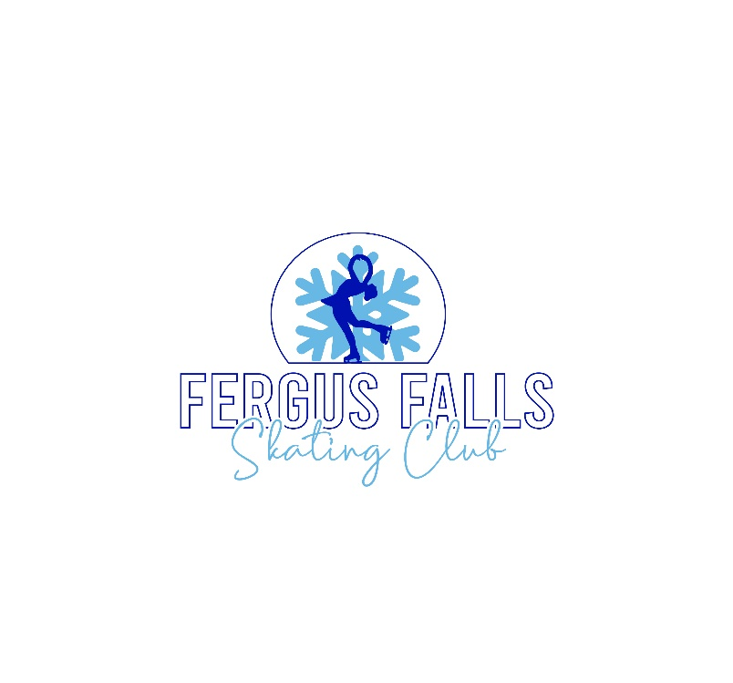

Welcome to the 2026 Winter Skating Session with the FF Skating Club!
Each skater is required to participate in ONE FFSC fundraiser. You MUST participate in the fundraiser offered at the time of your initial registration. This means that if you register and either pay the fundraiser buyout, or have participated in the Fall 2025 fundraiser, you will not be required to participate in the Winter 2026 fundraiser.
- We have paired up with KLN Family Brands for Wiley Wallaby licorice and Ole and Lena’s Pizzeria this winter! You can choose one or both to fundraise with as long as your profit for the club equals: $150 for 1st skater, $100 for 2nd skater & $75 for the 3rd skater. (ex: A family of 3 would need at least $325 of PROFIT-not total sales) See the Profit Calculation Sheet to see the amount of profit earned per item listed from either company. Each category has a different profit amount.
- If you choose to forego fundraising, you are required to pay the fundraiser buyout at the time of online registration. Buyouts equal $150 for 1st skater, $100 for 2nd skater & $75 for the 3rd skater. NOTE: Skaters 3 years of age and under are NOT required to participate in the fundraiser NOR pay the fundraiser buyout.
- ALL fundraiser packets are due back no later than:
Thursday, January 22nd and/or Monday, January 26th at the skating rink. Tentative delivery date set for Thursday, February 19th time TDB.
- All checks should be made out to YOU personally. When you turn your fundraiser information in on our turn-in night, please write ONE check payable to “Fergus Falls Skating Club” for all sales totals.
- You MUST turn in all order forms (you WILL receive these back when you pick up your order. You also must turn in a FILLED OUT calculation form along with the order forms and a check to cover all items ordered and any unfulfilled profits. Orders will not be accepted without these items turned in complete!

If you have any questions regarding the winter 2026 fundraiser,
please contact Alison at 218-205-9930 or ffscfundraiser@gmail.com

