SAC - MT
Meeting Minutes
1/3/24

Call to Order: Josh Burnham (SACC) called to order the regular meeting of the SAC-MT at 8:45 p.m. via Google Meeting. Present members: Josh Burnham, Denis Berry, Crystal Lawrence, and Sharon Mozer.

Announcements:
- Financials - N/A

2. Motion to approve minutes from 11/16/23.
Motion: Denis Berry
Second: Crystal Lawrence
PASSED

Old Business:
1. State Cup - Meet host BGS January 5-7, 2024
- Proposed schedule:
- Josh will look through numbers to make sure the schedule for the sessions will fit the time frame as proposed.
- L 7/8/9/10 (41) B/S (49) L2/3 (45) G/P (58) L4/5/6 (59)
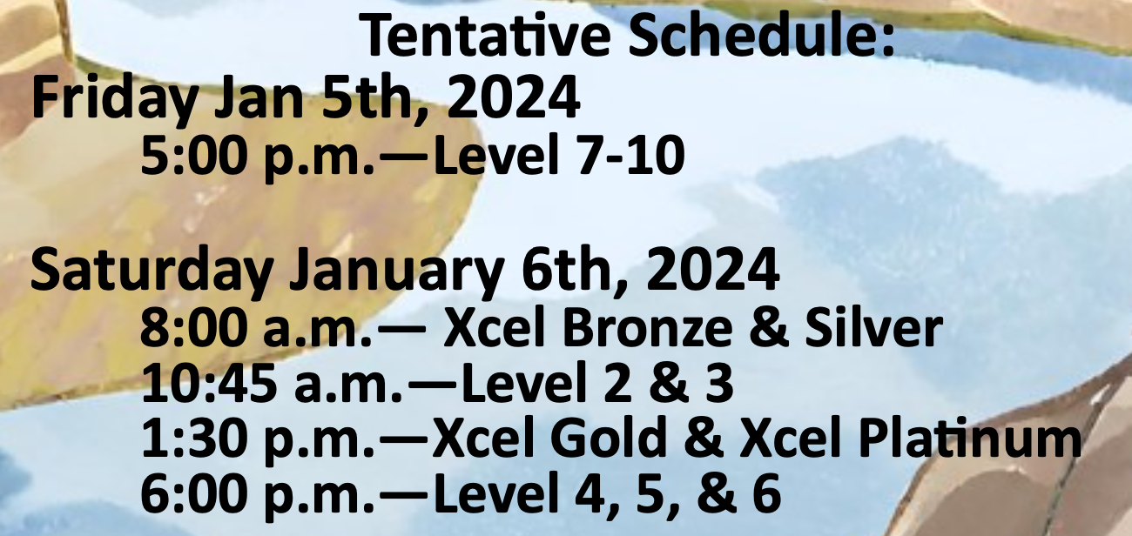

- Reminder for Josh to bring to Billings: awards, projector, banners.
- Denis will have scorecards printed.
- Sharon to remind judges that they will be paid via USAG so checks will be mailed.
- Post State Cup, the board will reevaluate the State Cup contract and make revisions as needed.

2. State Championships 2024
- The board had a quick glance at the state meet flyer.
- Josh is working with Laura to ensure all the information is correct prior to posting.
- The board would like the ALL-State Membership meeting to take place after the last session on Friday.

New Business:
1. Montana Summer Camp 2024
- An idea proposed is to have a summer camp for Levels 2-6 & Xcel, and ran by Top Flight (Ann Grisby).
- Top Flight’s camp is a 3-day camp and the cost is $450 per athlete (includes leo).
- A tentative date is July 13th weekend.
- Josh will visit with Ann Grisby to discuss the possibility of bringing Top Flight to Montana.

Other:
1. Motion to accept Lone Mountain Gymnastics to host the State Championships 2025. Josh Burnham was recused from all discussions and was present for the motion.
Motion: Denis Berry
Second: Crystal Lawrence
PASSED

2. Reserving venues for meets have become difficult due to venues not opening dates for booking that far in advance. Regarding the State championship bid, once the bid has been approved and if the venue falls through, the meet host will have the opportunity to find a new venue. The board will have to approve of the new venue. If it’s not approved, the bid will re-open to the state.

3. Club of the year - Tabled

Adjournment: Motion to adjourn at 10:26 p.m.
Motion: Sharon Mozer
Second: Crystal Lawrence
PASSED
Next Meeting: 2/1/2024 at 9 a.m.
Minutes submitted by Sharon Mozer

