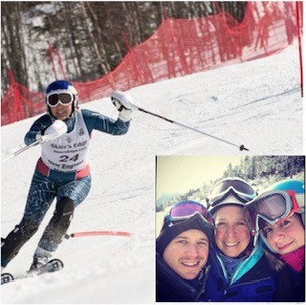
With the support of the Settel Bennett Family, the Foundation is announcing a campaign for a second endowed scholarship titled Path to the Podium. The family’s donation will also make it possible to provide scholarship recipients with up to 25 percent more funds than previous years. This donation honors the legacy of their mother, Barbara “Barb” Settel.
President
Gregory D. Gill

Vice President
Vacant

Treasurer
Kyle Anderson

Secretary
George “Kit” Dover

Board Members At-Large

John Lussier

Kevin Wickless

Matthew Dodge

Our website:
neskiracing.org

501(c)3 Tax ID#
46-2594282

Board of Directors
2024

Barb competed with New England Masters for around 20 years, winning countless races in her age class plus several regional and national titles. Though she lived in New York State, she developed life-long friendships with fellow New England racers. In 2018, she began serving on the NEMS Foundation board, leading the charge for fund raising efforts at races. Her 44 years working in student affairs and alumni relations at Syracuse University, plus two Masters Degrees, gave her the knowledge and skills to do the work. More importantly, her experience in education inspired a passion within her to impact the lives of young people. Barb cared deeply about the foundation’s mission, and the children they served. She wanted nothing more than to support young ski racers and provide them with access to opportunities they might not have otherwise.

Barb’s unique pathway to ski racing undoubtedly inspired her to help kids reach their potential in the sport. She never raced as a youth- she came from the suburbs of New York City and didn’t even put on skis until she was 14. She later moved to Upstate New York, and with her husband David “Dave” Bennett, they raised their two children on ski racing. They spent many winter days on the slopes of Labrador Mountain, earning their turns on 700 feet of vertical. Dave, from Virginia, had also never raced nor even skied until adulthood, but the family found community at Labrador and in the world of ski racing.

For many years, Barb supported parents, racers and coaches serving as director of the Labrador Ski Team board. Finally, at around 50 years old, she entered her first NEMS race. Barb quickly proved her natural athletic ability despite starting years later than most of her peers. She approached each race and each turn with determination and perseverance. She trained nightly at Labrador, attended ski camps, and simply never stopped learning how to improve in the sport she loved most.

Barb and Dave’s children, Lauren and Drew Bennett, are proud to honor Barb’s passion for the sport and continue her support of the NEMS foundation with a financial commitment to the next generation of ski racers.

