

CRYHA Meeting Minutes
Regular Meeting of the Board of Directors
July 28th, 2019
Scheduled Start time 8:00 PM
CRIC, Coon Rapids, MN

Meeting called to order by Jeremie Bresnahan at 8:04 PM
Board Members; Attendance was taken and the following were present:

Jeremie Bresnahan, President | Jenny Moe, Registrar
Mandi DeGrote, Vice President | Stacy Johnson, Equipment Manager
Holly Bachman, Treasurer | Steve Ellenson, Tournament Director
Todd Bushy, Recruiting and Retention | Jim Boden, Player Representative
Don Ruotsinoja, Secretary | Sue Erickson, Gambling Manager
Sara Barsness, Fundraising Coordinator | Assistant Gambling Manager (Vacant)
Dan Bieurance, Boys Traveling Director | Scott Brown, ACE Coordinator
Tim Matsche, House/Mite Director | Kelly Sartwell, Volunteer Coordinator
Geoff Spah, District 10 Representative | Kelli Rolstad, Referee-In-Chief
Jen Shirshov, Girls Traveling Director | Brian Alphin, Ice Scheduler
Brian Peterson, Sponsorship Coordinator
Brian Mountain, Website Coordinator
Number of Members present: 16

Sara Barsness, Kelly Sartwell, Tim Matche notified Jeremie they were unable to attend this meeting

Guests: Aaron Frach- Coon Rapids High School Coach
Board Vacancies – assistant gambling manager

Agenda:
- Call to order
  - Attendance
  - Quorum reached
  - Meeting minutes
  - July regular meeting agenda
Motion made by Don Ruotsinoja to revise Junes regular meeting minutes to correct net year to date revenue in treasurers report; Motion 2nd by Todd Bushy; UNANIMOUSLY approved. None opposed, Motion passes.

- Presidents Report- Jeremie Bresnahan
  - Jeremie provided update on his participation in the high school hockey coach interview process. Jeremie Introduced Aaron Frach, the new coach to the board
    - Aaron Presented his future vision to the board
    - Working on assistants
    - Staff will be involved in our community hockey
  - D 10 Presidents meeting coming up. Reminder to the board to get background checks and safe sport training completed

- Treasurer Report- Holly Bachman
  - Presentation of financials -
    - Net revenue $74,600 for the year
    - Amazon Smile is set up for the association. The board needs to be promoting this to the association.
    - Benevity – Our association is set up. We will post on website.
      - Donations can be automatically withdrawn from paychecks and donations are matched.

MOTION made by Mandi DeGrote to approve the above financials; MOTION seconded by Todd Bushy; UNANIMOUSLY approved. None opposed Motion passes.
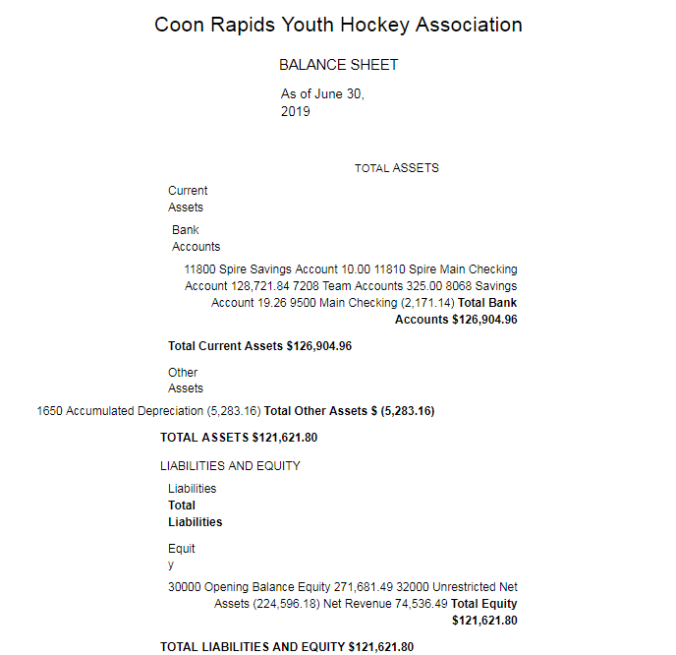

- Gambling Report- Sue Erickson
  - Presentation to the Board
    - Last month gambling ran a loss due to various factors
      - Purchased Security Camera’s
      - Paid prior months benefits
      - Summer is historically slow
      - Balance in checkbook is at $40,000. What is needed for cash flow for operating expenses.

MOTION made by Mandi DeGrote to approve report on May’s 2019 gambling activity; MOTION seconded by Jenny Moe; Vote- UNANIMOUSLY approved. None opposed Motion passes.

MOTION made by Jenny Moe to approve June 2019 estimated allowable expenses up to the amount shown for June, 2019 ($149,500.00); MOTION seconded by Geoff Spah; UNANIMOUSLY approved. None opposed, Motion passes.

MOTION made by Kelli Rolstad to approve (previous month) income, allowable expenses and required taxes and contributions; MOTION seconded by Brian Petersen; UNANIMOUSLY approved. None opposed, Motion passes.

- Additional Commentary- Sue Erickson
  - Summer is slow, gambling should see a pickup in August
- Upcoming Gambling site Golf Tourney’s- We are participating
  - Upcoming Gambling Convention in Rochester. Sue will be attending
  - Sue received a call from compliance auditor. There was a complaint on a particular Bingo game. Some issue with the game that needed updates. Changes were made to the game for compliance.
  - Sue received notification regarding the annual audit. The engagement letter was signed and turned in so that generated the audit. Sue will get it to her in a timely manner.
  - Jeremie commented that Sue saved the association $1000 by completing the audit earlier than past years.

- Hockey Operations Report- Jeremie Bresnahan, Dan Bieurance, Jen Shirshov, Tim Matche, Todd Bushy
  - Girls PTO – Jeremie Bresnahan/ Jen Shirshov
  - Coach Koltes sent Jeremie the flyer and layout to notify our association
  - Communication between the two associations needs refinement so all players get prompt information
  - We have a family asking to waiver to Rogers Girls to play at higher level. Information only. No resolution in the meeting.
    - There was discussion regarding a player may request to waiver out of our program to play a higher level than what CRYHA will provide. It was stated that past precedence will dictate that CRYHA will pay the waivered association for the Ice fee’s and CRYHA will collect fee’s from the family. CRYHA Financial Assistance may be necessary. More discussion to come.
  - Boys PTO – Jeremie Bresnahan
    - Camp is pretty much established, Hockey Ops Committee is working on who will run it
    - Hockey Ops will send out an email to update members on dates and times of the camp
  - Dan is to call returning coaches
  - Tryouts- Jeremie
    - Todd Bushy is creating a tryout process for this season. Proposed draft will be upcoming on the drive for review
- Unfinished Business – None covered in the meeting
- New Business
  - Proposed Bylaw amendment – Don Ruotsinoja
    - Proposed amendment was provided to board members prior to meeting
    - Board discussed adding language in the amendment to provide the board authority to make non-structural changes to the bylaws without special membership meetings and vote.
MOTION made by Holly Bachman to for the Board to approve the bylaw amendment proposal and post proposal to membership for 20 day review and special vote; MOTION seconded by Brian Petersen; UNANIMOUSLY approved. None opposed,

- Special meeting of the membership will be scheduled next month
- Coaches Salary structure – Geoff Spah
  - Geoff Spah presented a spreadsheet from Hockey Ops Committee and ran through proposed salary structure for non-parent coaches with the Board
  - It was discussed that there is no information to vote on because salary structure did not exceed the budget. No objections were provided in the presentation

- Good and Welfare

- Jenny Moe briefed the board on Minnesota Hockey background checks. Minnesota screening fee will be increased to $35.00 next year. This season it is $10.00. Safe sport will be annual training from here on out. This is a change.
- Don Ruotsinoja discussed the need for ratifying a list of current members on a yearly basis.

- Meeting Adjournment

MOTION made by Holly Bachman to adjourn meeting; MOTION seconded by Mandi DeGrote; UNANIMOUSLY approved- Motion Passes

Meeting called at 9:59 PM

Next Meeting
Meetings will be scheduled on the last Sunday of each month throughout the hockey season but are subject to change. Future meetings are scheduled to take place at Coon Rapids Ice Center but are also subject to change. Our next meeting will be on Sunday, August 25th @ 6:30 pm at Coon Rapids Ice Center.

Future Meetings
2019 Meeting Dates (subject to change) 6:30 Start:

August 25, 2019
September 29, 2019
October 27, 2019
November 24, 2019
December 29, 2019

Minutes submitted by: Don Ruotsinoja, Secretary

