- Go to www.lybsl.org
- Sign In to your Sports Engine account at top right of page
- go to your Account Settings page by clicking the account icon at top right (see illustration below)
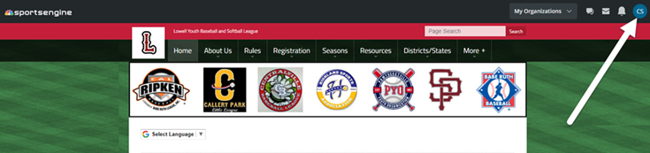

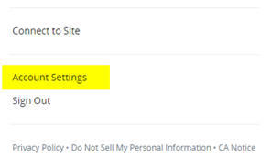
- Go to Settings Communication Preferences Lowell Youth Baseball and Softball League
- check the box next to email addresses you want to receive league communications (most should already be checked)
- check the box next to cell phone number(s) that you want to receive
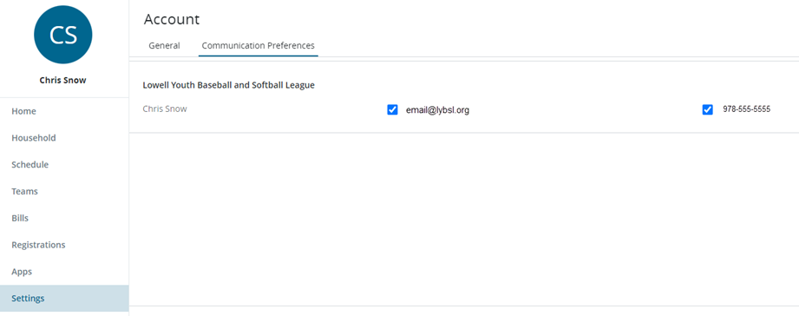
- To add an email or cell phone to a player(s) profile, select Household from left column menu and click on the player profile you wish to add the email/cell.

