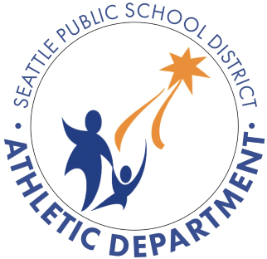
Seattle Public Schools
Student and Parent/Guardian Concussion and
Sudden Cardiac Arrest Awareness Form
Seattle Public Schools believes participation in athletics improves physical fitness, coordination, self-discipline, and gives students valuable opportunities to learn important social and life skills.
With this in mind, it is important that we do as much as possible to create and maintain an enjoyable and safe environment. As a parent/guardian or student you play a vital role in protecting participants and helping them get the best from sport.
Player and parental education in this area is crucial which is the reason for the Concussion
Recognition, Management and Information Sheet and Sudden Cardiac Arrest Information Sheet you received. Refer to them regularly throughout the school year .
This form must be signed annually by the student and parent/guardian prior to participation in Seattle Public School athletics. If you have questions regarding any of the information from these provided materials, please contact the Athletic Director at your school.
I have received, read, and understand the information presented in the Concussion Recognition, Management and Information Sheet and Sudden Cardiac Arrest Information Sheet.
_______________________________________ Student-Athlete PRINT Name  ___________________________________________________  Student-Athlete SIGNATURE Date | _____________________________________ Parent/Guardian PRINT Name  ___________________________________________________   Parent/Guardian SIGNATURE Date

