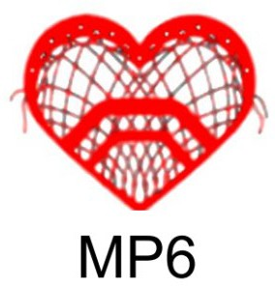
MP6 T-SHIRT AND HOODIE ORDER FORM
First and Last Name DATE
Street
City, State Zip Phone Number Email Address

T-SHIRT
$10.00
HOODIE
$40.00
ORDER FORM

AVAILABLE IN: AVAILABLE IN:
SMALL SMALL
MEDIUM MEDIUM
LARGE LARGE
XL XL
2XL & 3XL (Add $2.00) 2XL & 3XL (Add $3.00)
DESCRIPTION COLOR S M L XL XXL XXXL QTY UNIT PRICE TOTAL
 |  |  |  |  |  |  |  | 0 |  | $0.00
 |  |  |  |  |  |  |  | 0 |  | $0.00
 |  |  |  |  |  |  |  | 0 |  | $0.00
 |  |  |  |  |  |  |  | 0 |  | $0.00
 |  |  |  |  |  |  |  | 0 |  | $0.00
 |  |  |  |  |  |  |  | 0 |  | $0.00
 |  |  |  |  |  |  |  | 0 |  | $0.00
 |  |  |  |  |  |  |  | 0 |  | $0.00
Please make checks payable to “Mike Pane Memorial Fund”  OR Venmo us @Tricia-Tepedino |  |  |  |  |  |  |  |  | TOTAL:

Send this form and payment to:
Mike Pane Memorial Fund
P.O. Box 675
Canandaigua, NY 14424
THANK YOU

