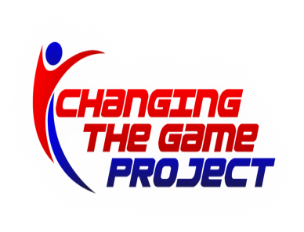
Membership Meeting MINUTES Thursday 1/18/18
- Treasurer report/update-
  - Scott Ridley new Treaurer taking over from Chris Gambardella. $86,000 in bank account-similar to last year at this time. Will have 2nd person monitor bank account online to allow for duplication of eyes on account.
- Travel Update
  - Some issues with question of the rec/travel policy. Miss 3 rec games then miss next travel game. More than that or missing rec practice routinely->travel committee
- Registration update
  - No new report
- Marketing update
  - No new report
- Equipment update/Uniforms
  - Medals ordered for rec and GHS rec championships. Minihoops-certificates
- Sponsorship Update
  - List sent to Brian Farrell for plaques. John Letizia and Bruce Freeman to distribute plaques.
- Rec League update
  - Playoff /seeding planning underway
- Referee update
  - No new reports
- Minihoops Update
  - Going very well all around. Issue of failure to put logo on shirts discusses. Error in clear communication. Did a reprint on site and most shirts have logo at this time.
- Social Media update
  - Going well but woud like more photos to be included-next year registration need to indicate default is photos allowed unless people contact us to opt out.

High School update
Some issues raised re sportsmanship and ref control of the gym. No adults in the gym other than refs. Jeff Hahn suggests some type of monitor but group felt that it would imterfere with the freedom the makes HS rec enjoyable for the kdis. Refs instructed to be more mindful of violations and issue warnings/technical if indicated.
- 3 on 3 update
  - No update available
- Planning for remainder of season
  - Coach/Official recognition night March Madness
  - Skilz and Drilz camp to return-Adams req to be sent by Mark Matlosz scheduler
- Planning for next season
  - Bruce Freeman announced that he will step down as GBL President at end of season. Any interested parties encouraged to discuss with him regarding role and he will remain available to assist with league planning to ensure smooth transition. Election vote next meeting.

Dates for 2017-2018
TRAVEL
- Last adams games?
- FCBL Tourney
- Milford playoffs
- Hoopfest
REC
- Quarterfinals 2/3
- Semifinals 2/10
- Finals week 2/12-2/16
Minihoops
- Last session ??feb 24
BEE Ball 3 on 3
- 2/17/18 Adams 9-4p
Membership Meetings: all 8p GCC
- Thurs 9/21
- Thurs 11/16
- Thurs 1/18
- Thurs 2/22
- Thurs 3/22

