The Tonka Wrestling Team is excited and energized for our 2018-19 Season. We have a solid group of new and experienced wrestlers, coaches, and boosters committed to building a nationally recognized wrestling program at Minnetonka High School.

Our goals for the 2018-19 wrestling season:
1. A unified approach for Tonka Wrestling – Grades K thru 12.
2. Provide for the safety, health, and well-being of our athletes.
3. Work toward establishing a best in class wrestling facility.
4. Minnetonka High School Wrestling Team goes to State.
5. Build Tonka Wrestling brand within our community
6. Increase number of wrestlers through recruitment and retention

Tonka Wrestling is a non-profit organization committed to supporting Minnetonka Wrestling. It is 100% volunteer managed. Our fundraising efforts are used to support our goals – including: wrestling room renovations, training equipment, mats, uniforms, tournaments and photos.

THANK YOU FOR YOUR SUPPORT OF TONKA WRESTLING
Tonka Wrestling Program Advertising
Order Form & Invoice
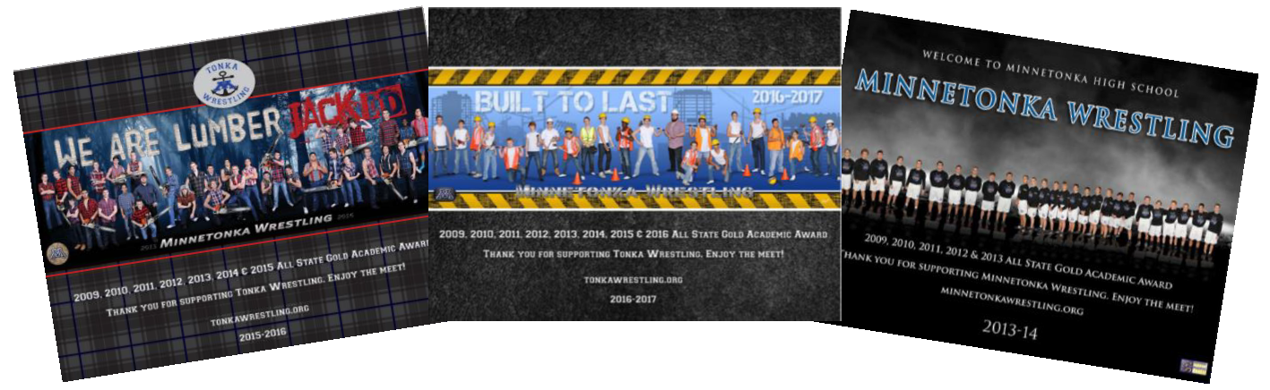
Thank you for advertising in the Tonka Wrestling Program. Our program is a full color, high gloss booklet distributed, free of charge, at all of our home wrestling meets. As an advertiser, you will receive a free panoramic picture of the team, a copy of the program, a Tonka Wrestling window sticker, and your company will be featured on our Tonka Wrestling website.

Tonka Wrestling will create an ad for you- free of charge--using your artwork, or you can email your high-resolution ads to: skipper@tonkawrestling.org. Ad submission deadline is November 27, 2018.
AD SIZE | AD DESCRIPTION | PRICE | ✔
2 ½ x 2 ½ | Mat size | $225
3 ¾ x 4 ¾ | Quarter page | $325
8 x 5 ½ | Half page | $440
8 x 10 ½ | Full page | $550

Date: |  | Sales Person Name:
Company: |  | Company Contact:
Address
City/State/Zip
Phone:
Email:

Payment can be made at www.tonkawrestling.org/program or send checks payable to Tonka Wrestling to Norma Gutierrez, 6340 Teton Ln, Chanhassen, MN 55317 email: normatgutierrez@gmail.com

