Hello Parents,

Welcome to the 2022 Tosa Blazers Football Season. With the season right around the corner, I want to give you some information as far as the upcoming events, volunteering, practices, scrimmages and games.

IMPORTANT PRESEASON DATES

Equipment Handout: Sunday July 31: Times listed below. Equipment is handed out at the football shed located north of the home bleachers at the Tosa West Football Field.

8th grade (A Team)) – 5-530pm
7th grade (B Team) – 530-6pm

All players are required to be present at equipment pickup as we will need to weigh each player and fit them for their equipment. We will also have a medical trainer that will be fitting kids for helmets as this is a League requirement.

Please note that we will be allowing PLAYERS ONLY into the helmet and shoulder pad fitting area. It is VERY important that these two pieces of equipment are fitted properly by our coaching staff only. The coaches have been trained as to how to properly fit this equipment and we want to ensure the safety of all players on the field.

Bring a bag of some sort to put the cloth equipment in as we will not want the player to enter the helmet/shoulder pad area with this equipment.

All fees, registration and volunteer, are required before any equipment will be handed out. NO EXCEPTIONS! If you have your physical form and Informed Consent form completed, we will collect those as well. If you don't have your physical form ready for turn in, it needs to be turned in prior to the first practice on 8/1/22.

Blazers Football Camp: Cancelled

Cookie Dough Fundraiser Kickoff: 8/4 at the start of practice.

Picture Day – TBD (tentative 8/28)

Scrimmages – Scheduled for TBD. Waiting to hear back from Lake Country (8/13) and Waukesha (8/20)

Practices: The first day of practice will be Aug 1 at 6pm. Practice will be held at Tosa West on the grass fields behind the bleachers. We will then be moving to the baseball fields at Whitman at a later date. Practices will run from 6pm-8pm, Monday through THURSDAY, weather permitting. (Schedules are subject to change.) Your head coach will determine whether practices will be held or not, due to weather. Once school begins, practices will be held Tuesdays, Wednesdays and Thursdays from 6pm-7:30pm. Your head coach will notify you in advance if times or dates change.

Water will not be provided. All players are responsible for bringing their own water bottles.

VOLUNTEERING

The volunteer fee is $150. This fee will be refunded at the end of the season once you have fulfilled three volunteer positions throughout the season. There are several positions available from helping out with equipment handout to game days. If the volunteer requirements are not met, your fee will not be refunded. Here are some of the positions that will be available during the season:

Equipment Handout – We will be looking for 3 volunteers on Sunday, July 31 from 430pm – 630pm to set up for the handout and assist players and parents with pickup. Please contact Chad Donovan (Donovan.vzc@gmail.com) if you are interested.

Fundraising – Our Cookie Dough Fundraiser kickoff is tentatively scheduled to kick off on 8/4/21 at 6:00 at the practice field. Cookie Dough will be delivered in September on a date to be determined. Michelle Hill (msmichellehill@yahoo.com) is our fundraiser coordinators and will be looking for volunteers to sort and fill orders.

Regular Season HOME Game Volunteers:

Field Set Up/Take Down: Field Set up involves opening the pressbox (hook up scoreboard and audio equipment), placing the yard markers, end zone markers and down markers on the field. Also doing a quick check of the playing field to ensure there are no obstructions on the field (stones, sticks, buckles etc). Field set up would be best for an A Team parent as A Team plays first and the field take down to a B Team parent as B Team plays last. Contact Dan Keenan to volunteer

Down Marker/Chains: (Must be at least 18yrs of age) The best seat in the house! There are 3 positions available every game. The only down side is that you cannot cheer out loud out of respect for the opposing team. This issue has been brought up at the League Coaches Meeting and the League is asking all down marker volunteers to refrain from cheering. In my years of coaching football, I can honestly say that it can be annoying when playing on an opponent’s field and having to listen to their volunteers, working the chains, cheering for their team on OUR sideline. ALSO, THERE IS NO RECORDING THE GAME WITH YOUR PHONE WHILE VOLUNTEERING FOR THIS POSITION. Contact Dan Keenan to volunteer.

Announcer: The warmest seat in the house….on a cold rainy day. Contact Dan Keenan.
- Keep it simple. Ex. “#33 ____name_____ for a 5 yard game. First down Trojans.” “Pass complete to____name____”.
- Refrain from personal comments Ex “#33 from the Lancers was crushed on the play”
- Refrain from talking as the ball is in play Ex “#33 heads up the right side of the field to the 40, the 30, 20, 10..”
- There will be a guide in the pressbox to assist with working the music too.

Clock Operator: Working the scoreboard and clock. This is a very easy, but important position. Please refrain from using your cell phone, taking pictures or engaging in any other type of activity that would distract you from the game, while the ball is in play. The Operator needs to pay attention to the Head Referee for clock stop and start. Please arrive 20-30 minutes prior to the start of the game for instructions. Contact Dan Keenan to schedule a training of the operations.

***For the scoreboard, clock and PA we would prefer one parent for each position for ALL HOME GAMES. This will fulfill your volunteer requirements and you will also be paid $25/game. I will conduct a training session prior to the season starting for anyone who is interested in these positions. Please contact your manager.

Videographer: We will be looking for one volunteer per game to video the games. Please contact your Team Manager or Coach.

Concessions: Numerous positions are available in the concession stand. Here is the list of the shifts that need to be filled (each requiring 6 volunteers):
730-9am
9-1030am
1030-12pm
12-1pm

Christina Hanks (mailto:hanksc_28@yahoo.com) is our Concessions Coordinator. Christina will use Sign Up Genius to fill these positions.

***Without volunteers this program cannot run and games cannot be played. All coaches will volunteer over 150 hours coaching your son. It’s not asking a lot to volunteer for approximately 6 hours. Your support is greatly appreciated.

Playing Field: Only Blazer Players and Coaches are allowed on the field and track while games are in progress. All players who are not playing during their scheduled game are also not allowed on the field or track. Any one on the field or track will be asked to move outside of the fence. People who wish to take pictures must be 18yrs of age and have authorization from the head coach of the team that they are shooting.

Please remember that there is no food, soda and/or sports drinks allowed on the turf field. The use of this facility is a privilege, given to us by the Wauwatosa School District. It is only fair to treat it with respect.
Parent/Fan Conduct: In my years of coaching sports in Tosa and observing other club’s teams and fans, Tosa, by far, has some of the classiest fans and coaches. Respect the referees, the coaches, the players, the fans sitting around you and the game of football.

All of our coaches have been coaching youth sports for several years. They are quite capable of handling what is happening on the field. If you do not agree with a referee’s call please keep your emotions/comments in check. If a fan becomes out of control, yelling at the coaches, players or referees, they will be asked to stop. If this continues they will be asked to leave the stadium area. If they refuse to leave, Wauwatosa PD will be notified and you will be escorted from the property and will not be allowed back for the remainder of the season. Please share this information with guest who may attend games.

If there is ever an issue you might have with a coach, please address it with the head coach. If you feel as though it is an issue that needs to be addressed with someone other than the head coach, please contact me (trojanprez@gmail.com). PLEASE, PLEASE PLEASE…IF THERE IS AN ISSUE THAT OCCURRED DURING A GAME, PLEASE DO NOT APPROACH A COACH IMMEDIATELY FOLLOWING A GAME! I ASK THAT YOU PLEASE WAIT 24 HOURS FROM THE END OF THE GAME TO CONTACT THE COACH. EMOTIONS ARE RUNNING HIGH AT THE END OF A GAME AND IT IS NOT THE TIME AND PLACE TO ADDRESS YOUR CONCERNS.

I do not see any foreseen issues with this, I just need to send the reminder. In a nutshell remember these two things……

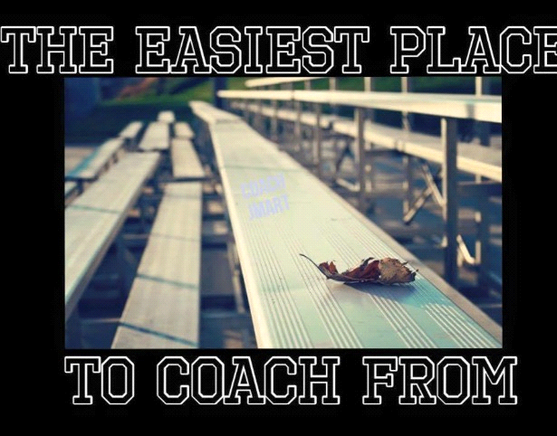

Thank you all for your support. I look forward to another fun season of Jr Trojan Football. Feel free to contact me with any questions or concerns.

Sincerely,

Dan Keenan (trojanprez@gmail.com)
414-698-1838
President/West Side Director

Joe Ehlen (jdehlen@uwalumni.com)
414-750-7697
East Side Director

