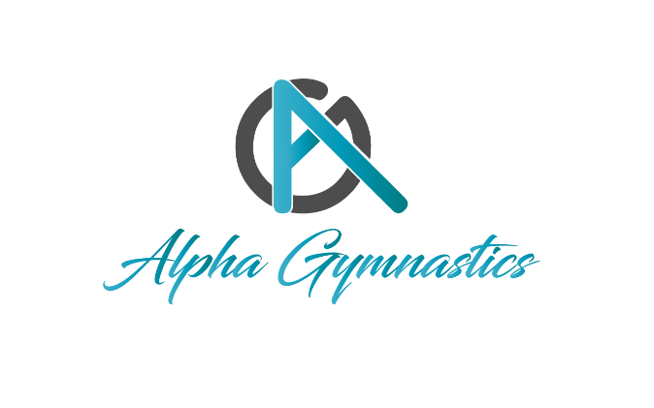
Policies and Procedures

Alpha Gymnastics would like to welcome you as a new member of our program. Our coaches and staff are looking forward to working with your gymnast! The policies and procedures is being given to you as a reference to help guide you as a new member of our program.

Session Information:
Each Session is 4-weeks. Once enrolled, your child will automatically be re-enrolled from session to session.

Your child will be dropped from their spot in a class if your account is left unpaid and your child does not show up to their first class. Please communicate by phone or e-mail, if your child will miss a class. This will ensure they do not lose their spot in a class.

Annual Registration Fee:
$50.00 per student or $85.00 for the entire family
The annual registration fee is paid once a year on the anniversary date of enrollment. It is paid every year on the anniversary of registration.

Tuition:
Tuition is due prior to the first day of each session. If Tuition is not paid by the first day of class a $10.00 late fee will be assessed on the account at the close of the first week of the session. Your child will be dropped from their spot if your account is left unpaid. Please communicate by phone or e-mail, if your child will miss the first class. This will ensure they do not lose their spot.

A 10% discount for each additional child in same family.

Cash, Check (payable to: Evergreen Athletics LLC), VISA, MC, AMEX, or DISCOVER are all accepted. Credit card payments can be made over the phone at 425-486-7429.

Auto Pay Option
Auto Pay Option: You have the choice to go on Auto pay and this may have arranged through the office.

Withdraw Policy
To withdraw from a class, we must receive written notice 30 days prior to dropping. If 30 days’ notice is not given in writing tuition will be due for the session.
Cash, Check (payable to: Evergreen Athletics LLC), VISA, MC, AMEX, or DISCOVER are all accepted. Credit card payments can be made over the phone at 425-486-7429.

Make ups
We understand that kids love their gymnastics and hate to miss even one class! When possible, we will try to accommodate one make-up class per session. Please note that this is not a guarantee of availability. The following rules apply to this accommodation:
- Please note that in all team programs there are no make-ups for missed classes.
- Only one missed class per session is eligible for a make-up.
- Only absences that have been reported to the office are excused and are eligible for a make-up class. A parent or guardian may report absences to the office by phone (425-485-7429) or email (info@alphagymnasticswa.com). An absence report is located on the website.
- Due to limited availability, make up classes may be scheduled only one week in advance.
- The student must be currently enrolled in class.
- There can be no outstanding balance on the family account.
- Each make up class must be completed within the session they missed or within the first week of the next session (so long as the student is enrolled in that session).
- When doing a make-up class, please check in with the front desk BEFORE heading out to class (even if you are late). Each child will need to pick up a “Make-up Class” slip from the front desk.
- Alpha will not prorate or credit if you are unable to schedule a makeup class for any reason.
- Make-ups may only be scheduled in the same class for which student is registered. Open Gyms/Parent’s Night Out events cannot be used for make-ups.
Tardy or Late Policy
It is important that students be on time for class. We understand that sometimes circumstances occur that cause you to be late. Missing the beginning of class students will miss instruction for class and the physical preparation warm-ups provide. TARDINESS is not safe physically and is also disruptive to class. Those students who are more than 10 minutes late for class will need to schedule a makeup or if available they may attend the next regular class that is at their level that has availability.
Dress Requirements (Appropriate dress standards for safety)
Gymnastics Students: Gymnastics should be dressed in attire that allows them to move with ease and flexibility and for safety.
- Girls should be in a leotard that fits the body. Stretch shorts or a leotard with attached shorts are appropriate. T-shirts should not be worn over leotards because they may be a safety hazard if a coach needs to spot. Bare feet are best. Do not wear any leotard with a skirt because this presents a risk on some pieces of gymnastics apparatus.
- Boys should wear shorts and a t-shirt that fit close to the body. Bare feet are best.
- Cheer participants may wear t-shirt and shorts and socks with clean white shoes are best. For those participating in the all-star program workout apparel and cheer shoes are available to purchase. Please enquire in the office.
- Jewelry: no jewelry should be worn while participating in any gymnastics or cheer class. This includes finger or toe rings, watches, bracelets, and friendship bracelets, and any kind of necklace. In gymnastics one post earring per ear is allowed under safety standards. NO DAGLING EARRINGS
- Hair: if hair is long enough to fall into the face it must be pulled back in a pony tail or secured off the face. It is important to have clear vision in both upright and inverted positions.
- Ninja kids are required to purchase and wear the Ninja Kids gear. T-shirt $18.00, Wrist bands $8.00
Parking
Parking in business parks is always a challenge. Please do not park in front of the following business front always:
Vitamin Life and North Sound Interiors: They operate 24/7 and will tow. No parking at any time from Bay 16 to the end of the building. This includes the parking spaces just to the left of the office front of North Sound Interiors.
Hisco: Do not park in the far-left parking spot during the day until after 5:00 pm or the loading bays
Martingale: During the day do not park in front or the loading bays until after 5:00 pm. Do not park in front of Bay Door 13 at any time.
Power Plus: Do not park in front of their business or the loading bays.
If you cannot park in front of our doors you may park at the far end of the buildings. This is open parking to all business park customers. If you have any questions our office staff will help you find a parking space. Please check the parking map provided.
Where do my children put their clothes?
We strongly recommend that students do not bring any items that are valuable. The gym is not responsible for lost or stolen items. Cubbies for shoes, coats, and clothing that need to be stored are in both the Men’s and Women’s restrooms and underneath the stairs.
Where does my child go to line up for class?
Students waiting for class will line up at the ½ wall. Signs will be posted for students to line up for their class. Coaches will line up their class to enter the gym.
All gymnasts waiting for class must stay behind the ½ wall and should not enter the gym until their coach calls for their class. Do not go in the gym or get on any equipment prior to class.
Viewing
Parent’s sit upstairs on the mezzanine. Chairs and a table are provided. There are no restrictions on watching your child in class. Please do not watch classes on the stairs or behind the ½ wall. Have your children meet you upstairs to keep the walkway clear for students lining up for the next hour of class.
Please leave the coaching to the coaches who are teaching your child. Talking or signaling to your gymnast during class is a distraction and a safety risk. If a coach needs your assistance, they will let you know.
Any children not in class must be supervised always. Please do not let them climb on chairs or swing on railing. Books are provided for entertainment. Please have your children treat the books with respect and do not damage the pages or binding.
Parents are required to stay behind the ½ wall always. Please do not enter the gym unless you are required to be with your child in class. This also includes small children who are not in class.
Do I have to stay while my child during class?
It is not necessary for you to stay and watch class each time unless your child can not use the bathroom by themselves. Coaches are unable to leave the class to assist.
A drop off and pick up zone is marked in front of the gym. If you are picking children up and stay in your vehicle children must wait inside the door for safety.
Dogs and Pets
We love your furry family members but please keep them at home. We want to keep the gym a safe place for everyone including those who are allergic or afraid of furry friends. This includes those you hold.
Pictures
You are welcome to take pictures of your child in class but please turn your flash and red lights off on phones and camera. This may blind a participant or be a distraction and may be dangerous.
Water and Snacks
A water fountain is located by the girl’s bathroom. Students may bring a water bottle and shelving is provided opposite the water fountain. Students are not allowed to bring any drinks or food into the gym. Please put you child’s name on water bottles. A vending machine with nutritious snacks and drinks is available near the office.

