Club members should use the following protocols as they prepare to participate in club activities
CLUB RESPONSIBILITIES:  - Create and distribute protocols to our members  - Provide coaches and team coordinators with hand sanitizing products.  - Identify strategies with public health to notify club members if COVID-19 has infected participants or adult leaders at the club, while maintaining confidentiality.  - Be accommodating and sensitive to members who may be uncomfortable with returning to play.  - Train and educate all club staff on club, state, CDC, and other necessary protocols.  - Develop plans for temporary closures and cancellation of future events to allow adequate time to sanitize and disinfect.  - Allow sufficient field space for social distancing.  - Provide hand sanitizing and hand washing stations and trash cans at fields.  - Stagger training session times to reduce high traffic times  - Establish a designated drop off/pickup zone for each training zone | PARENT RESPONSIBILITIES:  - Monitor your child’s health and temperature prior to club activity. If child is not feeling well or has abnormal temperature, DO NOT GO TO CLUB ACTIVITY.  - Notify club if child becomes sick or ill with COVID-19 symptoms or has tested positive.  - Carpools MUST remain the same. (If a child or driver becomes infected, this will allows us to track who the player/adult came in contact with).  - Arrive at training ONLY when scheduled and remain in vehicle. (Parents are not allowed to walk, run, and exercise at the facilities).  - Remind child of protocols and responsibilities prior to activity.  - Strongly suggested: Wash and sanitize equipment and training apparel after each training session.  - Provide a bottle of hand sanitizer for your child’s equipment bag
COACHES RESPONSIBILITIES:  - Ensure health and safety of athletes as priority #1.  - Limit equipment brought to training and disinfect all equipment before and after use.  - Do NOT allow sharing of any equipment between players. (Bibs, water bottles, etc.).  - Encourage players to bring own ball to training. (INFLATED)  - Inquire into athlete’s health and send them home if it is believed the athlete is acting or feeling sick.  - ONLY person that should be handling equipment.  - Encourage social distancing during training  - Report confirmed COVID-19 cases to Director of Soccer Operations immediately and cease training  - Comply with all local and state guidelines  - Have fun and stay positive! | PLAYER RESPONSIBILITIES:  - Sanitize or wash hands prior to and after training  - Do not touch training equipment except own ball  - Only use their own equipment, do NOT share equipment (bibs, water bottles, ball, etc.)  - Practice social distancing between other players and coaches. (Place bags 6 feet apart)  - Put a bottle of hand sanitizer in equipment bag for personal use only. No Sharing!  - Must stay in designated training group  - No group celebrations, high 5s, hugs, handshakes, etc.  - Wash and sanitize all equipment prior to and after training  - Inform coaches and parents if not feeling well  - Remain in car until designated training time (Do not leave car prior to training start time)  - Tie their own laces  - Must leave field immediately at the conclusion of training  - Have fun and work hard!

As we prepare to reengage and being offering group training at the “H”, we want to further emphasize the following protocols to ensure the safety and well being of our club members.
#MoreThanAClub
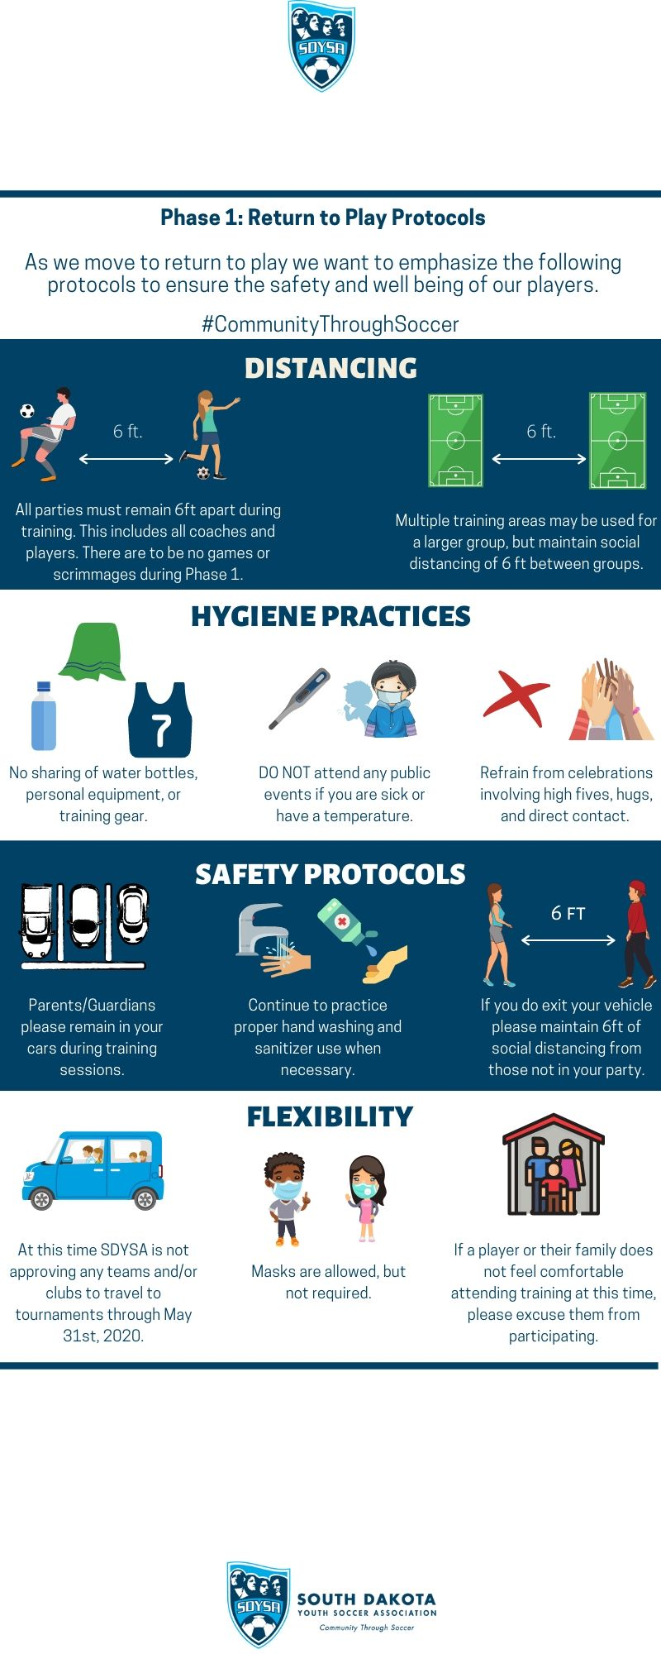
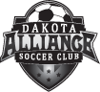
Thank you for your cooperation and understanding as we work through all of this together. Please feel free to reach out with any questions or concerns.
www.dakotaalliancesoccer.com

