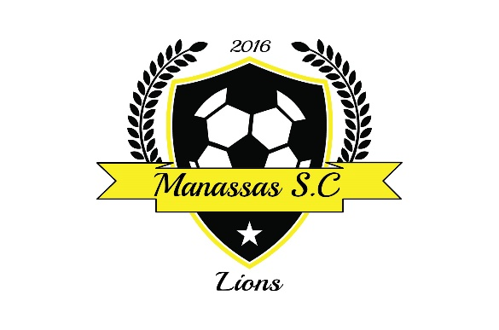
MANASSAS SOCCER CLUB
COMMUNICABLE DISEASE RELEASE OF LIABILITY AND ASSUMPTION OF RISK AGREEMENT
In consideration of being allowed to participate on behalf of the _____________________________________________, event or program (the ‘Program’) including, but not limited to, events and activities, observation or use of facilities or equipment, participation in or acting as a spectator during any program (collectively ‘Participation’), the undersigned acknowledges, appreciates, and agrees that, on behalf of him or herself and any of his or her minor children:
1. I am aware there are risks of exposure to directly or indirectly arising out of, contributed to, by, or resulting from an outbreak of any and all communicable disease, including but not limited to, the virus “severe acute respiratory syndrome coronavirus 2 (SARS-CoV-2)”, which is responsible for Coronavirus Disease (COVID-19) and/or any mutation or variation thereof, as a result of my Participation in the Program.
2. I am aware that my Participation or that of my minor children includes a risk of possible exposure to and illness from infectious diseases including but not limited to MRSA, influenza, and COVID-19; and that while particular rules and personal discipline may reduce this risk, the risk of serious illness and death does exist; and,
3. I KNOWINGLY AND FREELY ASSUME ALL SUCH RISKS, both known and unknown, EVEN IF ARISING FROM THE NEGLIGENCE OF THE RELEASEES or others, and assume full responsibility for my Participation and the Participation of any of my minor children; and, 4. I willingly agree, on behalf of myself and any of my minor children, to comply with the stated, reasonable, and/or customary terms and conditions related to my Participation—and that of my minor children—as regards protection against infectious diseases; and if I observe any unusual or significant hazard during my presence or participation, I will remove myself and my minor children, as appropriate, from Participation and bring such hazard to the attention of the nearest official immediately; and,
5. I, for myself and on behalf of my heirs, assigns, personal representatives, children and next of kin (‘Releasors’), HEREBY RELEASE AND HOLD HARMLESS ___________________________________________________________, it officers, officials, agents, consultants, and/or employees, other participants, sponsoring agencies, sponsors, advertisers, and if applicable, owners and lessors of premises used to conduct the event (‘Releasees’), WITH RESPECT TO ANY AND ALL INJURY, ILLNESS, DISABILITY, DEATH, or loss or damage to person or property, WHETHER ARISING FROM THE NEGLIGENCE OF RELEASEES OR OTHERWISE, to the fullest extent permitted by law.
I HAVE READ THIS RELEASE OF LIABILITY AND ASSUMPTION OF RISK AGREEMENT, FULLY UNDERSTAND ITS TERMS, UNDERSTAND THAT I HAVE GIVEN UP SUBSTANTIAL RIGHTS BY SIGNING IT, AND SIGN IT FREELY AND VOLUNTARILY WITHOUT ANY INDUCEMENT.
Participant’s Name: __________________________________________ Age: ____ Participant’s Signature: ________________________ Date: __________________
FOR PARENTS/GUARDIANS OF PARTICIPANT OF MINOR AGE (UNDER AGE 18 AT TIME OF REGISTRATION):
This is to certify that I, as parent/guardian with legal responsibility for the below-named minor child participant, do consent and agree to his/her release as provided above of all the Releasees, and for myself and for the other Releasors I do hereby release and agree to indemnify and hold harmless the Releasees from any and all liability incidents to my minor child’s involvement or Participation in the Program as provided above, EVEN IF ARISING FROM THE NEGLIGENCE OF THE RELEASEES, to the fullest extent permitted by law.
Parent/Guardian Name: ________________________________________________ Minor Child Participant’s: _____________________________________________
Parent/Guardian Signature: _____________________________________________ Date: _________________

