- Create a Sports Engine Account (if you do not already have one). if you already have an account then click LOGIN and proceed to Step 4 below.
Go to the league home page at www.marylandmajorsoccer.com
In the top left corner, select where it says Create Account
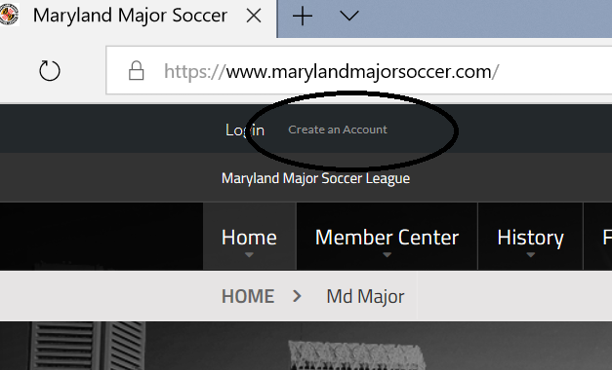

- Create your account by filling in the necessary information and then click the green sign up button at the bottom of the page. Be sure to use a valid email address.

- You will receive account creation confirmation to your email address – CONFIRM
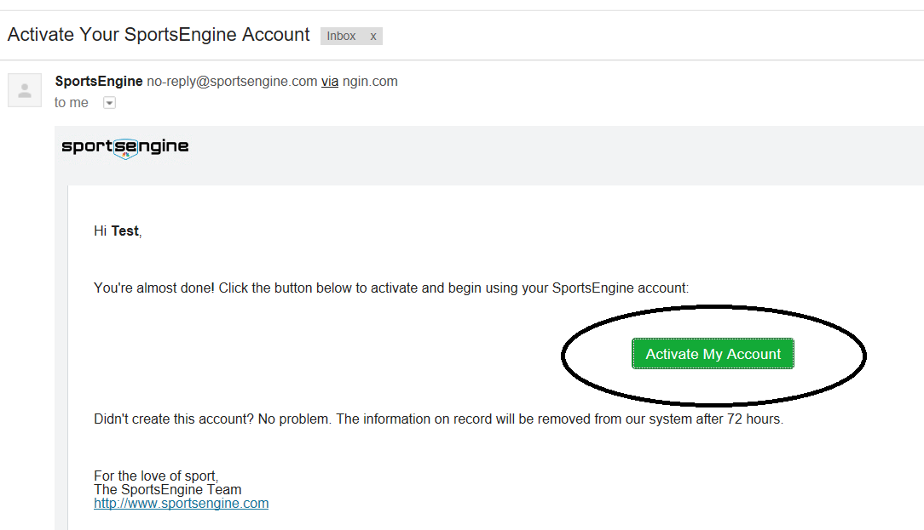

- You will then be brought to the Maryland Major Soccer League website – once there, select the option “Become a Member”
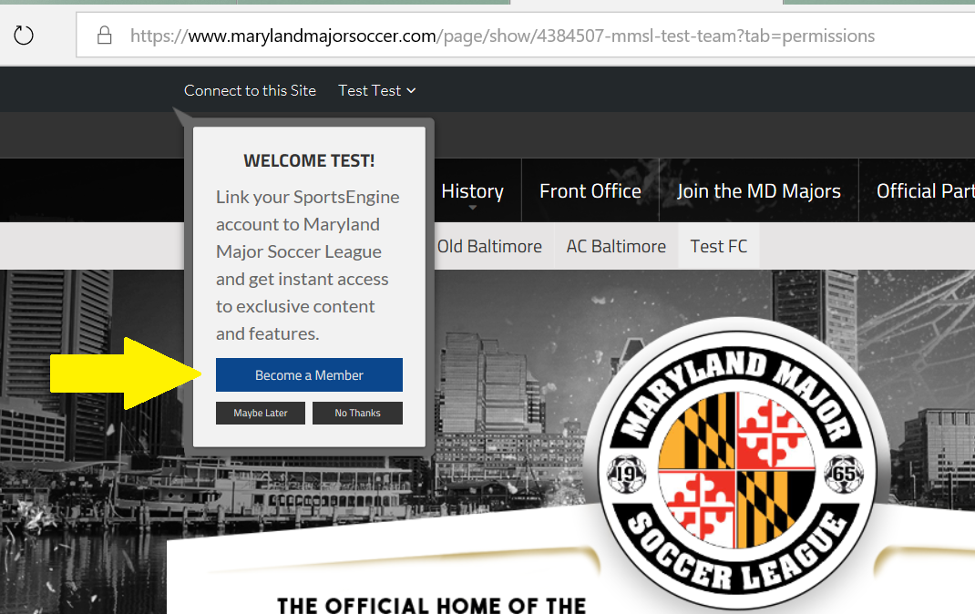

- Then select “Join Network with Selected Profiles”
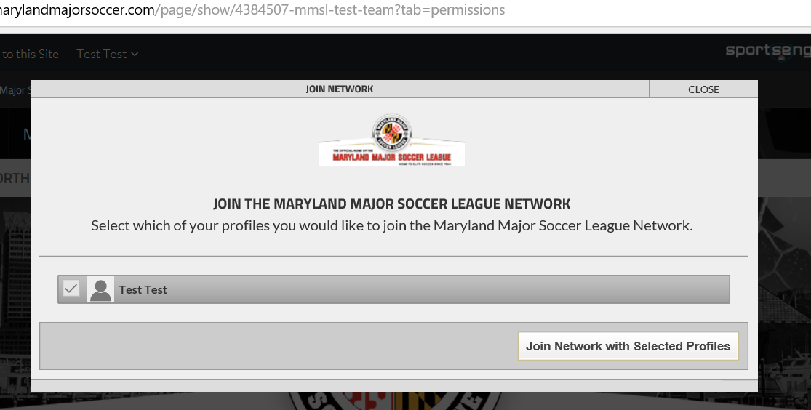

- Now when at www.marylandmajorsoccer.com make sure you are logged in (top left corner of the website, near where you created your account)

- Navigate to your team’s page on the website. On the league home page, click the little arrow below “Home” to pull up the Md Major league page, then navigate to your respective division, then select your team to go to your team page
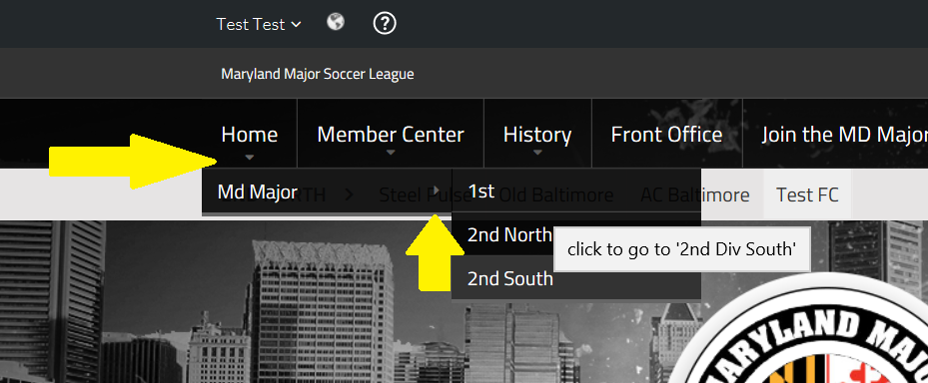

- Upon pulling up your respective team’s page, an “Edit” icon will appear on the left side of the page. Click the icon to toggle ON/OFF edit mode.
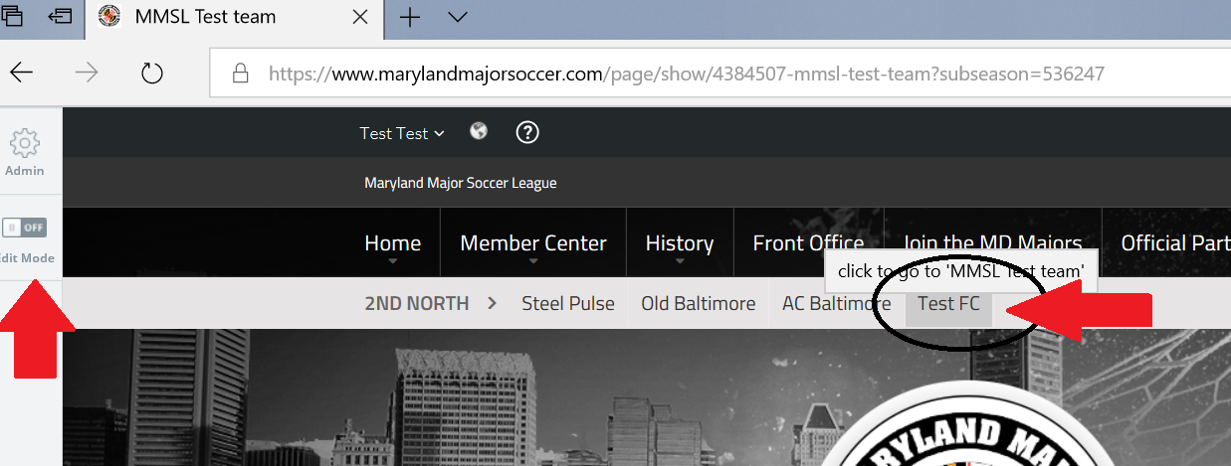

- In EDIT mode, as Manager/Admin of your club you will have access to your Maryland Major Soccer League team page to add/edit content, news stories, pictures, videos, etc. This is also where you will manager your roster.

- Feel free to post content utilizing the Sports Engine features. Click on the question mark for help to learn how to post content

- To UPLOAD player photos to your roster (THIS IS MANDATORY AS EVERY PLAYER MUST HAVE A PHOTO ON THE ONLINE ROSTER WHICH ALSO PRINTS OUT ONTO GAME DAY ROSTER)

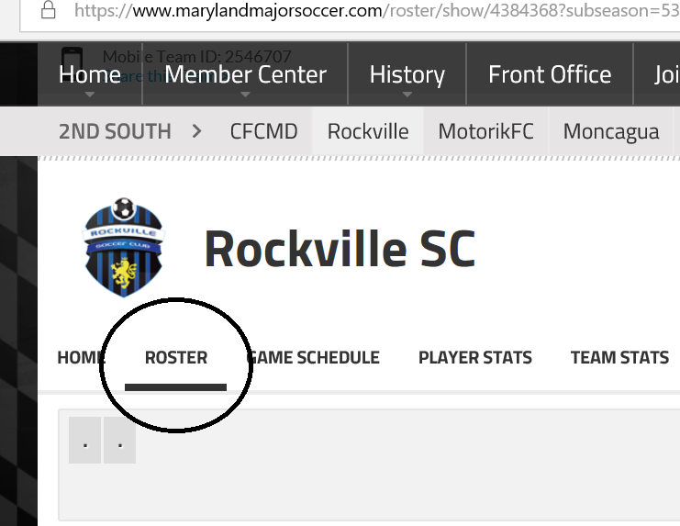

- Then click on the blank head shot on the roster page
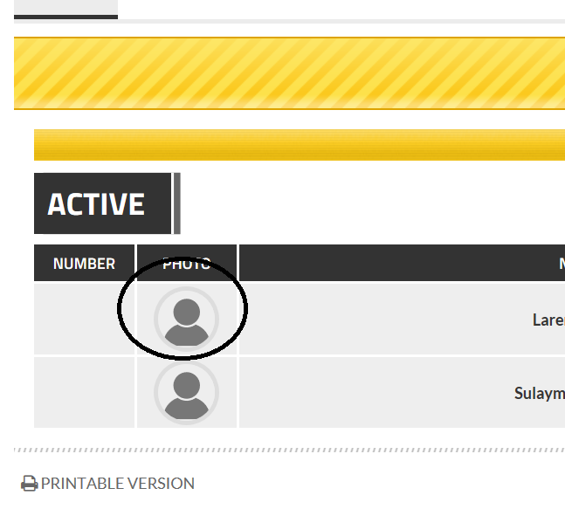
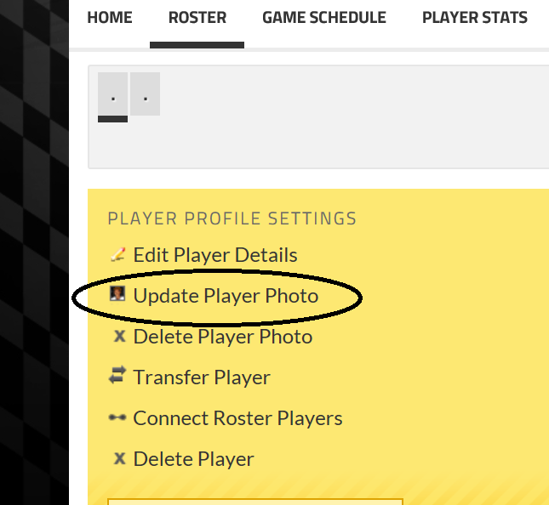
- Upload the player photo
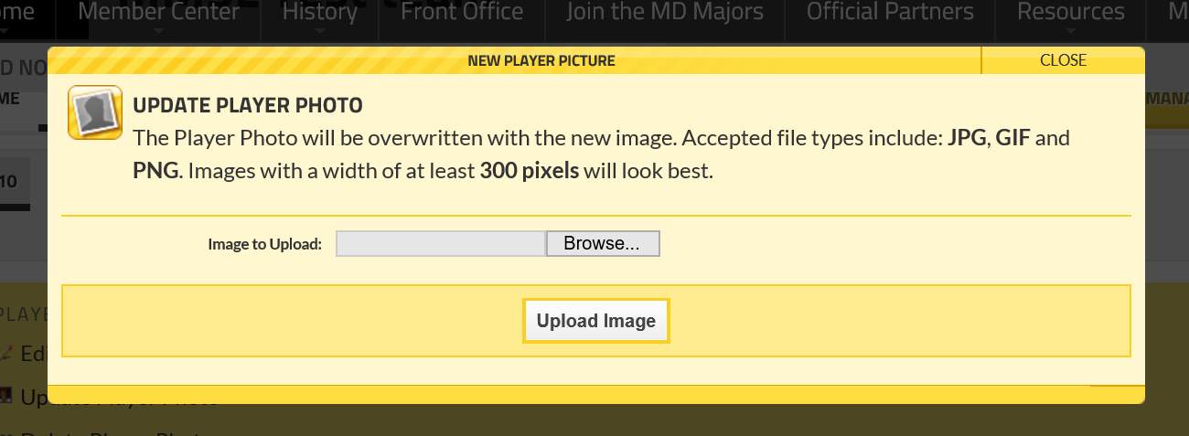

- To PRINT ROSTER FOR MATCH DAY – CLICK ON “Manage Team”
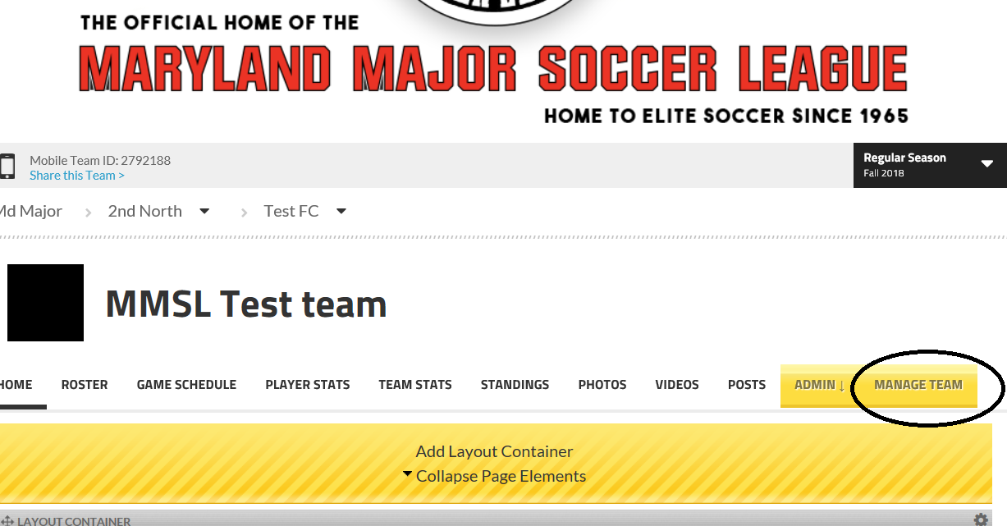

- PRINTING YOUR MATCH DAY ROSTER – YOU MUST PRINT 2 COPIES FOR EVERY MATCH – YOU MUST PRESENT 1 TO THE REFEREE OR ASSISTANT REFEREE AND ONE TO THE OPPOSING TEAM – BOTH MUST BE COMPLETED WITH PLAYER NUMBERS WRITTEN IN
