Minnesota Girls Gymnastics Officials Association
A Minnesota State High School League Association of Excellence
FLIP IT FORWARD
Become a High School Gymnastics Official!
For more information, contact us on our website or Instagram:
MGGOA.ORG
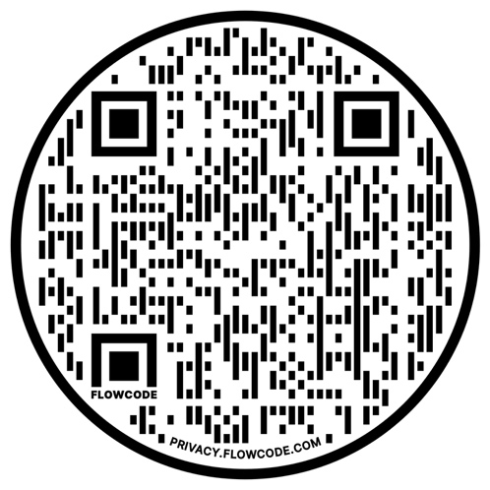
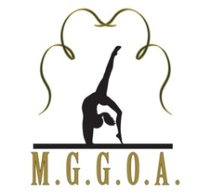
Every Routine, Every Time

