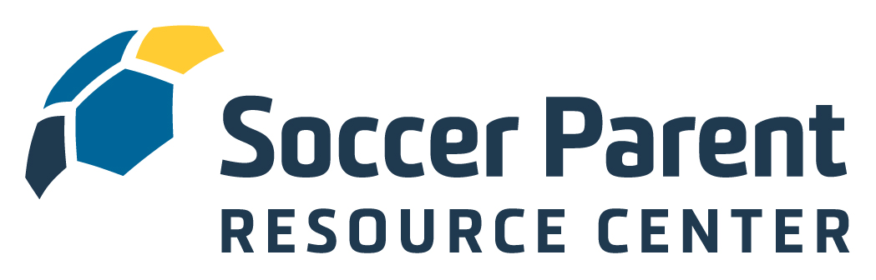

Welcome to the SoccerParentResourceCenter.com!

Boerne Soccer Club understands the importance of engaging and educating soccer parents and has secured a club-wide membership to SoccerParentResourceCenter.com, the parent education platform from the Soccer Parenting Association. You now have complete and free access to the interviews, articles, webinars, videos, courses, and an amazing community of level-headed parents at SoccerParentingResourceCenter.com.

To activate your free membership, copy this link into your browser:
https://soccerparentresourcecenter.com/register/club-membership/boernesoccer/

The mission of the Soccer Parenting Association is to inspire players by empowering parents.

- We believe youth soccer parents will be difference-makers in improving the game.
- We believe that great things will happen when parents seek information about how to best support their players.
- We believe a collaborative environment between the coach, parent, club, and player is in the best interest of player development.
- We believe a strong, supportive community of level-headed, like-minded parents and coaches will inspire players.

Like you, I am a soccer parent. I am also a former professional player, collegiate coach, active youth soccer coach, speaker, and coach educator. I am positive that the information you now have access to on the SoccerParentResourceCenter.com platform will help your child thrive and feel inspired on the field and in life.

I look forward to connecting within the Community Forum. If you have any questions, suggestions, or ideas for articles, please don’t hesitate to reach out.

Let’s Keep Going,

-Skye

Skye Eddy Bruce
Founder, Soccer Parenting Association
Skye@SoccerParenting.com

