
MINUTES Valley Youth Hockey Association
February 2022 – Board Meeting P.O. Box: 20362
February 15, 2022 @ 7:30pm Roanoke, VA 24018
Location: In Person & Virtual via WebEx Email: HOCKEY@vyha.onmicrosoft.com
_________________________________________________________________________________________________
Members In Person: J. Rosenberg, R. Parrish, J. Jamison, R. Schilling, D. Furrow, C. Kenney, A. Gergley, L. Dalton
Members Virtual: M. Ferguson, M. Amos, P. Madden, C. Coble, S. Kanode, M. Quonce,
Members Not Present: J. Pollard
Guest: N/A

Meeting Called to Order at 7:34pm by J. Rosenberg
- Approval of January Board Minutes.
  - Motion to Approve J. Jamison; 2nd – D. Furrow, +Motion Passed Unanimously+
- CONSENT AGENDA:
  - J. Rosenberg = Request to move Treasurer’s report/Finance and Fundraising out of the consent agenda.
    - Finance Report and Fundraising out of the consent agenda and into General Business.
  - See data/forms starting on PAGE 3 from the following committee’s consent agenda:
    - Registration Report – Removed from Consent Agenda for discussion.
    - Girls Hockey Update
    - 10U Travel (A&B)
    - 12U
    - 14U
    - LTP
    - House
    - Mites
    - Fundraising – Removed from Consent Agenda for discussion.
  - Motion to approve consent agenda: J. Jamison; 2nd R. Parrish +Motion Passed Unanimously+
- GENERAL BUSINESS –
  - Finance Report – J. Jamison reporting
    - Roughly $16,000 in the account currently.
    - Ice bill is paid quarterly
    - The key figure to work on next year is to know how many ice slots we have, and make sure Coaches of each team know how many home games they can have next season.
    - Must be stricter on approval of extra expenses.
    - See consent agenda for full Finance details.
  - Fundraising – S. Kanode reporting
    - Spring Raffle
      - Salem Red Sox is sponsoring the tickets.
      - Each raffle ticket will have a general admission ticket attached to it.
      - Goal to work on is trying to figure out how to get a family of 4 sell each of their 1st set of 5 tickets.
    - See consent agenda for full Fundraising details.
  - Revisions of COVID Protocols
    - Will keep COVID Policies as is until the end of the season.
    - AG will meet and is scheduled to update policies and protocols by Spring.
  - Spring Hockey
    - Registration fee = $35
    - Season will consist of 10 practices and 2 tournaments.
    - Goal is to be done by Memorial Day.
    - Looking to hold at least 1 team per age group.
  - Ice Schedule – presented by D. Furrow
    - Lot is booked from April to August.
    - Meeting with Joe Miller is in the works to help facilitate VYHA Ice needs for Spring Hockey and upcoming Fall Season.
    - Motion: Drew – to send the ice schedule back to the Exec Board for them to work through with the Lot.
      - 2nd = J. Jamison +Motion Passed Unanimously+
  - Coaches Committee Update = presented by R. Parrish
    - On Ice Stuff
      - April 23rd is 1st day of Fall Tryouts that we can hold due to Nationals, and requirements set by PVAHA.
      - Spring Travel Hockey
        - April 4th start date for Travel Hockey
        - Expected to send out registration for Spring Travel by March 1st = $35 for registration fee.
      - Spring House Hockey
        - 2 hours of ice time for House League.
        - 1 hour for Mites.
        - Registration will go out with Spring Travel as well (expected March 1st).
    - Off Ice
      - Safe Sport issue occurred during House League session.
      - No formal conclusion has occurred yet.
      - All parties: Lawyers/Authorities were notified and been informed.
      - Issue did not involve any VYHA Coach or staff member.
      - Issue was quickly notified to VYHA and handled appropriately.
    - Travel Programs
      - Off ice program proposals have been submitted.
        - 2 proposals so far. Expected to receive 1 more.
      - Will be asking Celly for off ice data from the 14U program they ran this past season.
        - 14U parents – Any feedback from parents on how they felt about the off-ice program.
      - Travel Coordinators for next season (As of right now)
        - 10U – Rob Parrish
        - 12U – Drew Furrow
        - 14U – Jason Reger
        - 16U – Eric Westlund
        - Girls Hockey – Lindi Dalton
  - Motion to adjourn = 8:38pm

- CONSENT AGENDA DOCUMENTS/DATA:
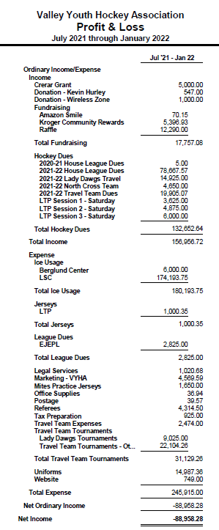
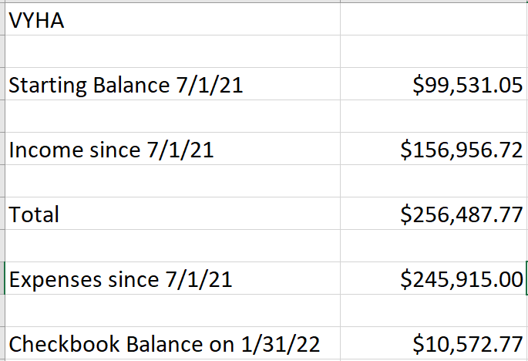
- Finance Report:

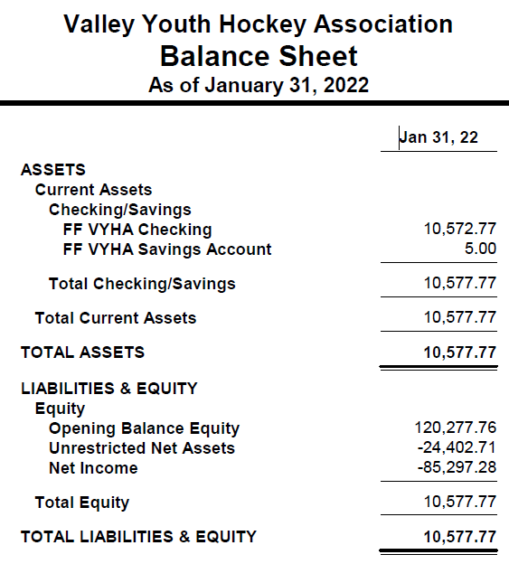

- Registrar’s Report:
- As the regular season draws to a close, final VYHA enrollment for 21-22 is 323. 59 adult volunteers, 45 6U players, 53 8U players, 64 – 10U players, 48 – 12U players, 34 – 14U players, 15 – 16U players, 5 – 18U players.
We have 44 girls playing this season (included in above age groupings).
- Registration for Spring House and Spring Travel will open soon pending details approved at meeting - Target date is March 1.

- Girls Hockey Update:
The girls have been progressing well even with the limited practices. The 12u has shown growth overall however we have one parent say her daughter will not play next year unless we offer something lower level because she has not made progress. The 16u has made big steps forward with coming together as a team and the older girls helping the younger girls on and off the ice. They got their first 2 wins two weeks ago and tied the same team this past weekend even when the other team had stacked the team with non-roster players. All the parents in this group are very happy and want to see the girls move to a more competitive level with a similar offering as the regular season of the coed. The 8u team was successful at the Beach Bash with some wins and a whole lot of fun.

I have below the proposal for the girl’s program for the 2022-2023 season. I also have included the numbers of girls in VYHA in different ages for the 2022/2023 season.
8u/6u- 13 Girls
10u/12/ -14 Girls
14u/16u/19u- 16 Girls
- 19u Team
  - Ages 14u/16u/19u
  - Register Tier 2
  - Register in CBHL Bronze
  - Attend Select CGHL showcases
  - 1 Tournament
  - Weekly full ice Practice
  - Preseason Camp
  - Selection Tryouts – Top 14 with others as provisional
- 12u Team – Ages 10u/12u
  - Register as Travel
  - Attend CGHL Showcases
  - Host a CGHL Showcase
  - Weekly ½ ice practice with 8u
  - Skill assessment vs Tryout – All players accepted to play on team
- 8u Tournament Team
  - Ages 8u/6u
  - Attend Girls Jamborees
  - Girls Beach Bash
  - 1 other Girls Mite Tournament
  - Open Registration
  - Weekly ½ ice practice with 12u
- Girls Developmental League (recommended by Pam Weiss- Girls hockey chair for PVAHA)
  - Girls new out of and or in LTP of any age
  - Travel Girls ages 12u and younger (will be assessed to be appropriate or not)
  - Provisional older girls
  - ½ ice games 3v3 or 4v4 with goalies.
  - Once a week
  - Goal is to be a steppingstone to build the girls' confidence to get them up into house or travel programs the following season.

- 10U (Blue & White)
10u White Travel
- CHL record 3-11-2
  - 5th place overall
- All set for DC tournament for this weekend.
- Set to play their last two CHL games in Charleston, SC. on Feb 26-27.
  - We are still trying to get a game in with Greenville while we are down there, but so far, no ice available. This will not impact the team if they can’t play the game. They have already played Greenville 3 times this year.
- They are set to make playoffs for CHL in Greenville, NC.
- No unresolved Issues or concerns over the last 30 days.
  - Please let me know if you need details of any issues over the last 30 days.

10u Blue Travel
- Competed in the EJ playoffs in Hershey, PA.
  - Lost to AAA NY Stars 7-2.
    - Our team played well considering only having 4 subs due to COVID exposures.
    - It was a great experience for the kids, and nice to represent Roanoke in the EJ 10u Silver 1 division.
- CHL record 8-1-2
  - 1st place overall
- This past week we played Lynchburg and won 7-3. Also, we traveled to Raleigh to play Jr. Canes 11uA team. We tied first game 3-3 and won the second game 6-2.
- Set to play in Va. Beach tournament this weekend. I would say chances are good to win the tournament.
- Qualified for CHL playoffs in Charleston, SC.
- Scheduled to complete CHL regular season on Feb. 26-27 against Pineville here at LSC.
- ALL players are developing extremely well, and I am very proud of every player on the team.
  - They are playing fun, fast hockey. Our organization regularly receives praise from other teams and coaches complementing our play, sportsmanship, and character. Truly a special group of kids.
- No issues or concerns

- 12U
  - The Roanoke Jr. Dawgs 12UA team has finished regular season play as follows.
  - EJEPL Record 11-5
  - CHL Record 9-3
  - Overall 20-8-0
  - The 12U Dawgs achieved a berth in the EJEPL Playoffs with a overall Krach rating of: 51.1576 which seeded our team 4th in the playoff standings of the 6 teams to qualify. Unfortunately, a late goal in the third period of our first playoff game eliminated our chances at an EJEPL Silver 1 Title.
  - Our CHL season has been that of ups and downs. Our team roared out of the gate with a 9-game win streak clenching the CHL 12U Upper A regular season championship. However, faltered down the stretch to drop our last 3 regular season games. In a strange turn of events, after qualifying for the CHL playoffs based on our record. The CHL crowned us the regular season champions and excluded our 12U Dawgs team from their playoffs.
  - Our team has two remaining tournament appearances. One in Louisville, KY over Presidents Day weekend and our final event of the 2021-2022 season in Charlotte, NC March 11-13.

- 14U
- Roanoke Jr. Dawgs 14UU has a record of 23-9-3.
- We participated in the EJ GOLD 1 playoffs (qualifying #2). Lost in the quarterfinals 1-0 with 18 seconds left.
- We are currently in third place in the CHL 14UAA division.
- Our next games are this weekend at the Louisville tournament (14UAA division).

- Learn To Play
- We have 54 enrolled in session 3. I asked Melissa to cap there based on coach availability.
- We have a handful that still need help but are moving along well.
- If the head coaches from the other age groups could reach out to your group and see if anyone is available we can still use help on the ice.
- Thanks to all that have helped out this year. It has been a big help.
- Is there an update on the jersey order?

- House
- Regular season is coming to an end.
- Last practice is set for 2/15.
- Last regular season games are on 2/17
  - Playoffs start on 2/24
- Playoff rules have been added and shared with all coaches, players, and parents.
- Should be an exciting end of house league
- Kids are playing well and having fun.
  - No issues or concerns

- Mites
  - House Mites
    - Going well. Continuing with practice on Mondays and games on Saturdays.
    - Ordered personalized trophies for 56 players last week. (Thanks to Jenny Parrish for recommending AAA Trophies!)
    - Annual Mites v. Coaches game is slotted for 2/26/22. We also have a final practice on 2/28/22.
  - Tourney Team
    - We played in the Scruffy City Shootout and came in third place against some talented competition. Our kids started the tourney 0-3 and battled back to a 4-3 record with the win in the #3 vs. #4 final game. SO proud of these kids!
    - Practices—we are practicing during normal Mites time. Our team begins with the full ice drills but then the Tourney team does not rotate with other groups. They stay together and run more advanced drills. Thanks to Rob Parrish and Luke Peery for handling the Coaching with this, while I direct Mites.
  - Games/Tourneys
    - Completed
      - January 28-30--Scruffy City Shootout (Knoxville, TN)
      - February 6—Lynchburg came to play us at the Lot
      - February 20—Winston Salem coming to play us at the Lot
      - February 26—Richmond is scheduled to play us at the Lot
      - March 18-20—BODYARMOR State Games (Raleigh, NC)
      - Final cost for players participating in the Tourney team was $270.
    - I would really like to implement the tryout and 8U Tourney team beginning in the fall. Looking to participate in 4 tournaments next season.
  - Jamborees/Games with other clubs
    - So far, we have sent teams to Jamborees in Lynchburg. Two teams attended both with a total of 23 players take part in the opportunity. Parent/player feedback has been very positive. Kids are having fun!
    - There is one other Jamboree possible, March 5 in Winston-Salem.
    - I am hoping with decreased Covid numbers and available ice time to host 2 jamborees next season.
  - Mites on Ice
    - We have had three Mites on Ice at the Railyard Dawgs games in the past month. We had to cancel Sunday (1.16) due to snow.
    - We do have our final Mites on Ice at the Dawgs game this coming Sunday (2.20)—We had parents send top three dates and organized players according to best dates for their family. If players can’t make it, we try to offer to waiting list. We have had 35 mites take part in this opportunity so far. Overall, it has gone well and kids/parents have loved them.
  - Mighty Mites at the Carolina Hurricanes game
    - Our Jr. Dawgs will be skating during the intermissions of the 3/12/22 Canes game in Raleigh!
    - As of today, we have 31 players signed up to take part in the event. We sent out the discounted ticket link this past week. Deadline for players to sign up to participate is February 21. Our ticket goal is 160 tickets.
    - Parents and players were really excited about this opportunity.

- Fundraising
  - Fall Raffle
    - Excel info should be completed/sorted by family and to Jennifer by the end of the week.
  - Spring Raffle
    - Talked with Red Sox GM about sponsoring ticket printing. In addition, on the back of the tickets, there will be a coupon for one general admission ticket to a Red Sox game.
    - Going with the normal $1,000.00 for first prize and $100.00 for third prize.
    - Second prize thought is a “Grill and Chill” option (a grill and/or a YETI cooler package). In touch with two local businesses about sponsoring second prize with donations.
    - Dates for Spring Raffle—tickets should be available the week of March 7.
    - Sales will be through April 11 or 18. Drawing April 13 or 20?
    - Coordinate with spring season?
    - How do we encourage all players to at least sell the first five?
    - Thinking of adding a prize drawing for families who sell at least five? Just trying to think of how to make it more meaningful for both families who need the financial boost to play AND so the VYHA makes more as a fundraiser overall.
    - Ideas- Stick and Puck card donated by the Lot or Celly/Hockey House Gift Certificate
  - Upcoming Opportunities
    - Old jerseys by cages
    - Use one for marketing purpose as a giveaway for the Facebook page when it reaches a certain number of followers-Ryan’s idea.
    - Use one in a silent auction giveaway (sponsored by VYHA) at a local elementary school.
    - Organize and post them in some online format to sell at affordable prices. ($10-15/each)
    - Old equipment—same concept as #3 above
    - Chipotle night—Mid-April
    - Domino’s night—reached out, getting more information

