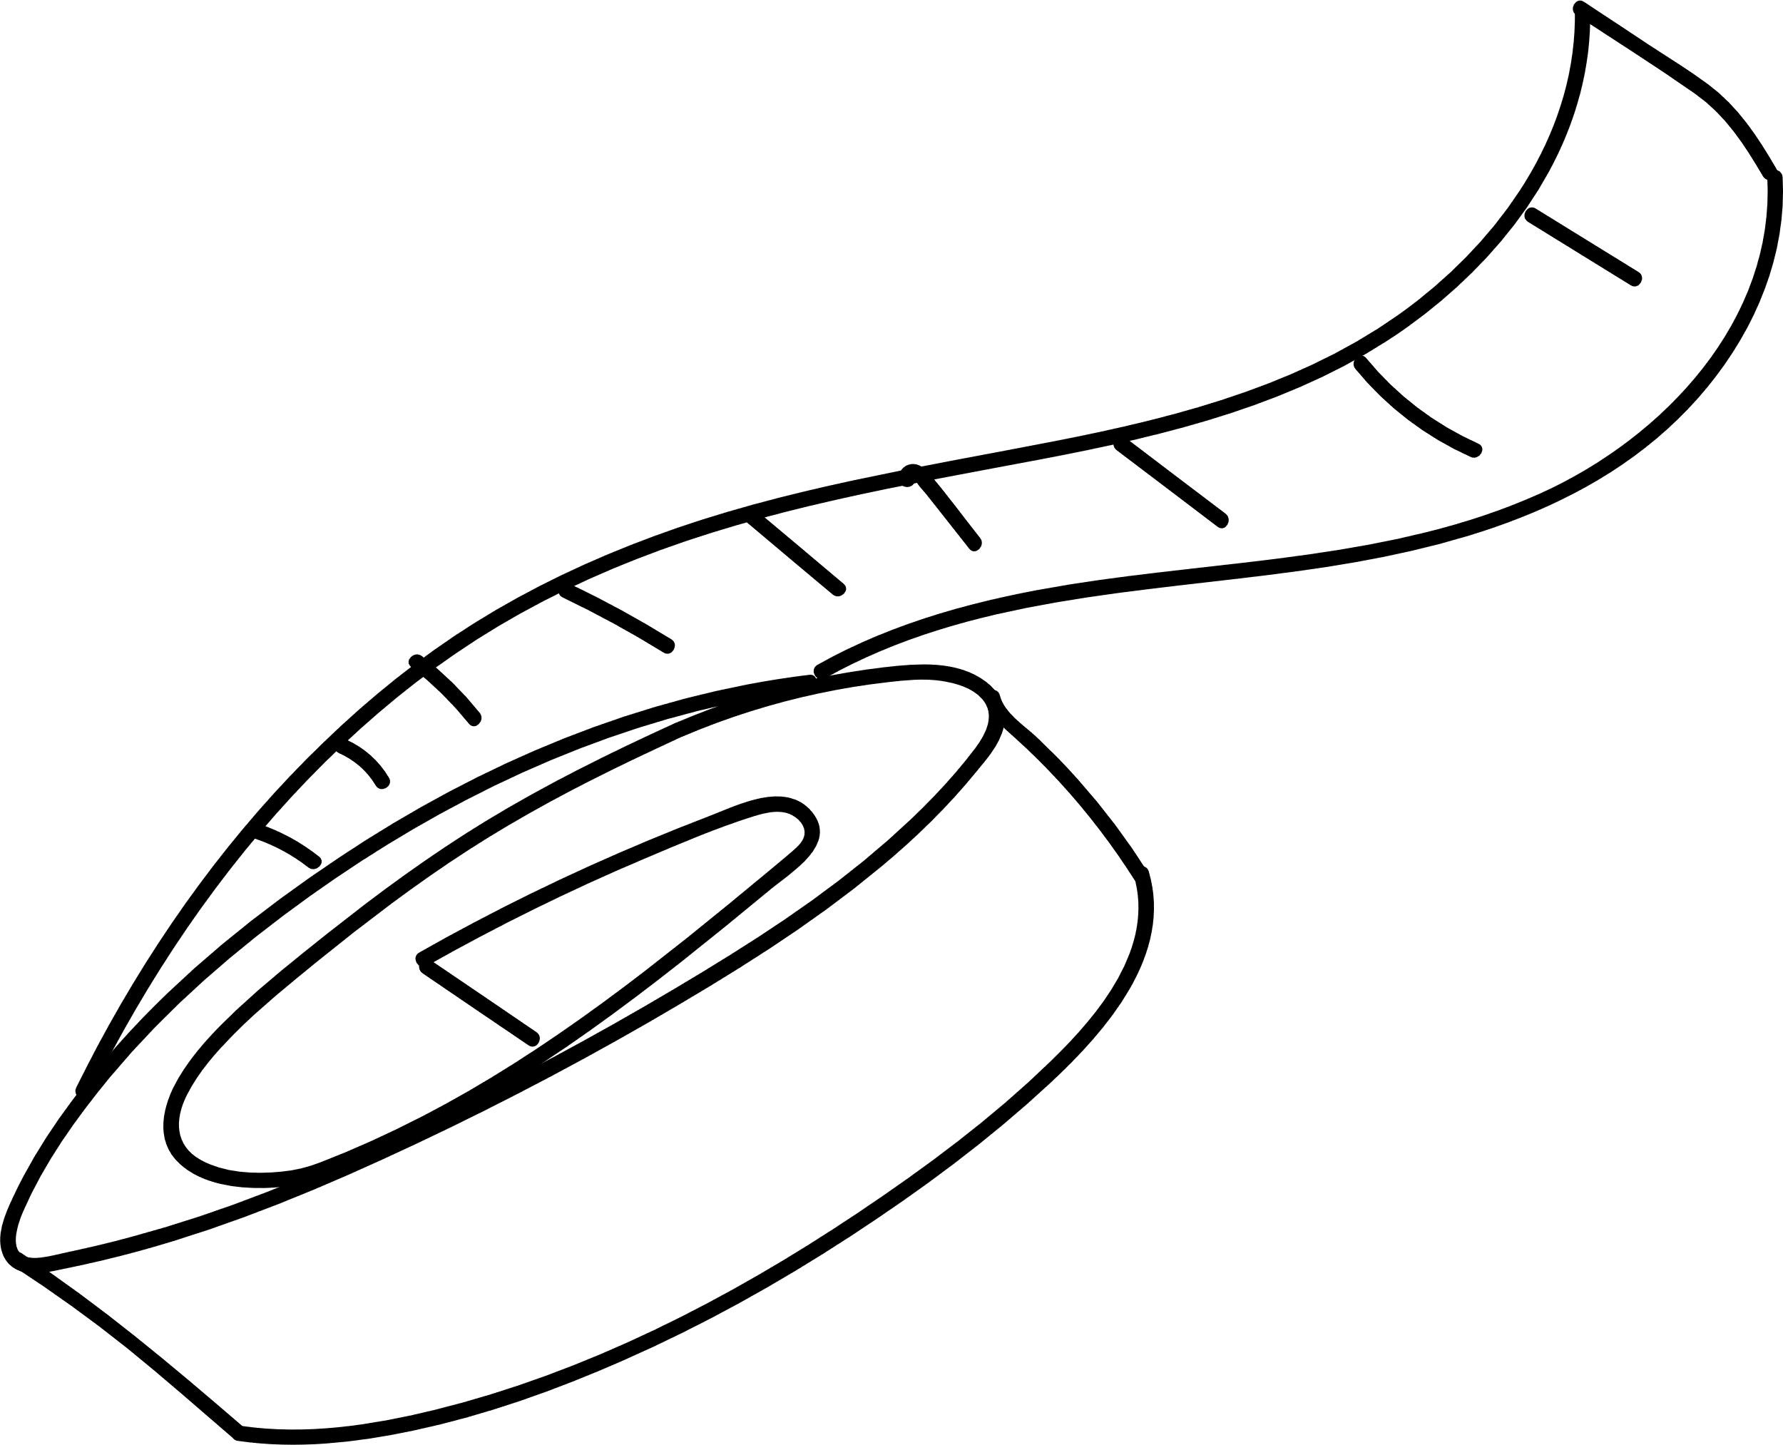

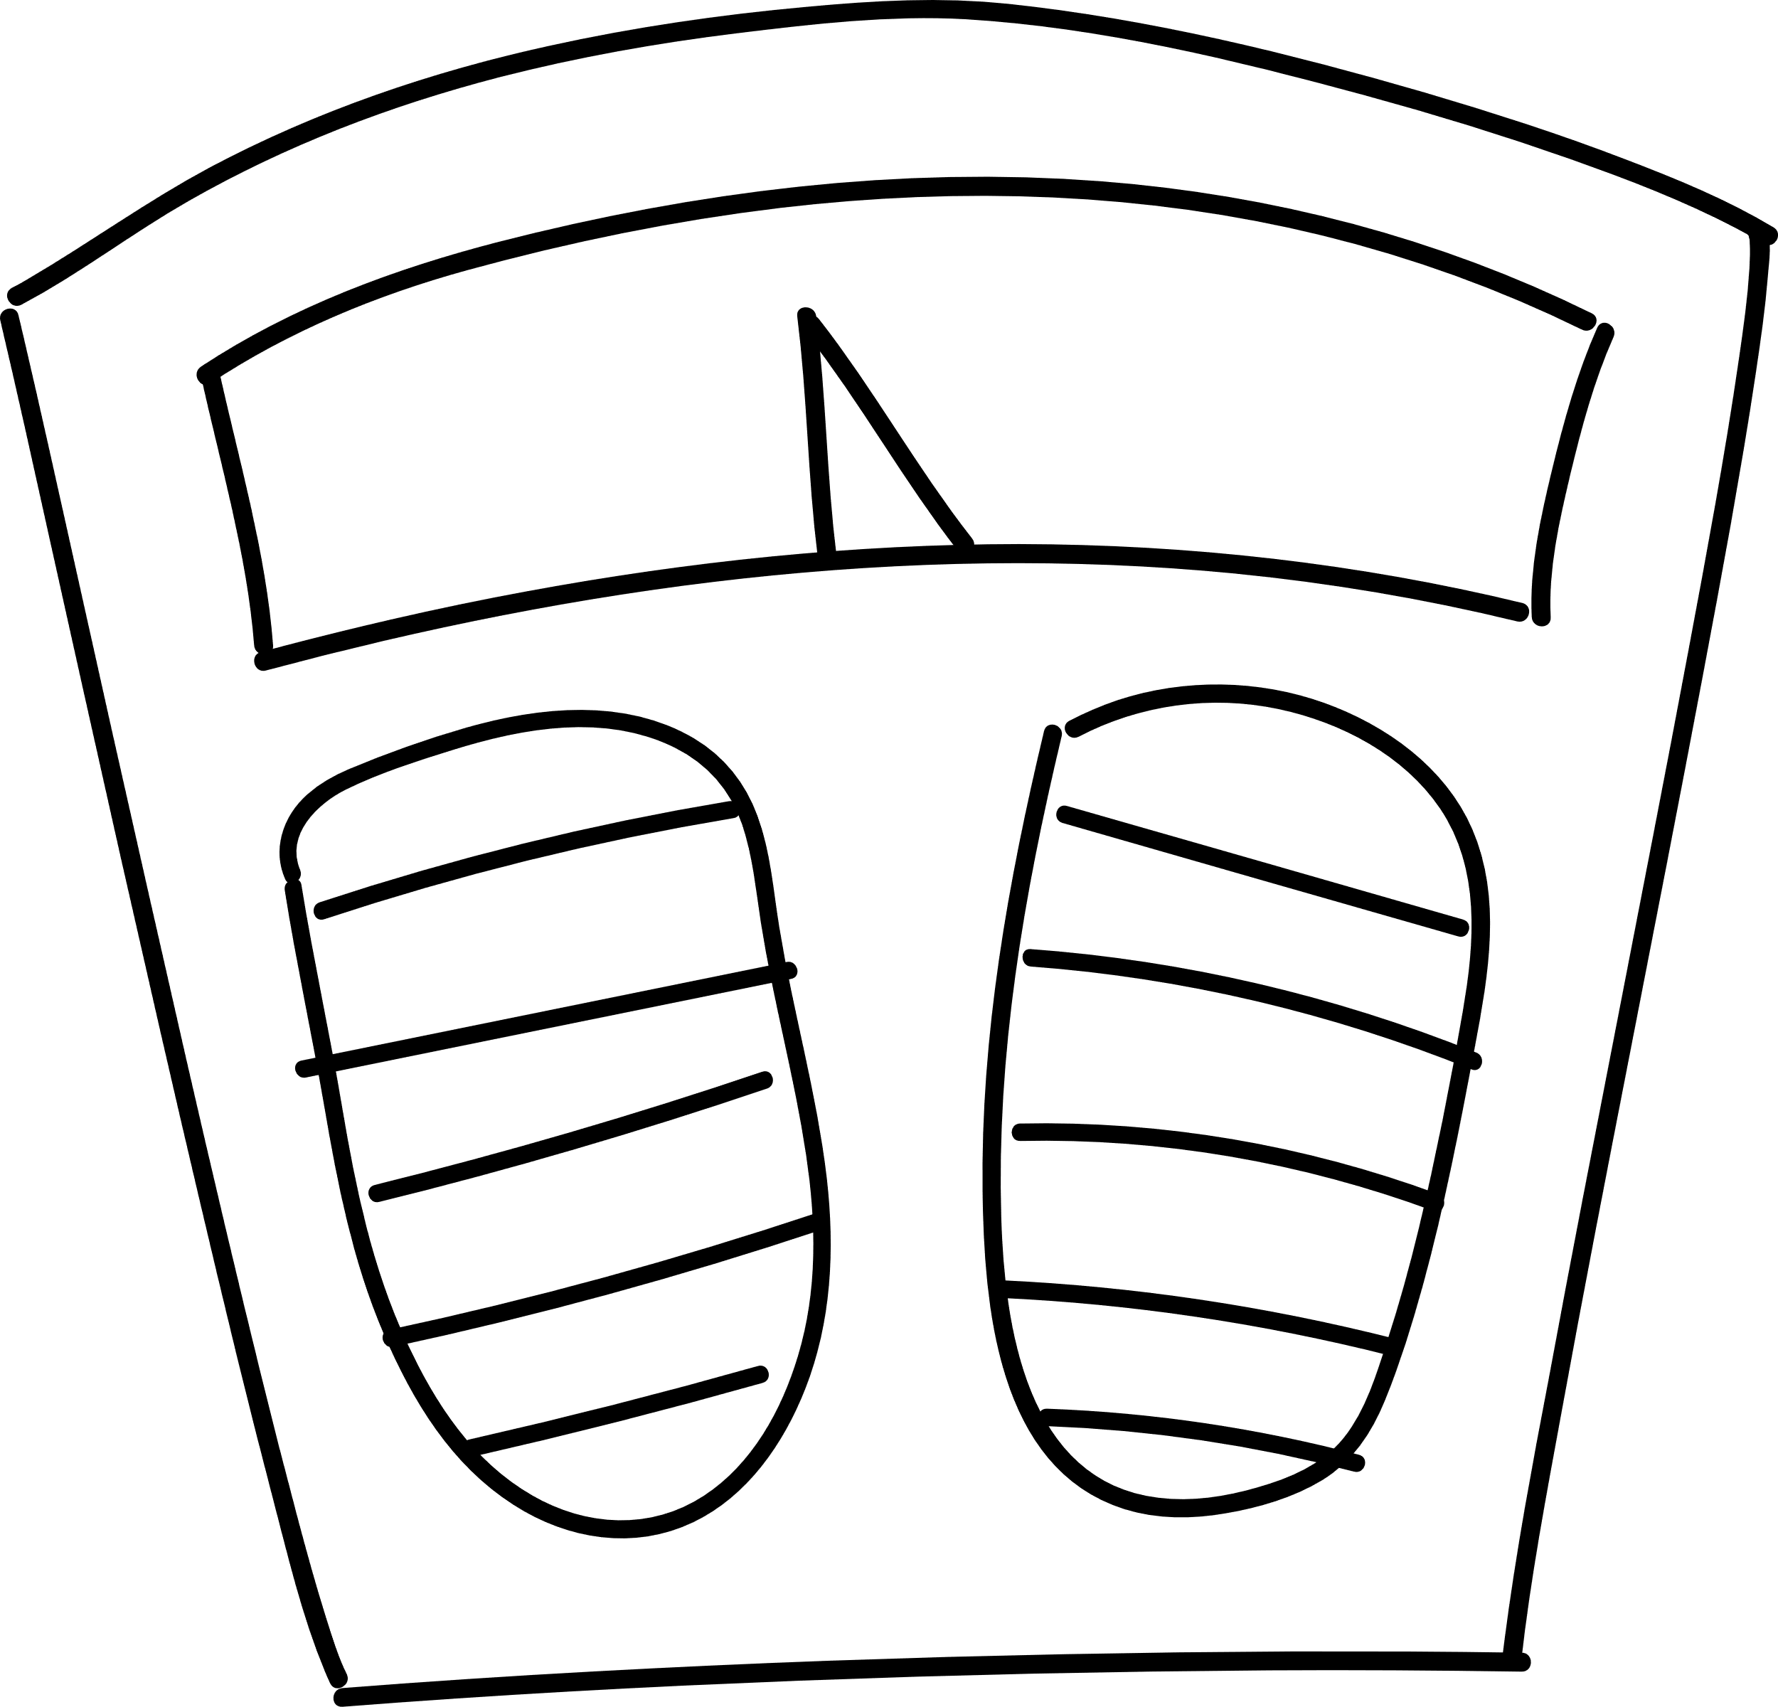
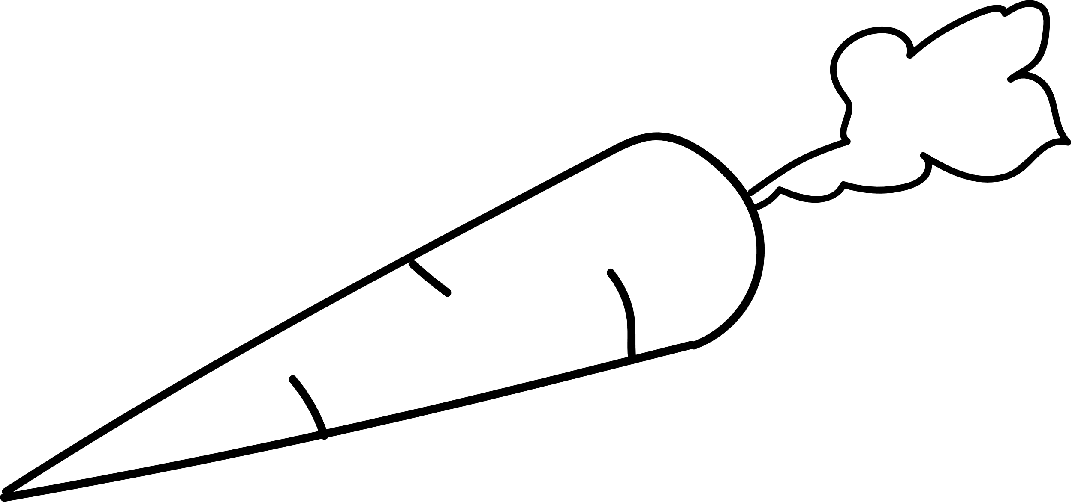







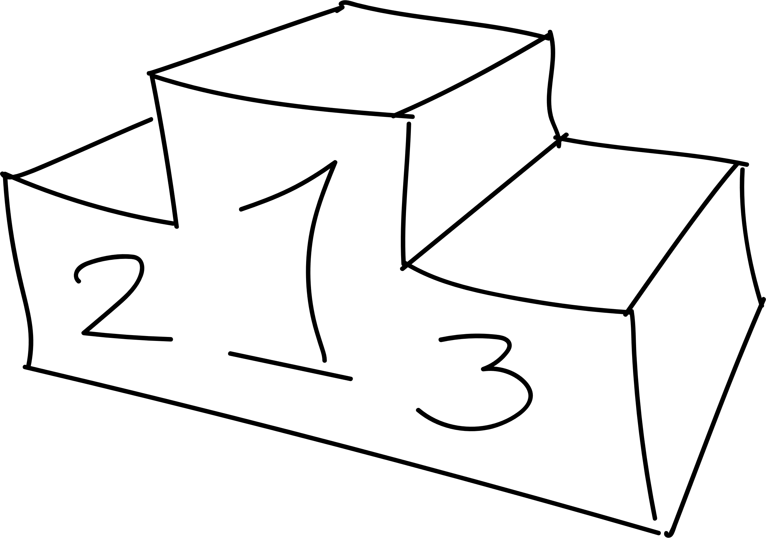




Kickers FC

U17 Boys

NUTRITION
JOURNAL




Healthy Snack
Ideas

 | Nuts |  |  |  | Veg |  |  |  | Fruit
 | Seafood |  |  |  | Fish |  |  |  | Sweet

Other

Weekly Food Log
Write down what foods you eat daily
 | Sun |  | Mon |  | Tue
 | Wed |  | Thu |  | Notes
 | Frid |  | Sat

Water Tracker
Keep track of your water intake. Each circle below represents 1 pint.

1 |  | 16
2 |  | 17
3 |  | 18
4 |  | 19
5 |  | 20
6 |  | 21
7 |  | 22
8 |  | 23
9 |  | 24
10 |  | 25
11 |  | 26
12 |  | 27
13 |  | 28
14 |  | 29
15 |  | 30

Weight Tracker
 | Jan | Feb | Mar | Apr | May | Jun | Jul | Aug | Sep | Oct | Nov | Dec

50

49

48

47

46

45

44

43

42

41

40

39

38

Measurements
 | Jan | Mar | May | Jul | Sep | Nov

Chest

Hips

Left Thigh

Right Thigh

Left Arm

Right Arm







Healthy Rewards
Start |  | Stage 1
 |  | Stage 3

Finish




Stage 2

Stage 4

Nutrition Goals

Goals Group 1

 | Goals Group 2 |  |  |  | Goals Group 3

Goals Group 4

