Enjoy a Night at the Races!

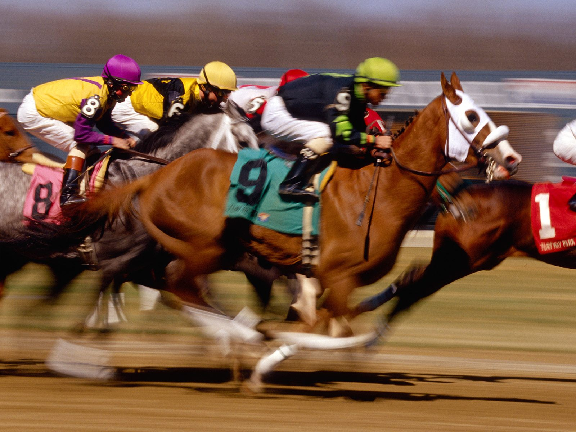

**Place your bets and spend an exciting night supporting**

**The Wentzville Lacrosse Team**

**Saturday, March 14th**



**Contact Karen at (314) 560-3345 or go to** [**WWW.WENTZVILLELAX.COM**](http://WWW.WENTZVILLELAX.COM) **for more info!**

**New Melle Rec Banquet Hall 4700 Hwy Z, New Melle 63365**

**6:00pm Doors Open 6:30 Betting Begins**

***Free Beer, Wine & Soda!!***

***Fill a table today - $200/table of 10 by Mar 7th***