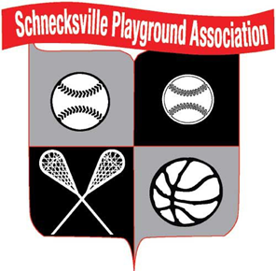

Throughout the course of our sports seasons, Schnecksville Playground Association will be taking action photo shots of the players and the teams within the organization for all sports.

These action photo shots will be highlighted on the organization website/Facebook/Instagram to help promote the organization and the sports we offer.

Schnecksville Playground Association does and always will respect our member’s privacy and confidentiality.

Please click “NO” below if you wish to not have your son or daughter personal action shot posted on any web or social media outlet used by Schnecksville Playground Association.

By clicking “YES” below as a parent you are consenting that Schnecksville Playground Association may use your son or daughter’s personal action shot on our website and social media outlets.

This does not apply to team pictures or group photos.

- YES – If you consent to your son or daughter personal action shot being used on internet media outlets by the Schnecksville Playground Association

- NO - I do not consent to my son or daughters personal action shot being used on any internet media outlet used by the Schnecksville Playground Association. I do understand that any team or group photo may be used on these internet outlets by the Schnecksville Playground Association

