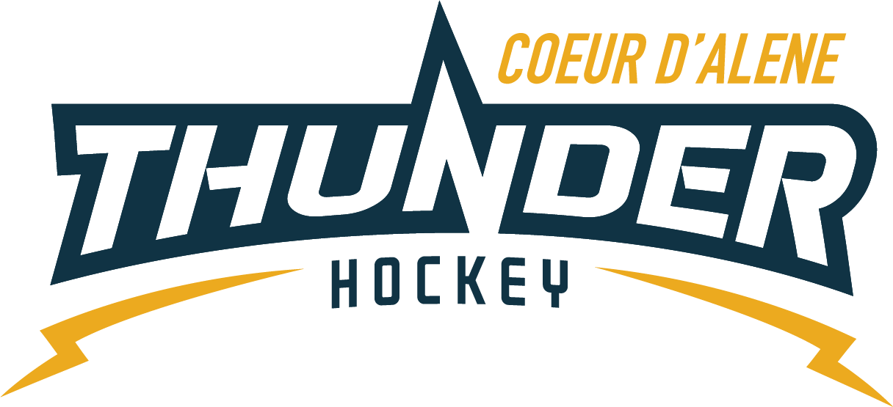

CDAHA

Meeting minutes
Location: Frontier Date: January 19, 2022
Attendees: Bob Nelson, Katie Lovitt, Megan Smith, Matt Creighton, Josh Leppert, Matt Fisher

Absent – Bart Barrett, Elliot Taub, Will Higgins,
Guest – Matt Pelz, April Hocking
- Call to order
Matt Creighton, Vice President called meeting to order 1/19/22 6:42PM
- Roll call
As stated above -
- Approval of minutes from last meeting
Minutes approved motioned by – Bob Nelson second by Josh Leppert passes unanimous
- New Items
  - Banners/Trophies
    - With new take over Matt will see if there is a way we can display these as we are low on storage.
- Treasurers Update
  - See attachments
  - 128k in account with 3 checks still outstanding
  - Oldtimers have a grant that issued to one of our skaters this year, maybe we look into this every year. They said they love doing this for hockey players.
  - Need a POA for our state taxes for the 501C3 to finish off our taxes for 2021
  - Squirt Coaches would like xtra goalie gear for their teams, it will have to be tabled until next season. Money spent for this season. We can send a blast to Association to see if there are any sets people want to donate.
  - Storage will be an issue for continuing to buy extra things we will need to discuss this in the future for purchasing a unit.
  - Projections for next year were discussed
    - Head Coaches – stipend
    - Skating Coaches
    - Registration
    - Opening a reserve account
All tabled until full board available
- Holiday 3 v 3 all ages
  - Actually a 4x4 was a HUGE success will continue with this
- Coaching Committee Update
  - Joe would like to send out a survey to families – Josh will get with him on this and sending it out.
  - 2 coaches suspended for a Match penalty awaiting their outcome from their hearing.
    - Match penalty was for failure to play the game and walking off the ice during a game causing a forfeit.
    - Needing a plan for coaches/parents/Association for educational learning to ensure this doesn’t happen moving forward.
- Scheduler
  - Vince has us scheduled until March 10 we will abide by that date. April will fix calendars and we need to notify Vince.
Minutes submitted by: April Hocking
Minutes approved by: BOD
- Next Meeting
  - Wed February 23, 6:30PM
  - Bob motions to adjourn – Josh seconded

