Date: 11/13/2023
Day: Monday Practice: 1 Next Opponent: Unity Scrimmage
Energy, Toughness (details, mental), Be a great teammate, communication
Time | Length | Activity/Drill | Notes
3:45 | 8 | Warm-up/Talk
3:53 | 10 | 90 second defensive Stations  - 1 on 1 closeouts  - 1 on 1 full court  - 2 on 2 positioning  - 3 on 3 rebounding | DS  EL  JG  SE
4:03 | 10 | Pack Line intro and Shell Drill  - Ball Pressure  - Two feet in the pack line – make sure we put the pack line down  - Closer to the ball than your man – off ball  See man and see ball | DS  What are the NO’s
4:13 | 8 | Ball Handling | EL
4:21 | 8 | Finishing School - from the slot - 2 side - 6 baskets  - Two foot - jump stop, stride stop  - Reverse pivot - stride stop  - Inside hand  - Extended Arm | EL/DS
4:30 | 10 | Teach Transition D and run 4 on 4-line transition  - Halfback/fullback  - Pick up, build a wall.  - Communicate  - 1st 3 steps | DS
4:40 | 20 | 2-Sided Break – first 3 steps  - 5 on 5 slow learning – 5 man rebound – non 5 man rebound  - 3 on 1 to 2 side (2 full courts)  - 4 on 2 (2 full courts | DS
5:00 | 10 | Intro to Offense – pass and cut 4 out spacing – X’s on the floor  - .5 second decision making – peaking  - Talk about big picture 5 on 5 slow learning | DS
5:10 | 10 | 2-man drills  - Kick Up  - Kick Back  - Back Door  - Hammer | 3 baskets
5:20 | 8 | 3-man Drills  - Kick Up  - Kick Back  - Backdoor + Hammer | 3 baskets
5:28 | 8 | 4-man drills  - Kick up to kick back.  - Kick back to kick up.  - Backdoor hammer to 1 more | 3 baskets
5:35 | 15 | 4 on 4 live with constraints – film this – 2 ends
5:50 | 10 | 5 on 5 - add 5 man, stay away
6:00 | 8 | Conditioning – FT or shooting conditioning

Reminders:
Lifting tomorrow morning – 6:30 – 7:30 – shooting/conditioning 6:55-7:20
Energy, toughness, detail, being a great teammate, communication.
Defense: communicate, stay in stance, see the ball, energy, finish possessions
Offense: take great shots, protect the basketball
Tomorrow and Near Future: BOB, SOB, Press Breaks, Press, Zone offense vs 1-3-1, 2-3, man sets, FT line situations, ½ ct traps, post entries, guarding common actions, ball screen defense, late game situations and clock, rule changes, any more?
Shot Selection:
Supplementary Notes:
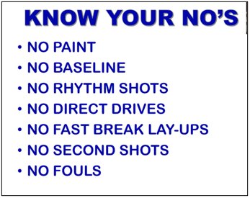
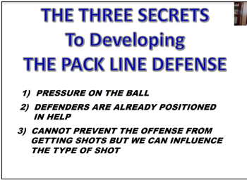

Energy Giving Behaviors (EGSs) – Pre practice meeting about Core values:
- Talking on defense
- Loose ball recovery
- Touches
- Fist bumps
- Taps on the back
- Deflections
- Steals
- Offensive rebounds
- Defensive rebounds
- Blocked shots

