WNS VIDEOGRAPHER INSTRUCTIONS (Varsity and JV)

TO GET iPad: Find the coaches before the game. If you are Varsity volunteer, it is possible that the JV volunteer has it from earlier game.
1. iPad On/Off Button. Turn On
2. Press Button to prompt Password
3. Enter Passcode (Coach or Board has PC)
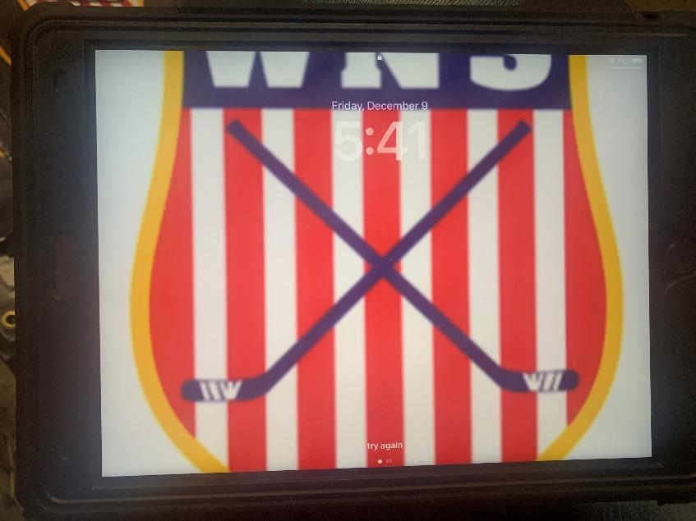

2

1
3. Find and Select Hudl App: Hudl is used to record games. It allows coaches to edit and call out certain plays to the players.
4. Select Video Record Icon
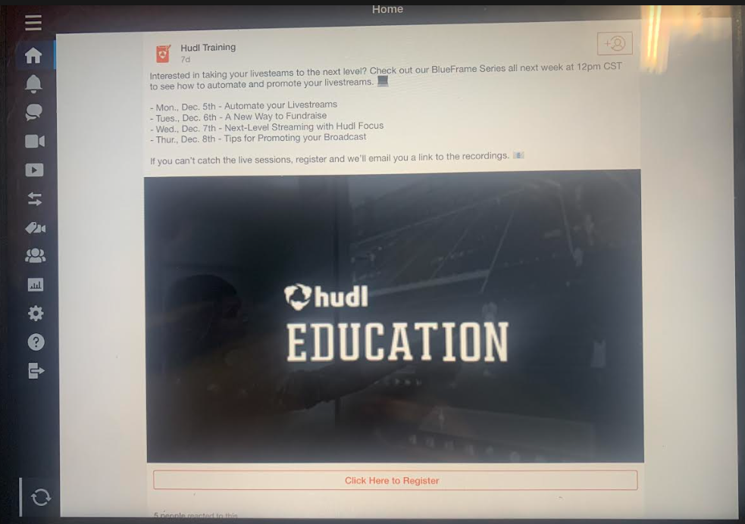
Hudl App Icon

3

4
5. Press Red Button to start recording. Press Red Button to stop recording
- You should record near mid-ice from the stands (between mid-ice and blue line ok)
- Optional: You can start and stop recording during stoppage of play (not required)
- You should stop recording at the end of each period
6. At the end of each period, press “Save and Edit” (not pictured here but appears when you stop recording)
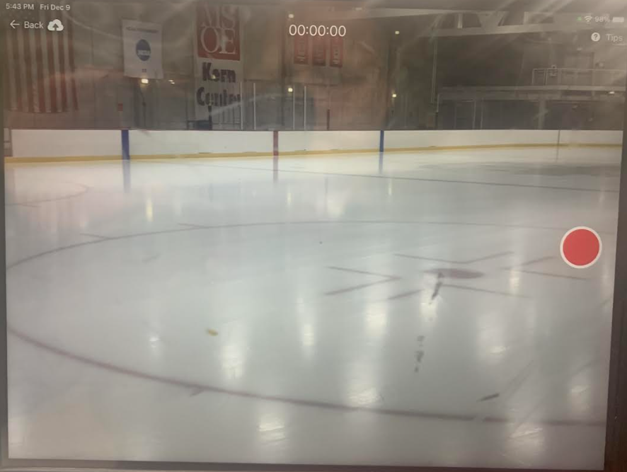

5

6
7. Enter visiting team name and period. Example: “Cedarburg Period 1”
8. Press “Done” after you title the video. NOTE: “Done” is hard to see, but it is located where this box is located. You’ll know you pressed it when the iPad goes back to the Hudl content page
9. Go back to #4 to start recording 2nd and 3rd Periods (or earlier if iPad is off/locked)
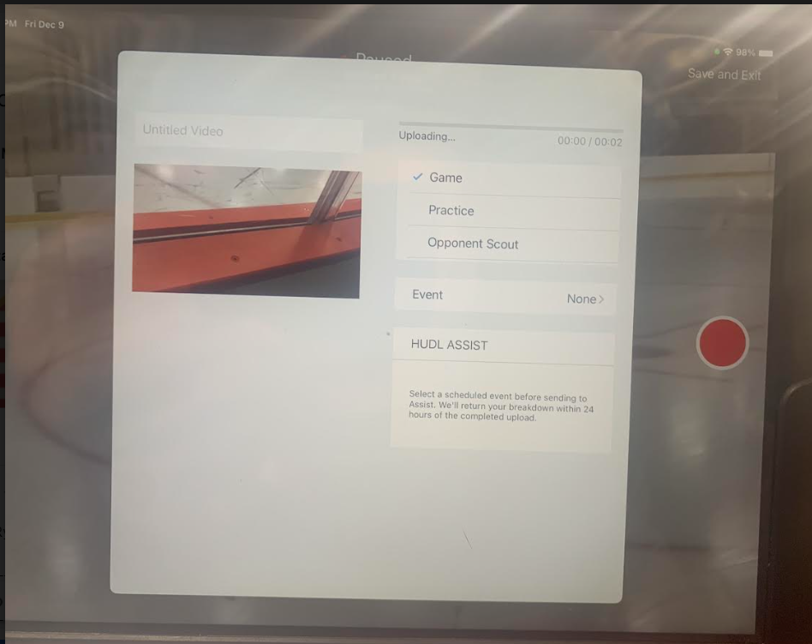

7

8
After Game: Return iPad to a coach. In some cases, the JV volunteer might hand-off the iPad to the Varsity volunteer.

Tips for Recording:
- Players and coaches use the video to review certain plays and the overall game.
- Following the puck is the top priority. Ideally though, try to get multiple players in the frame and anticipate where useful play development might be taking place. Ex: if the puck is in the corner, try to get the area in front of the goal in the frame as well.
- Minimize game commentary. While the volume typically isn’t used in the uploads, it can be.
- You have the option of pausing the recording each time there is a stoppage of play. If you do that, just remember to start the recording again prior to puck drop.
- It is easy to forget you are recording while watching the game. There is no real tip offered here other than to remind yourself that you are recording.

