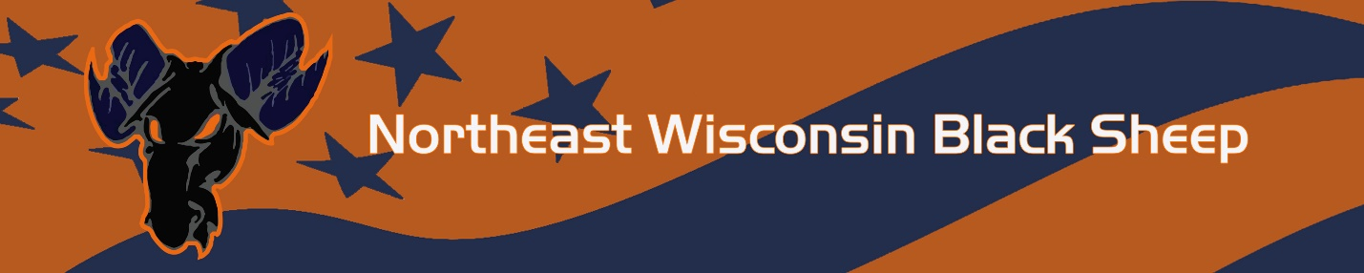

Player Conduct Contract Northeast Wisconsin Black Sheep
It is important that everyone understands the goals, boundaries, and expected conduct for players on our teams. A “contract” helps us communicate this.
Our goal is to help develop young men by providing an environment where they will practice the values of sportsmanship, teamwork, commitment, and hard work. Therefore, the following guidelines are how we will act as players:
- I will listen to and respect all coaches at all times.

- I will have sportsmanship as my #1 priority in all games and practices.

- I will be a good teammate by having a strong commitment to excellence and by putting in hard work both at practice and in games

- I will work hard in school. I will keep my parents and my coaches informed of my progress in school.

- My parent(s)/guardians can limit my participation if I fail to do my best in school.

- I will respect and obey my parent(s)/guardians.

- I will respect referees and opposing players and coaches at all times.

- If I have an unsportsmanlike event, for the first offense the coach will determine disciplinary action. If this continues the player will meet with the disciplinary board which consists of two board members and a parent who is not a relative of the player in offense. The disciplinary board will determine the appropriate disciplinary action for the player.

- If I have an unsportsmanlike event that is a result of a poor interaction with and official, it will result in my removal from a game and possible further disciplinary action.

- I will not use profanity or abusive language will NOT be tolerated.

- I will encourage my teammates in a positive way, regardless of circumstances.

- I will attend all scheduled games and practices.
- If unable to attend a game, I will contact my coach at least 30 minutes prior via text, email or phone call.

- Missing the practice directly before the game can result in loss of playing time if deemed appropriate by my coach.

- I will be in the current year uniform for whichever team I am playing for either tournament or league. If this is not followed I will not play in that game.

- I will respect, protect, and maintain my equipment. I will NEVER throw my helmet or other equipment.

- I will return all equipment, uniforms issued to me at years end or immediately upon dismissal from the program. Failure to do so will result in the fee for the equipment, uniform cost.

- I will not use drugs, alcohol, and tobacco or vaping products.

- I will conduct myself in a way that presents a positive image of myself and Northeast Wisconsin Black Sheep baseball both on and off the field.

- I will maintain a 3.0 GPA for the entire year.

THIS MUST BE SIGNED AS A CONDITION OF YOUR PARTICIPATION IN N.E.W. BLACK SHEEP BASEBALL
I agree to abide by the above player conduct guidelines for N.E.W. Black Sheep games and events
Player Name: ___________________________ Parent Name: ____________________________
Signature: ______________________________ Signature: _______________________________
Date: ___________________

