Game Day Announcing
- 30 Minutes Before Game Time
  - Pick up iPad for Music and Game Sheets iPad from the office.
  - Optional: Turn on the heater.
- Music
  - Start music from a Spotify playlist on the iPad (or use your own device).
- Load Gamesheets Ipad
  - Load game on Gamesheets and verify
- Player Announcements
  - Confirm if coaches would like the players to be announced. If so, do that prior to the national anthem.
  - “Welcome to the Worthington Ice Arena.”
  - “Today’s match-up is between the visiting (opponent name) and your Worthington Trojans ___________ (Squirt, PeeWee, Bantam, etc.).”
  - “Let’s meet our players, starting with the visiting team.”
    - Rosters can be located within Gamesheets Rosters
- National Anthem
  - Only play if it’s the first game of the day.
  - Pick a song from Spotify. This is the first song listed under the Squirt 2025-2026 playlist.
  - Announce, “I ask that you please rise and direct your attention to the flag for the playing of our National Anthem.”
  - Once over, “Good luck to both teams today. LETS PLAY HOCKEY!”
- Playing of Music
  - You can play music during intermission and in between whistles.
Game Sheets Guide

📱 Game Sheets iPad

1. Starting a New Game
- Open the GameSheet app on your iPad by tapping its icon on the home screen.
- Enter the access code (found on the backside of the Ipad case).
- Tap "+ New Game" and then "Load from Schedule" .
- Locate your game and tap the "Load Game" button. This will download the game to the iPad and bring you back to the Games page. If you do not find your game in the schedule, tap "Back to active games" and create a new game from scratch.
- Touch the game to begin.
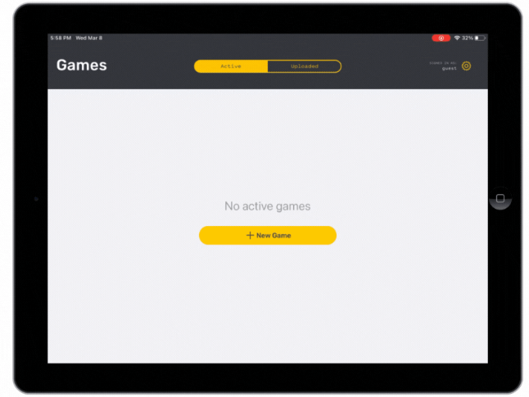
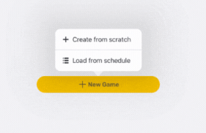

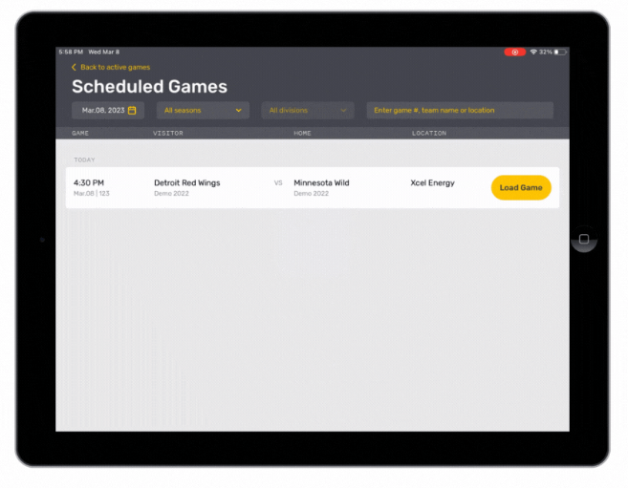

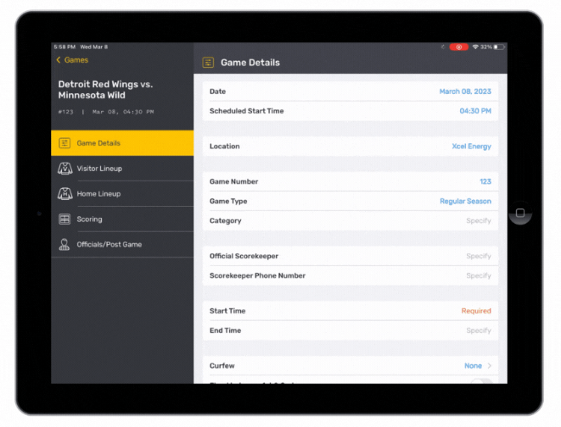

2. Confirm Lineups
Team rosters are downloaded when the game is loaded, so coaches should only need to make updates specific to the game's lineup.
  - Tap either "Visitor Lineup" or "Home Lineup" on the left side to load the team's lineup.
  - Pass the iPad to the coach/manager and instruct them set their lineup.
    - Players can be set to Starting, Playing, Sitting Out, Injured, or Suspended by tapping on their status.
    - Editing of players and coaches can be done by tapping the content you'd like to edit and following the prompts.
    - When the lineup is correct, the coaches must sign before returning the iPad.
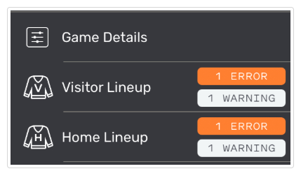
  - Verify that there are no errors displayed beside the Home and Visitor Lineup page titles. If the orange Error button is displayed, tap on it to review the errors

- Repeat these steps for both the Home and the Visitor lineup pages.

3. Score the Game
The pre-game setup is now complete and the iPad should be given to the Scorekeeper.
  - Tap "Game Details" on the left side.
  - Fill in any missing details and confirm the period lengths are correct.
  - Tap "Scoring" on the left side to enter the game scoring page.
  - Enter the "Start Time", e.g. 7:01PM, and tap "Start Game" when the puck is dropped.
  - Record the game's events.

- Scoring out page
  - Adding a Goal
    - + Goal Button
      - Choose time of game
        - Person who scored & assisted
      - Click on microphone icon to have it tell you how to announce the goal.
        - For example, “Goal scored by [player's name], assisted by [assisting player's names], at [time of the goal] in the [period number] period!”
  - Adding a penalty is done in the same manner as a goal.
    - Add penalty in time
    - Add penalty out time (duration is 1 ½ minutes)
    - Add penalty type
    - Click on the microphone icon to have it tell you how to announce the penalty.
      - For example, “Penalty assessed to [player's name] of the [team's name] for [infraction], [duration of penalty] minutes.”
  - Removing an error to either goal or penalty section is deleted by swiping the line left.
    - Changing the goalie
      - Click on Goalie
      - 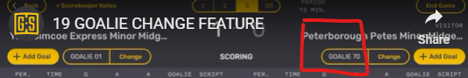
      - Enter time in and new goalie.

- Post Game
  - When the game is over, verify there are no errors on the Scoring page (shown in the top right) and tap " End Game" in the top right corner. This will load the Officials / Post Game page.
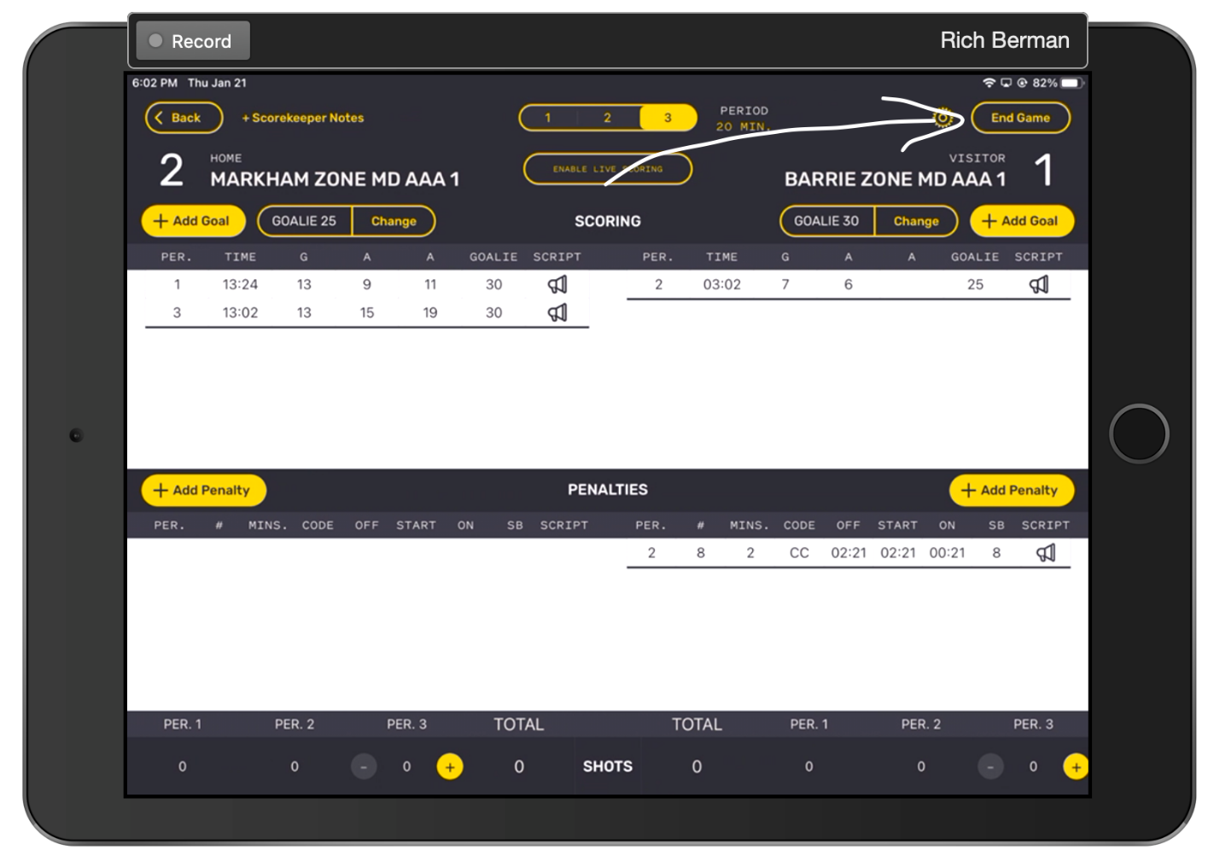
  - Verify that there are no errors displayed in the top right corner of the Post Game / Officials page. If the orange Error icon is displayed, tap the icon and then tap on the error to make the necessary adjustments. Warnings should be reviewed, but do not need to be addressed to upload the game.
  - Give the iPad to the referees to complete the Officials / Post Game page and sign .
  - Referees are expected to:
    - Add themselves to the game by tapping "+ Add Referee".
    - Review the penalties and confirm the codes and lengths have been correctly recorded. If any penalties are incorrectly recorded, the referee may edit them directly by tapping the "Edit" button above the penalties table.
    - Add notes to major and misconduct penalties (if instructed to do so by the league).
    - Sign.
    - Lock the game by tapping "Lock Game" button.
  - After the referee has locked the game the app will return to the Games page and a blue icon will appear to the right of the game. Tap the blue icon to upload the game. Once uploaded the game will disappear from the Active games list, the league will have a copy of the game, the website will be updated and the managers and coaches of both teams will have been sent a copy of the scoresheet via email.
