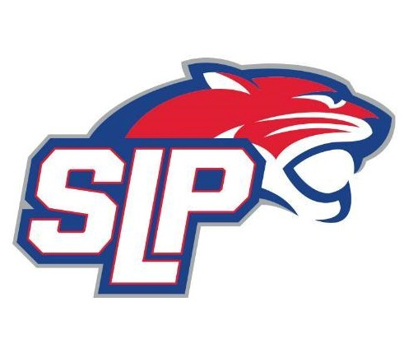

New Skater – Equipment Checklist

Hello SLP Hockey Parents!

First, I would like to thank everyone and congratulate you for choosing the great sport of hockey! Many kids have already been through youth hockey programs. For those who have not, we wanted to provide some additional information regarding the proper equipment needed and how to get players ready to skate.

There are many options for equipment including buying everything new, buying everything used, or a combination of both. Please note, a lot of hockey stores may have a starter kit that gets you most of the equipment. This can be a good deal buy may not include everything, so make sure to get everything listed below. As an experienced hockey player and hockey parent, I am a strong believer in getting good skates and a good helmet and filling in the rest in a manner that best fits your budget. Even if you are not buying new skates, I would strongly recommend going to Pure Hockey, Letterman Sports, or Dave’s Sport Shop to get your child’s feet measured to get an ACCURATE sizing of their skate size.

That being said, here is a check list of everything your child will need:
- Hockey Skates
- Shin Pads
- Jersey – These will be provided upon team assignment, but if you can have or borrow one for your first few practices to come fully dressed that would be greatly appreciated.
- Hockey Socks – These will be provided with Jerseys, but if you can get a pair before your first few practices to come fully dressed that would be greatly appreciated.
- Jock Protective Cup (boys) / Pelvic Protector (girls) – When buying this piece of equipment I recommend getting the kind that is like a pair of shorts with Velcro at the bottom front and back to hold up the hockey socks
- Hockey Pants (aka Breezers)
- Shoulder Pads
- Elbow Pads
- Hockey Gloves
- Youth Hockey Helmet with full cage
- Mouth guard
- Hockey Stick – if your child is a new skater, you may want to consider a straight stick to start because many kids take several practices before they decide what hand is more comfortable.
- Water Bottle – you need one with a long straw that can be used through the helmet cage
- Hockey Bag – there are a lot of options here, but consider one that your skater can handle themselves (if not this year, in coming years)
- Neck Guard – new for 2024, this is a requirement coming down from USA Hockey. No youth skater is allowed on the ice unless they have one. This can be the style that is just a separate guard that velcro’s around the neck, or the style that is integrated into an under shirt.

Here is a great link from Pure Hockey that explains each piece of equipment. https://www.purehockey.com/c/youth-hockey-gear-guide-a-checklist-for-parents

Finally, labeling equipment with your skater’s name is highly recommended. Many skaters have the same things and can easily get mixed up when undressing.

ORDER FOR GETTING YOUR PLAYER DRESSED:

Based on current protocols, below is order for getting your hockey player dressed as follows:

- Put on Jock Protective Cup/Pelvic Protector Shorts
- Put on Shin Pads.
- Pull hockey socks over shin pads and secure to the Velcro at bottom of nut cup/pelvic protector shorts.
- Put on Hockey Pants (Breezers) and pull the tackle belt tight so they do not fall down.
- Put on shoulder pads.
- Put on Elbow pads.
- Put on jersey.
- Put on Skates. Make sure skates are tight around the ankles to give skaters the support needed for a strong stride.
- Put on helmet.
- Put on hockey gloves.
- Grab your stick and go have fun!

Thank you and congratulations again for signing your child up for hockey! If you have any questions, please feel free to reach out to Mike Watts 219-406-1549 (boomersdaddy@gmail.com) or Brandon Halonen 612-384-1425 (bthalonen@gmail.com) with any questions.

