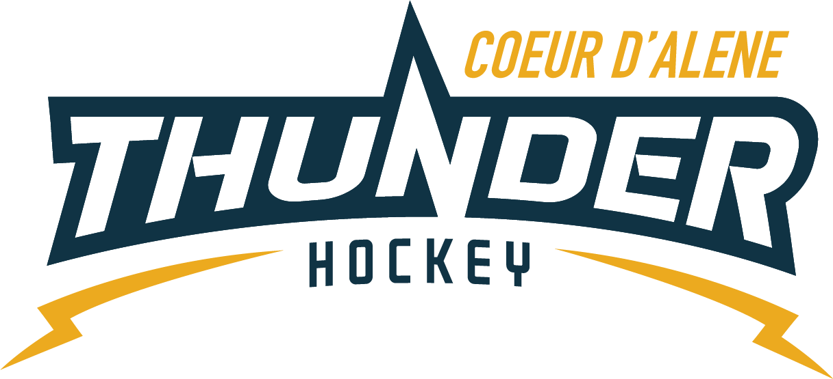

CDAHA

Meeting minutes
Location: Frontier Date: October 13 2021
Attendees: Bob Nelson, Katie Lovitt, Will Higgins, Megan Smith, Elliot Taub, Matt Creighton, Josh Leppert

Absent -, Matt Fisher, Bart Barrett, Jarred Hansen
Guest – Joe White, Kami Winfrey
- Call to order
Matt Creighton , Vice President called meeting to order 10/13/21 6:33PM
- Roll call
As stated above -
- Approval of minutes from last meeting
Minutes approved motioned by Bob Nelson– Second by Megan Smith passes unanimous after two edits
- New Items
- Treasurers Update
  - See attached documents
  - Create invoices and start billing for tournaments – next year start on tournaments earlier – but deposits down even before teams are formed
  - Set up meeting to talk about registration for next year select and commit to tournaments
  - Write a guidelines for scheduling and policy for managers on tournament, when they are what websites and get it done ( include Matt, Kami, Katie, Will) ask Vince what he wants to see in order to work to together for long term planning
  - Motion by Bob to pay yoga instructor 75 dollar for 2.5 hours of work Second by Will passes unanimously
C) Coaching Committee Update
      - Need name and email of all the head coaches – Jennifer needs name and emails s of all team managers
(Specifically PEE WEE House / Bantam House / Midget House)
      - Need team names and who they are assigned too
      - Please forward all parent concerns and coaches concerns to Joe White to assist with resolution and escalation
      - Would like more coaches involved in contributing to camps and clinics come out to a practice work with me and have some fun and learn
      - Will be coming to the practices and be part of what is going on and help out
  - Gear Committee Update
    - Have enough gear
    - Need 9 jerseys AS 30.00 286.20 Elliot motions Bob seconds passes – unanimously
  - Discipline committee update
- No update
  - Safesport update
- Locker room monitors are a must
- Female locker room monitor can stand outside locker room
- Coaches follow instructions - laid out by Torsten – signs will be ordered and part of a kit magnetic kit will be completed by Torsten by Thursday the 21st
- Scheduler Update
  - 155 games scheduled
  - Most teams have 16 plus or minus – Mites have 16 hours plus tourneys etc.
  - Midget rep games are getting ready to go and rep to be scheduled earlier next time
  - Confirmed that we will pay Samantha the youth mite coach 50 per session per the budget and Will will manage it.
Motion to Adjourn Bob Nelson second by Megan Smith
Minutes submitted by: Elliot Taub
Minutes approved by: BOD
- Next Meeting
  - Wed OCT 13 2021 6:30PM
  - Megan motions to adjourn – Bob seconded

