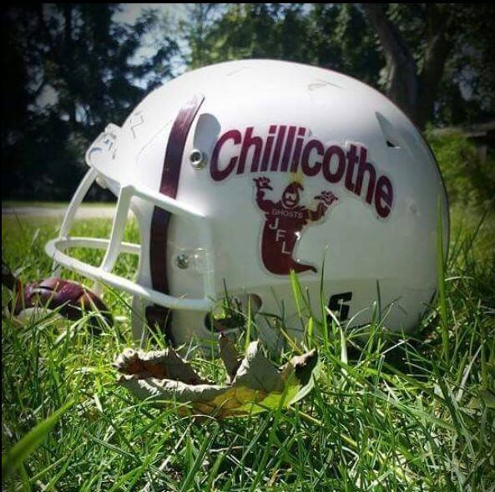
Sponsorship Form
Chillicothe JFL’s mission is to provide an opportunity for kids to learn about their sports in a fun, supportive environment. The goals and intentions across all age groups of our program include building confidence, teamwork, sportsmanship, and to enhance skills. Would you please consider sponsoring a team within our program?
We are looking to gain support of this amazing community, local businesses, and individuals in hopes to offset raising cost of equipment, uniforms, and other items of need.
We will offer 3 different sponsorship tiers. Please consider helping the local youth have another successful year!
Tier 1: Social Media Plug Sponsor Only
The investment in this sponsorship is $50. Sponsors will have their business site posted and thanked on our social media page once a month throughout the season.
Tier 2: Social Media Plug + Main Banner Placement
The investment in this sponsorship is $100. Sponsors will have their business site posted and thanked on our social media page once a month throughout the season. As well as have their business name on our main banner displayed at the field.
Tier 3: Social Media Plug + Display Sign
The investment in this sponsorship is $200 for the 1st year, with a renewal cost of $150. Sponsors will have their business site posted and thanked on our social media page once a month throughout the season. They will also have their own banner displayed at our fields.

Please complete the following information:
Business Name: __________________________________
Contact Name: __________________________________
Contact Phone Number: ____________________________
Enclosed is our remittance for: $____________ (Checks payable to Chillicothe JFL)
Signature of authorized party: _____________________________________
*Shirt Color Preference #1: _________________ *Not Guaranteed*
*Shirt Color Preference #2: __________________ *Not Guaranteed*
You may email this form to ghostjfl@gmail.com or mail it to the Treasure below. Payments can be mailed to the Treasure or use our email to contact a board member to make other arrangements.
Storm Bundren
1142 W Chestnut Ct
Chillicothe, IL 61523
Select which sponsor program you would like to choose:
Tier 1 (Social Media Plug Only): Tier 2 (Media+ Group Banner): Tier 3 (Media + Own Banner):
For Tier 2 & 3 ONLY:
Please email a digital image of your logo to chillicothejfl@gmail.com
For all tiers:
Please email your website or Facebook link that you would like shared on our social media to ghostjfl@gmail.com.

