The City of Rock Hill has a new parking procedure for the year 2023 please pay attention to the following instruction and map for parking at your tournament.
DO….
- Park at Deck A and Deck B. Both facilities are now gateless. $5 per day
- Pay Virtual payments, upon arrival only – Download App, Scan QR Code, Text to Pay (P3406), or Call To Pay (844-236-2011) upon arrival.
- Pay by vehicle plate information, before you leave your vehicle. 24/7 License Plate Enforcement, routine patrols.
  - Payment links:
www.premiumparking.com/P3406 (Deck A)
www.premiumparking.com/P3407 (Deck B)

- The plate of your vehicle is scanned upon entry and exit to ensure payment compliance. Nonpayment will result in enforcement, including additional fees for noncompliance.
DO NOT….
- DO NOT Drop off … drop off will not be allowed at the front door.
- DO NOT Park in the 1939 deck this is a private deck and will only open if needed
- DO NOT Park in the “Springs lot” gates will be locked
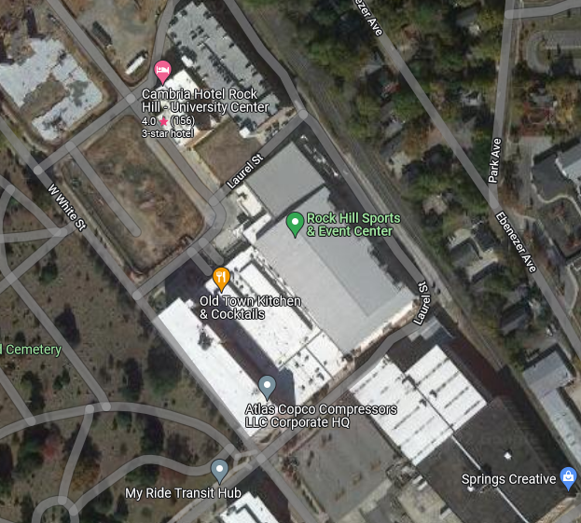
No Parking
No Parking
Deck B
Deck A

