Hussey Seat Quote
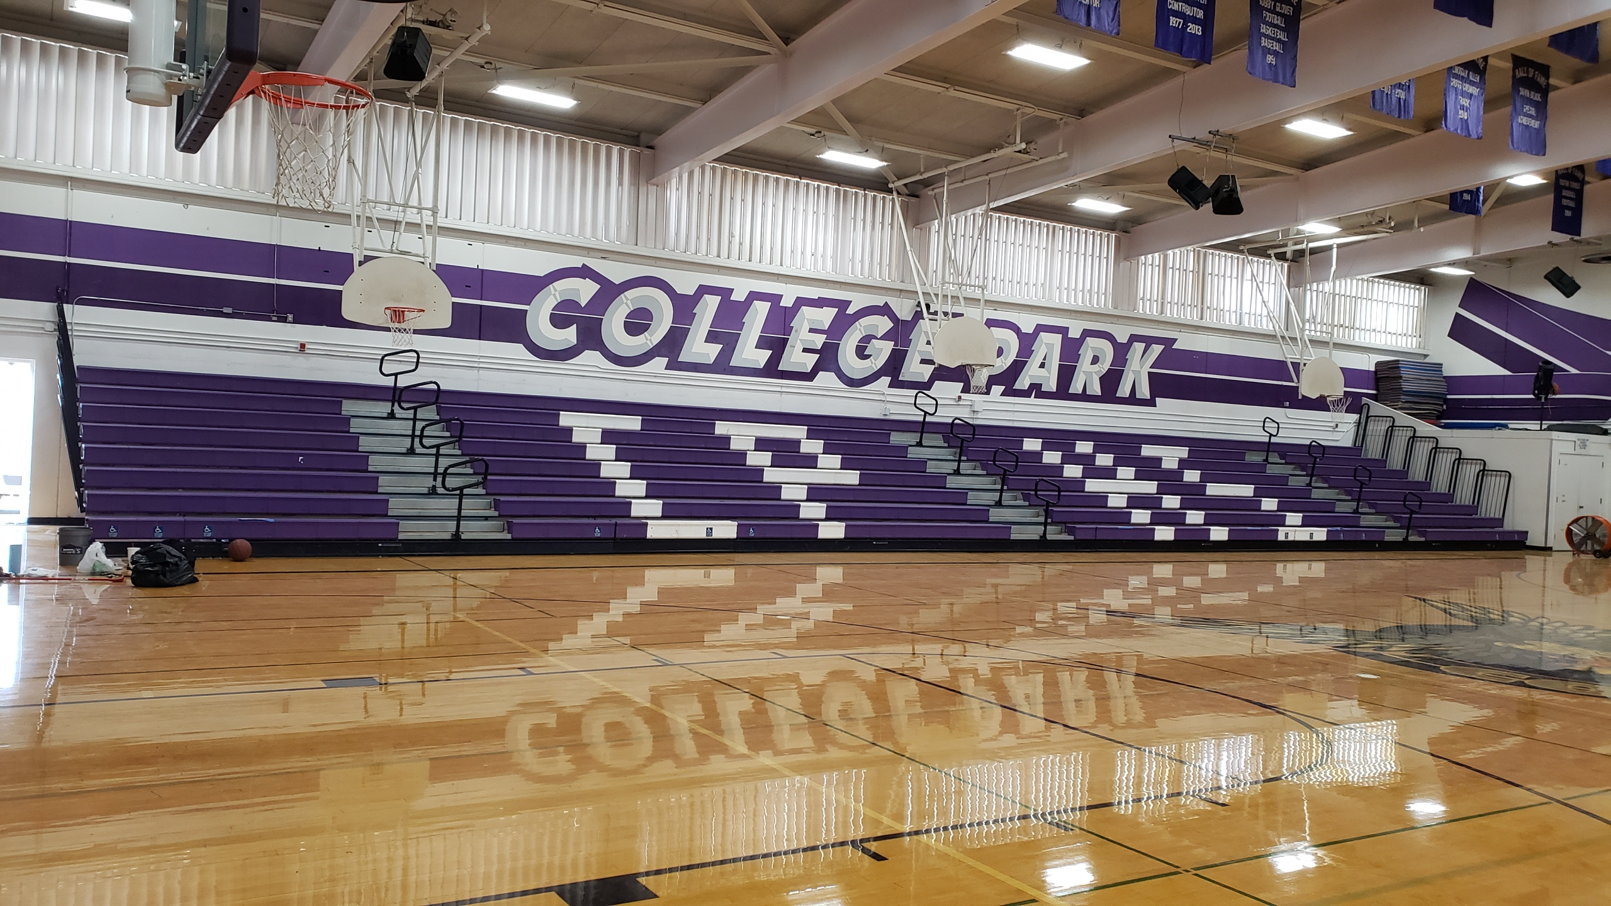 | No. California Hussey Seating Rep. | Date 1/19/21  Quote # 21020  Quote expires in 60 days

  1225 Cayetano Dr.  Napa Ca 94559  Phone 916-434-6561  Fax 916-434-6562  Jerrykincanon@gmail.com | TO | College Park High  Total seat conversion  Replace Bank A, Bank C and finish Bank B  Hussey seat replace

Qty | Description | Unit Price | Line Total
827 | New Hussey Courtside seats | 26.00 | 21,502.00
 | Sales Tax 8.75% |  | 1,881.43
 | Freight |  | 4,700.00
 | Labor to replace old MVP seats with new Courtside seats |  | 8,270.00
 | Disposal |  | 1,500.00
 | Convert from MVP to Courtside Seating
Seat price |  |  | $37,853.43

:

