PRESS RELEASE

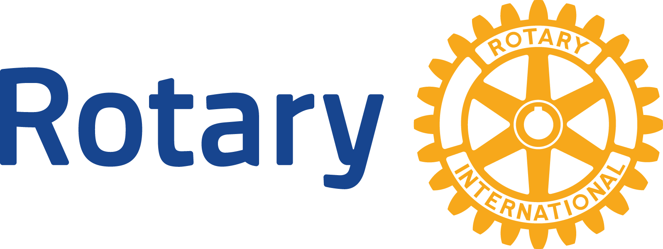
Tamra Hartman-Johnson, Lake Elmo Rotary Club President
Hartman.tamra@Gmail.com
LakeElmoRotary.org

June 29, 2020

The Rotary Club of Lake Elmo Recognized at District Event

On Tuesday, June 23, 2020, Rotarians from District 5960, which covers south east and east metro Minnesota and western Wisconsin, met virtually for the 2019-20 District Awards Happy Hour. Clubs were recognized for their efforts in various categories and based on the size of the club – Large, Medium Plus, Medium, or Small – as part of the District’s Awards Program.

The Club was responsible for submitting examples of their efforts against a checklist for up to six categories – Club Service, Community Service, International Service, Public Image, Vocational Service, and Youth Service. The submissions were then judged by Rotarians from Clubs in a different size category to keep the voting objective. The Rotary Club of Lake Elmo was in the small size club category.

After the tabulating, the club received the Small “Club of the Year” award, including five other first place awards for Lake Elmo, said Club Past-President Rita Shepard.

“Here is a recap of some of our Club's accomplishments over the past 12 months to receive such an honor.
We provide a meal from the Lake Elmo Inn and serve it six times a year at the Ronald McDonald House.
We provided Lake Elmo Inn ice cream sundae buffets, with all the trimmings, to individuals who attended the Fourth of July parade in downtown Lake Elmo.
We provided shuttle service at the Washington County Fair.
We volunteered at Santa's workshop at Cimarron.
We provided a Kindness Retreat delivered by Youth Frontiers, Inc. for all of the Lake Elmo Elementary 5th graders.
We had members volunteer in the STRIVE program at SAHS and also provided $3,000 in scholarships.
We paid for two students to attend Camp Enterprise.
We provided a new dictionary to every 3rd grader at Lake Elmo Elementary.
We hosted two successful Red Cross Blood Drives.
We rang the Salvation Army Bell to raise funds for their organization.
We purchased and installed benches at the Sally Manzara Nature Center.
We partnered with the St. Paul Saints to hold a fundraiser for Rotary International (Cancelled due to Covid19)
We participated in the District COVID 19 grant to purchase gift certificates from local restaurants to give them to first responders in our Community.
We donated $1,000 to the India World Class International School and other international projects.
We served a meal at the Union Gospel Mission.
We held a successful Gold Plate Dinner Fundraiser.
We were awarded a grant from Rotary International to match our club’s funds to give $2,500 to Acres for Life for individuals who cannot afford to attend.”

About Rotary and District 5960

Rotary’s vision is “Together we see a world where people unite and take action to create lasting change, in our community, across the globe, and in ourselves.” We do this through a global network of volunteer leaders dedicated to tackling the world’s most pressing humanitarian challenges. Our mission is to advance world peace and understanding, good will and peace through improved health, the support of education and alleviation of poverty. Rotary connects 1.2 million members of more than 35,000 Rotary clubs in over 200 countries and geographical areas. Within District 5960, which includes much of south east and east metro Minnesota in addition to 6 counties in western Wisconsin, there are 63 clubs focused on humanitarian service. Locally, the Rotary Club of Lake Elmo members provides both hands on skills and financial support for sustainable projects to improve our community. Our work improves lives at both the local and international levels including our continuing work toward a polio-free world. For more information, visit LakeElmoRotary.org or Rotary5960.org.

###

