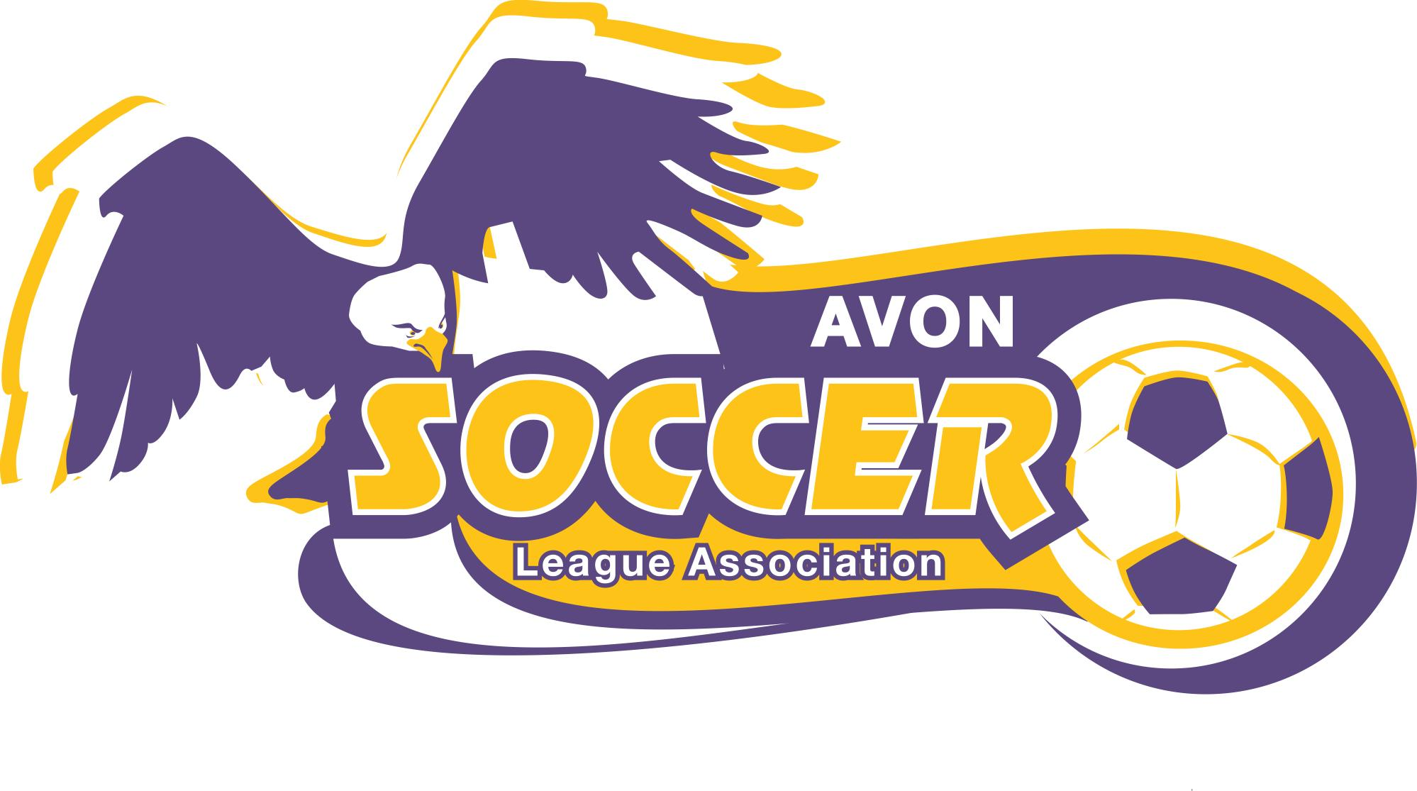

AVON SOCCER LEAGUE ASSOCIATION
RECREATIONAL LEAGUE
RULES OF THE GAME

2024

The laws used by the Avon Soccer League Association (recreational league(s)) are based on current FIFA laws. The laws have been written using the following sources with suitable changes and/or exceptions to fit the needs are requirements of our recreational league(s). The Avon Soccer League Association reserves the right to make any necessary league rule changes to insure safety and/or fair play at any time.

Sources:

FIFA Laws of the game

United States Youth Soccer Association, Inc.

Original Avon Soccer League Rules compiled 4/88 with changes and modifications dated 4/19

General Note:
Referees are provided for U6 and above age groups. The coaches referee the U4 and U5 leagues. A single coach from each team is permitted on the field for each team in the U4 and U5 league to instruct their team, but to also referee the game. U6-U12 Coaches should be limited to two, a head coach and an assistant coach, both keeping on the same side of the field.

Pre Game Procedure:

A: Referee and players should arrive 15 minutes prior to game time.
- Referee should check all players for proper shoes and shin guards.
    - No player is permitted to play without shin guards. Sock or material covering should be worn over the shin guard.
    - No shoes with metal cleats or baseball shoes with toe cleat in place may be worn.
    - Players with improper equipment may not play until corrected and checked in by the referee.

Referee should instruct the Linesmen of their responsibilities and issue flags. (The use of Linesman may or may not be followed in any rec games)

Start of Game:

- Starting kick off by the home team (2nd quarter away, 3rd home, 4th away.)
- All Defending players outside the center circle in their defending half of the field.
- Play and the clock begin with the referee whistle. No stoppage time.

During Play:

- Player’s safety and well being is the referee’s primary concern.
- Keep a reasonably accurate account of time
  - 20-minute practice is followed by a 20-minute game for U4.
  - 10-minute quarters for U5, U6, and U7
  - 12-minute quarters U8
  - 25-minute halves for U12
- You (referee) are in control of the game. Take charge and be confident but do not become the game.
- You (referee) can only call what you see, do not be intimidated or upset by what others see or say. If you are involved in any situation with parents or coaches remain calm and polite; remind them it’s just for fun. Unreasonable coach, player or parent behavior is not to be tolerated. If any participants or spectators cannot bring themselves under control, they should be asked to leave the field, play stops until the offender(s) vacate the field. Report all problems to the League Manager and Referee Director.
- Briefly explain fouls to offenders.

End of Game:
A. Be sure players line up and shake hands.
Law 1 – the Field:

- Dimensions:
  - 4v4: approximately 20 yds x 30 yds
  - 5v5: approximately 30 yds x 45 yds
  - 7v7: approximately 40 yds x 60 yds
  - 9v9: approximately 45 yds x 70 yds

The field of play varies by age.

- Markings:

  - Distinctive lines not more than 5 inches wide.
  - A halfway line shall be marked out across the field
  - A center circle with a 6yd (rec) 4yd (U7) radius.
  - Goal area (rec 6yds) U7 4yds from each goal post and (rec. 6yds) (U7 4yds) into the field of play joined by a parallel line with the goal.

- Goals:

  - 4v4: 4’ high X 6’ wide
  - 5v5: 6.5’ high X 12 wide
  - 7v7: 7’ high X 21’ wide
  - 9v9: 7’ high X 21’ wide

- Corner flags:

For safety of our young players, corner flags will not be used.

Law II – the Ball:

Size 3 balls – U4, U5, U6 & U7

Size 4 balls – U8 & U12

Law III – The Number of Players

- Maximum number of players on the field at any one time:

U4 – 4v4 (no goalie, coaches on the field)
U5 – 4v4 (no goalie, coaches on the field)
U6 – 4v4 (no goalie)
U7 – 5v5 (4 players & a goalie)
U8 – 5v5 (4 players & a goalie)
U12 – 9v9 (8 players & a goalie)

*The goalkeeper positions are not to be the responsibility of one player; all members of the team must take turns playing this position. A change in goalkeeper must take place at the end of each quarter. Please note that only the goalie can touch the ball with his hands during a field of play.

- Roster:

  - A maximum of eight (4v4), ten (5v5), eighteen (9v9) players may not be exceeded.
  - A roster may be changed at any time during the season
  - Teams will be comprised of an equal distribution of registered players
  - A parent coach and his/her player children will be placed on the same team.

- Substitution:

  - End of Quarters or Halftime (both teams)
  - During injury timeout (both teams)
  - After a goal has been scored (both teams)
  - Prior to a goal kick being taken (both teams)
  - Prior to a throw-in being taken (both teams)
  - No substitutions on the fly or while the ball is in play
  - Players should sub in at the halfway line

- Playing Time:

  - Each player shall play a minimum of 50% of the total playing time, regardless of missing practice etc. (do not bench players, except in extreme cases of poor on the field player behavior)
  - Since the safety of our players is foremost, no coach shall be deemed in violation of rule (iii D.1) when a player is clearly in no condition to play or whose physical condition is uncertain.

Law IV – Players Equipment:

- Uniforms & Equipment:

  - Home team (listed first on schedule) is always dressed in purple jersey.
  - Visting team (listed second on schedule) is always dressed in gold jersey.
  - Players must wear league-approved uniform only including jersey, shorts and socks.
  - Soccer cleats (no metallic cleats) or tennis shoes should be worn. No BASEBALL shoes may be worn due to the presence of a front middle cleat.
  - Shin-guards are mandatory and MUST be worn by all players at all times.

- The referee MUST enforce the above rules and allow no player on the field with equipment that is unsafe. They may not enter (or re-enter if discovered during play) the field until the infraction(s) are corrected and rechecked by the referee.

Law V – Referee:

- Referee decisions shall be final. Coaches should not argue with a referee’s call. If there is an issue with a referee, coaches should follow up with the referee director.
- All rule infractions shall be briefly explained to the offending player.
- The league obtains referees.
- Referee support:

  - Before, during and after a league game all coaches shall support and assist the referee in maintaining decorum on the field.
  - The Referee Director should be notified of any and all disrespect directed at the referee or any players.

Law VII – Duration of the Game:

- The game shall be divided into (4) equal ten (10) minute quarters for U5, U6, U7 and (4) equal (12) minute quarters for U8. The U12 league will utilize two 25-minute halves. As mentioned earlier, the U4 league will have a 20-minute practice followed by a 20-minute game.
- There shall be a two (2) minute break after the first and third quarters
- A five-minute break should take place after the second quarter
- Referees and teams must be present at the field of play 15 minutes before the scheduled game time.
- Switch fields (direction of attack) at halftime only.
- Should a referee fail to show by game time, the coaches should appoint a mutually agreeable replacement and notify the Referee Director. There are typically “off duty” officials at the park. An effort should be made to locate an “off duty” official before looking into the crowd for parent volunteers.

Law VIII – Start of Play:

- Opponents must remain outside of the center circle in their defending half of the field until the kicking team touches the ball.

Law IX: Ball In and Out of Play:

- The ball is out play when:

  - It has wholly crossed the goal line or touchline, whether on the ground or in the air.

- The ball in play at all other times, including:

  - It rebounds from a goalpost or crossbar and remains in the field of play.

Law X – Method of Scoring:

- A goal is scored when the whole of the ball has passes over the goal line, under the crossbar, and between the goal posts, provided that the team scoring the goal has committed no infringement of the Laws of the Game previously.

- No official scores will be recorded

- Team standings are not recorded or maintained in the ASLA recreation league

Law XI – Offside:

- There shall be no off-sides

Law XII – Fouls and Misconduct:

- All fouls will result in an INDIRECT FREE KICK with the opponents six (6) yds away.
- The referee should breifly explain all infractions to offending players.
- No slide tackling

Law XIII – Free Kicks:

- INDIRECT:

  - A goal may not be scored until the ball has been played or touched by a second player of either team, other than the defending goalie.
  - No kicks shall be taken by the attacking team within the defending team’s goal area. The ball shall be placed on the goal area line closet to the point of the foul.

- DIRECT:

  - To be used only in extreme situations with use of excessive force or a disregard for player safety.
  - A goal may be scored without the ball being touched by another player.
  - Defending players must be 6yds away from the ball.
  - No kicks shall be taken by the attacking team within the defending team’s goal area. The ball is to be placed on the goal area line closest to the point of the foul.

LAW XIV – Penalty Kicks:

- No penalty kicks shall be taken.
- All fouls occurring inside the goal area will result in an indirect kick. The ball is to be placed on the goal area line closest to the point of the foul.

LAW XV – Throw-in:

- A second throw in must be allowed of the player commits a foul on the initial attempt.
- A legal throw in consists of the following.
  - Player must be on or behind the touchline
  - The ball must be thrown from behind the touchline.
  - Both hands must be on the ball until released.
  - Both feet must remain on the ground
  - The throwing player may not touch the ball again until it has been touched by another player.

LAW XVI – Goal Kick:

- A goal kick is required to restart play when the ball passes completely over the end line and was last touch by the attacking team.
- Goal kick may be taken from any point inside the goal area.
- Opponents must be 6yds away from the ball or outside the goal area for 5v5 and 9v9.
- May be taken by anyone on the defending team.
- May not be touched the kicking player until another player has touched the ball.

LAW XVII – Corner Kick:

- A corner kick is required to restart play when the ball passes completely over the end line and is last touched by the defending team.
- Is taken within 2 feet of the field corner closest to where the ball went out of play.
- Opponents must be 6yds away from the ball.
- May be taken by any player on the attacking team.
- May not be touched by the kicking player until another player has touched the ball.

LAW XVIII – Heading:

- There is no heading in Avon Rec Soccer

LAW XVIV – Crossbars and Goal Netting:

- There shall be absolutely no hanging on crossbars or goal netting at anytime

LAW XVV – Rule: NO PUNTING OF THE BALL IS ALLOWED BY GOALKEEPERS at U7 and U8 Division

- Avon Soccer Rec Rule for All Goalkeepers at U7 and U8
- Game Play: 5v5 (four field players and one goalkeeper)
- Goalkeepers should play the ball out of the back by rolling out the ball or by passing the ball on the ground
- Punting the ball is not allowed, as this style of play is contradictory to proper player development
Purpose: Players are encouraged to develop soccer skills by dribbling the ball and by making passes to teammates feet
Remedy: If a goalkeeper punts the ball - play should stop and the goalkeeper should be allowed a "redo" to properly distribute the ball

