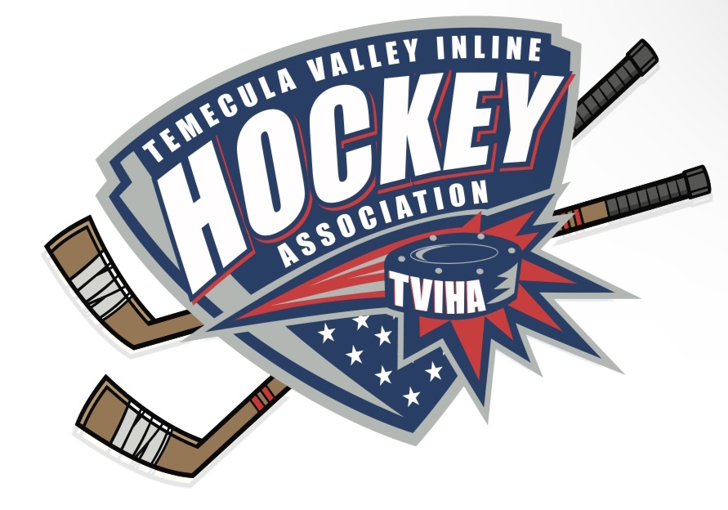
Meeting Minutes of the Temecula Valley Inline Hockey
Association Board Meeting August 28, 2022

- President Matt McCaffrey called the meeting to order at 1:09pm.
- The following people were present: Jeff Martin, Geoff Bricker, Ryann McCaffrey, Justin Kalnas, Alma Bricker, and Matt McCaffrey.
- Matt McCaffrey made a motion to approve the June 2022 minutes. Jeff Martin seconded the motion. Minutes for the June 2022 meeting were approved by the board members.

Treasurer Report - Geoff Bricker
- As of June 30, 2022
Checking Balance $47,399.17
Savings Balance $20,176.01
TOTAL $67,575.18

Credit Card Balance $3,822.62
Credit Card Points Balance 223,057

- Income – June 2022
  - Bank Account Interest $0.16
  - Fall Registration $4,220.00
  - Warriors Tourney Fees $2,385.00
  - Total Income $6,605.16

- Expenses – June 2022
  - Fee for Direct Pay $18.00
  - Payroll
    - Officials $3,490.00
    - Scorekeepers $2,453.75
  - Rink Lights $402.75
  - Rink Supplies / Maintenance $1,220.48
  - Skills Day $392.52
  - Taxes $75.00
  - Trophies, Medals & Wristbands $43.59
  - Warrior Jerseys $750.26
  - Warriors Tourney Cost $10,750.00
  - Total Expenses $19,596.35

- Total Net Income for June $-12,991.19

Treasurer Report - Geoff Bricker
- As of July 31, 2022
Checking Balance $73,721.69
Savings Balance $20,176.19
TOTAL $93,897.88

Credit Card Balance $3,822.62
Credit Card Points Balance 223,057

- Income – July 2022
  - Bank Account Interest $0.18
  - Fall Registration $31,140.00
  - Summer Clinic $1,400.00
  - Warriors Tourney Fees $2,790.00
  - Total Income $35,330.18

- Expenses – July 2022
  - Fee for Direct Pay $18.00
  - Jerseys Fall Rec $8,750.00
  - Rink Lights $21.00
  - Rink Supplies / Maintenance $218.48
  - Total Expenses $9,007.48

- Total Net Income for July $26,322.70

Treasurer Report - Geoff Bricker
- As of August 31, 2022
Checking Balance $78,240.12
Savings Balance $20,176.36
TOTAL $98,416.48

Credit Card Balance $3,822.62
Credit Card Points Balance 223,057

- Income – August 2022
  - Donation $2,000.00
  - Bank Account Interest $0.17
  - Fall Registration $2,430.00
  - Warriors Tourney Fees $5,580.00
  - Total Income $10,010.17

- Expenses – August 2022
  - Fee for Direct Pay $10.00
  - Quickbooks $590.00
  - Refund for Fall $200.00
  - Registration Refund $590.00
  - Rink Lights $935.09
  - Rink Supplies/ Maintenance $181.48
  - Warrior Tourney Cost $2,985.00
  - Total Expenses $5,491.57

- Total Net Income for August $4,518.60

League Update

- Matt McCaffrey made a motion to approve the treasurer report for June 2022. Justin Kalnas seconded the motion. Treasurer report approved.
- Matt McCaffrey made a motion to approve the treasurer report for July 2022. Justin Kalnas seconded the motion. Treasurer report approved.
- Matt McCaffrey made a motion to approve the treasurer report August 2022. Justin Kalnas seconded the motion. Treasurer report approved.
- The board agreed the school league registration needs to be opened asap to give Jim Day, school league director, plenty of time to organize teams, coaches, and practice/ game schedule.
- There may not be enough rink time and interest for a 6u/8u division in the winter. The league will revisit this after the school league survey results come in.
- Matt McCaffrey suggested possible candidates for the new 2022/2023 Disciplinary Committee. Possible Candidates were Jim Day, Jim McCann, Chris Barsamian, Sheldon Ivester, Martin LaRouche, Matt Olsen, and Scott Husband. Committee will be chosen before the next board meeting.
- Jeff Martin will draft a coaches agreement that will need to be signed by all the coaches before the start of games for the 2022 Fall Season.
- The league received a generous donation in honor of Cole Chamberlin. The board voted to use the donation for some type of iron man competition in honor of Cole and to upgrade the Cole Chamberlin Cup. Ryann McCaffrey will contact Temecula Trophy.
- The league discussed how we can support junior refs for their volunteer time on the rink.
- Justin Kalnas proposed a Ronald Reagan Rink Committee to help stay up to date with construction and upgrades on the rink.
- Jeff Martin suggested we contact Pure Hockey to help offer some type of Learn 2 Play gear purchase for new families.
- In regards to special events the league would like to have a Reign Night in the future.
- Ryann McCaffrey suggested purchasing personalized trophies for the 6u division since they will not be involved in playoffs or championship games.
- The board approved this purchase and Ryann McCaffrey will get them ordered.
- Jeff Martin discussed a possible 8u Warriors team and a meeting with the Warriors director Tom Bilek to talk about the Warriors future.

Meeting Adjournment: 2:23 pm

