WELCOME: Patrick Flaherty 804.381.9926 / 603.580.1750 ExeterBaseballPres@gmail.com
Thank you! Our kids are the most important part of this organization but they don’t play without each of you. For most of our players and parents, you are the face of our league. Your actions and communications largely determine whether our players have a positive, fun experience or not. No pressure!
- Cal Ripken League promotes such things as effective communication, being a role model, create a safe & enjoyable environment, and being organized
- EJBSL promotes fun, good sportsmanship, staying positive, teamwork, and treating each other with respect
- We are a competitive league, BUT the number of wins and losses does not make your season a success!
- These ideals are also specifically stated in our Code of Conduct
- All Coaches (both Head and Assistant) are subject to a Background Checks & Abuse training every 2 years.

We will have a form on our website to collect coach, parent, etc code of conduct issues and to start the review process with our league coordinators as well as to inform the Incident and Response Committee in case an escalation has to occur. If there is insufficient response, my number is above.
ANY REPORT SHOULD BE MADE WTHN 48 HOURS OF THE EVENT IF AT ALL POSSIBLE.

Code of Conduct, your role as a coach…
- Get familiar with our Code of Conduct!
- Work TOGETHER with your opposing coaches, not against each others. League coordinators are there to help. Make their job easy. They don’t have a kid in your league yet they are volunteering in the league.
- If there is a conflict, try to work it out between one another. Then, fill out the form (to be built) and go to your League Coordinator (listed below) as an escalation point. League coordinators will take further steps if necessary.
- Each coach should READ THROUGH with the players and families and have players, families & coaches sign the Code of Conduct at INITIAL MEETING. Collect signed copies and keep these on file for use in the event you or the league encounters a conduct issue. This can be found at www.ExeterBaseball.com/resources

Game Management & Player Utilization
- COMMUNICATE - if you are not good at email, then assign an Asst. Coach or team parent to do your email communications. Let parents & players know your expectations as a coach and your goals as a team with a team meeting. Our website platform and APP (SportEngine) can simplify team/league communications.
- Be fair with playing time – it will not always be equal, but make it FAIR
  - Pay attention not only to time but also infield and outfield time
- Move players around – especially lefties. Bring back the lefties at 3rd, SS and 2nd.
- If a player asks to play a position, then give them a chance. If a player wants to pitch and you feel they are not ready, then invest some time before games and during practices to get them to a point to pitch. Then make it happen. We’re using pitch count rules, so we’ll probably need them ALL. No player should be denied the opportunity to play a position they wish to unless you feel it is a risk to the player’s safety. If you preplan your position rotation for each game, just let the kid know that and try to work them in on the next game at a requested spot.
- Many players also play travel ball and/or for their school team. This is a HUGE benefit to the player and league. Be mindful of their usage while with their other club or school team. The kid playing on varsity in 4-10 years from now is far more important than a rec league win this season.
- Pitch count and days rest rules are in place for a reason. This goes hand in hand with the prior paragraph. We have not had a reason to question this in a very long time; please don’t make us start.

Treatment of Umpires
- DO NOT argue balls and strikes!! Encourage a generous strike zone, and jointly request this of the umpire at the start of the games (or between innings). Kids should learn to swing, not walk. I appreciated Mike Farrand’s zone when we would ask him to step in and umpire from time to time.
- Umpires will make bad calls. Some will help your team; others will hurt your team… It evens out. Move on.
- We used junior umpires as well as adult umpires. Keep this in mind!
- Your role is as a coach and a role model and how you deal with those bad calls goes a very long way.
- Remember, you have 20+ kids watching how YOU – as a coach – handle adversity. They will follow your example.
- Work with the coaches. A blatant misinterpretation of the local rules should be self-corrected by the coaches.
- If you have a question about a call, respectfully and quietly address the umpire. This should not be a drawn out conversation. IDEALLY, don’t question it at all or do so in between innings.
- The EJBSL Standard is that only Head Coaches can approach and speak to umpires. Assistant Coaches should always defer to the Head Coach. You – as the Head Coach – are in charge of your team, coaches and parents!
- EJBSL has a great reputation amongst umpires for being fair and respectful – please, let’s keep it that way.
- If any coach is ejected from a game, they serve an automatic 1-game suspension. Personally, this is too lenient.
- If any coach is ejected a 2nd time in the same season, additional suspensions will be handed out, up to an including the remainder of the season. Personally, this is too lenient.

Practices – Set clear expectations and build a schedule
- Have a plan for what drills you’ll perform. Teach the kids!! Show the kids how to throw, hit and field.
- Coach to ALL LEVELS of players on your team
- Be Organized!
- Keep practices to the time scheduled. End of time.
- SHARE SPACE WITH OTHER TEAMS! There will be limited space – especially early in the pre-season. Work together not against each other! Share space - don’t monopolize it.
- Be mindful of how many. The season goes quick. Trying to do anything (games and practices combined) more than 3 times a week will start to fray parents. SUNDAY AMs ARE OFF LIMITS TO ALL LEAGUE ACTIVITIES.

Safety
- 2024 COVID-19 Guidance – what our SAU rule is becomes our guidance.
- First Aid – Ice Packs, Ice Packs, Ice Packs – in each storage shed. If something is used up, let Andrew Patton (or another board member) know and we will coordinate restock.
- Defibrillators Update - Jim
- Connor’s Climb
- League Safety Officer – Andrew Patton – 781.334.0000 – avpatton@gmail.com
SCHEDULING: Scott Battey 603.969.3320 sbattey@gmail.com
- Report Game scores to Scott after each game (sbattey@gmail.com) so they can be entered into system.
- In general, it’s very difficult to make-up games. Therefore, we try to play through some adverse conditions.
- Thunder and Lightning policy - Make sure it’s safe to play (wait 30 minutes after last sound of thunder, or site of lightning no matter how far away it is)
- On occasion there are schedule conflicts with Town Rec departments or SAU. In the event of a schedule conflict, do not assume that EJBL has priority to that field. Call Scott or Patrick Flaherty for guidance. Town Rec departments (Brentwood, Newfields, Kensington, East Kingston) have priority over EJBL (we don’t own the fields)
- ALL game reschedules MUST be coordinated through Scott Battey. Do not reschedule games on your own as there are steps to be taken with field availability and umpire re-scheduling.
- PRACTICE FIELD SIGN UP SHEET – this will be made available. Use this sheet rather than any website/SE functions to schedule a practice.
- Practice spaces – we coordinate use of fields with other programs like lacrosse. Give them space when at Walsh. Use the Baseball field, batting cages, space around these area but leave the large rectangle field as theirs. If it’s within 60 feet or so of the baseball fence you’ll be fine.
- Scheduling is Hard. If you have 8 get the game in and give the other team a kid when they are in the field.

UMPIRES: Scott Battey 603.969.3320 sbattey@gmail.com
- The names & phone numbers of the assigned umpires can be found? (In past, in google sheets or via email)
- In the event of a significant weather or other community impacting event, a subset of the EJBSL board will make a determination and may cancel games. This would include notifying coaches and umpires. Follow up with your team and make sure they are aware.
- IF A GAME NEEDS TO BE CANCELLED FOR OTHER REASONS than a league determined reason, the HOME TEAM coach must contact Scott Battey AT LEAST 90 minutes before the scheduled game time. SCOTT IS ALSO A COACH IN OUR LEAGUE.
- Umpires usually have back-to-back games in other towns. Sometimes they are late. Please ask a parent to umpire from *behind the pitcher* until the scheduled umpire arrives. Also, coaches can call balls & strikes for their own team. BE FAIR & MAKE IT WORK!!
- If an umpire does *not* show for the entire game, please let Scott Battey know
- If you have a complaint about an umpire, please let Scott Battey know
- We often use Junior Umpires. These are umpires that fairly recently probably played in the league. We already said this but be over the top nice.

LOCAL RULES These are highlights. They can be found at www.exeterbaseball.com > RESOURCES > DOCUMENT ARCHIVE.
- Make sure you are familiar with the local rules regarding pitching, innings pitched, mandatory rest, steals, mercy rules, game durations, balk (majors), batting, etc.
- For the safety of our players, there is a NO CONTACT rule at home plate! Catchers cannot block the plate
- If there’s a play at home plate, runners MUST SLIDE or will be called out automatically. This is for safety - be forewarned.
- All Leagues:
  - Print/Download a copy of the local playing rules and have it with you during games
  - Umpires do NOT enforce our local playing rules – this is up to the coaches in EJBL. Inform them at game start of any unique rule that applies. They usually ask.
  - We use a continuous batting order. Therefore, all players hit, regardless if they are playing in the field or on the bench.
  - We use free substitution; therefore, players can be moved to different positions or on the bench
  - Six inning games (A league is 5 innings)
  - Prior to May 15th new inning shall start after 7:45p. After May 15th, no new inning after 8:00p. If it’s too dark to play ball, stop regardless of the time or score.
  - Night Lights at Kensington Sawyer Park – no new inning after 9:30p as lights turn OFF at 10p.
  - 4 innings constitute a full game or 3 ½ if the home team is in the lead (A league rules may differ)
  - Majors League may enforce balks penalty. This is a warning only for the first half of the season. After the mid-point, the balks can be enforced. This is a decision that must be made by both teams prior to the game, during the meeting with the umpire. Suggest warn in April and enforce in May.
  - Leading is permitted in Majors. Leading is not permitted in A or AA

LEAGUE COORDINATORS
- League coordinators are here to help with any league questions or conflict resolution.
- They are your 1st point of contact.
- A – Matt Warlick 978.918.1258 MattWarlick@gmail.com
- AA - TBD
- Majors – Mike Wissler 603.512.4774 wiss774@gmail.com

League Coordinators have been instructed to escalate if an issue cannot be resolved in 2 or fewer conversations/email cycles. In game issues, move the game along and resolve for future games after the fact. If in doubt, please report it through the website.

FIELDS & FACILITIES: Dan Provost 603.661.2855 dprovost@sau16.org
Game Night Responsibilities
- The HOME TEAM is responsible for…
  - Prepping and lining the field before games
  - Raking & dragging the infield, mound & home plate after games
  - Tarping the mound and home plate if rain is expected (very important). Anchor the tarp with sandbags.
    - Try to avoid tarping grass areas (it kills the grass quickly once the sun shows
  - Emptying the trash cans at Newfields & Currier Field & Walsh & Sawyer (maybe Sawyer)
    - Dumpsters are located near the Lincoln St. School parking lot, near SST and near the entrance of Newfields park.
- Every team is responsible for cleaning their dugouts and surroundings!! Clean under the benches too (esp. in Kensington).
- We do not own any of the fields we play on; please do your best to keep them clean!
- In the event of a schedule conflict with a field, please contact Scott Battey AND Patrick Flaherty.
- Codes and combos to sheds, snack shack, etc will be provided. DO NOT SHARE outside the coaches in the league.
  - Other coordinated organizations (like Seacoast Pirates) may have access to specific buildings as they have paid to have materials stored in our sheds (Walsh primarily). If unsure, reach out to Patrick.

Maintenance Notes:
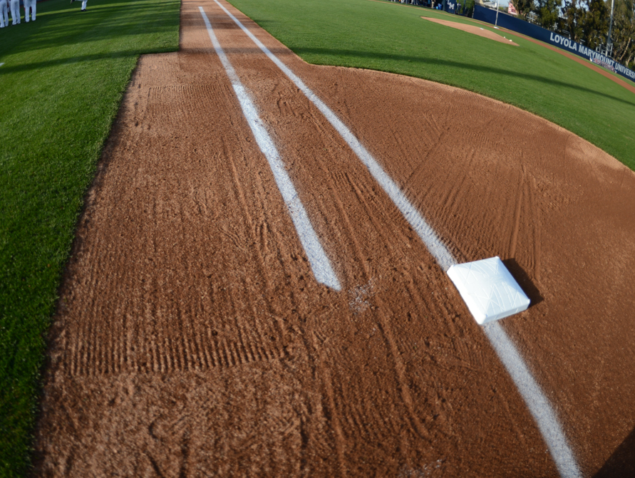
- Game Saver – Game Saver is a drying agent to spread in mud.
NO
- Try to remove as much standing water as possible
- Please use Game Saver (aka stay-dry) on wet areas around base paths, mound and Homeplate. Spread & then rake it in.
- A little goes a long way!!! Do not over-use.
- Storage Sheds are stocked with Game Saver, Lime and all the tools you require
YES
- Combinations: A laminated card containing all of the storage combinations will be provided by Tim Bond
- Raking: Please do NOT rake the infield grass-to-grass. Instead, rake up and down the base paths. This prevents dirt from building up underneath the lip of the grass and causing unsafe bounces of the baseball.

EQUIPMENT: Brian Hoyt (603) 772-4607 (home) bhoytsox@comcast.net
- Remember - No player may use any bat which does not have the USA BAT stamp on it (this includes practice) due to insurance requirements through Cal Ripken League (no exceptions)
- Inventory of equipment – If you need something during the season, please call Brian!
- You will be provided with a gear bag of equipment – Pick up today!
- Game Balls – they’re expensive. Get creative with post game player recognition.
- Foss-Wasson may require more baseballs due to foul ground behind home plate is private property
- It’s always good to have a towel or 2 on-hand for those rainy games!!!

SNACK SHACK: Megan Stagnone 603.582.1538 meganstagnone@gmail.com
- Snack Shack at Currier will once again be OPEN for business. It helps us defray many league costs.
- In most cases, the HOME team at any game at Currier supplies 2 to 3 volunteers for snack shack duties.
- Failure to provide snack shack detail will be subject to forfeiture of the game or other penalties
- RECOMMEND assigning this at start of season for all games and having parents and their own sub. Use the league app or signup genius can help.
- SNACK SHACK AT KENSINGTON SAWYER PARK MAY ALSO BE IN PLAY THIS YEAR. Stay Tuned.

FUNDRAISING: Geoff Dennett 617.943.7756 Geoff.Dennett@gmail.com
Corporate Sponsorships: Dave Richards 603.553.2025 drichards@innovestus.com
- Corporate Sponsorships rebounded well post COVID downturn. Always looking for more.
- Looks for tag days, etc.
- Picture Day is back – tied to opening ceremony;
- Annual EJBSL Golf Tournament 5/18 – need planning sponsor

UNIFORMS: Mike MItchell 603.812.1008 mrm603@gmail.com
Geoff Dennett 617.943.7756 Geoff.Dennett@gmail.com
- Making another shift this year
- Continue to move away from MLB jerseys. Supply Chain issues and reduction in authorized resellers.
- Wear your uniforms with pride! They represent Exeter Jr. Baseball League

CALENDAR of EVENTS (if known):

March 23rd – Field cleanup; batting cages up
April 6 – Opening Ceremony and Possible Opening Day / Picture Day
May 18? - Golf Tournament
~June 7 target last EJBSL games. All Star tournament games will happen after this date. We will avoid 6/8 and 6/7 for EHS graduation. 6/7 may have games for Rookie and A.
Closing Ceremony - TBD

LOVE THE GAME!

