Roosevelt Athletic Booster (RAB) Club Meeting
Minutes: 01/09/23
Location: Roosevelt High School Library, 7:00pm-8:00pm
RAB website: https://www.rooseveltathleticboosters.org/
- Meeting Hosted by: Kirsti Rochon (co-president)
- Attendance – 23 were in attendance (*see section at end of minutes)
- New RAB Reps: Jamie Gowen/Girls Water Polo, Steph Olson & Jessica Colette / Wrestling.
- Upcoming meeting: Monday, February 13th, 7-8:15pm
- Future meetings: 2023: Mar 13, April 4, May 8, June 12

1, FINANCIAL UPDATE: Jennifer Mahlum
- Contact for Jennifer: jmahlum2@gmail.com
- Almost reconciled for January 2023 from Jennifer M. 🙂
(from 12/1 Available General Fund balance as of 12/1 - $18k
- General Fund balance as of 12/1 - $28k
- Grants have resumed, with strict parameters. (form on RAB google drive). The board approved new tennis uniforms and it was under $1k so it was not taken to the group.
- New peeps! Please confirm your email with Lisa Hanson so we can have you added to the roster and confirm banking information. To be confirmed as a signer on the key bank account, check in with Wendy and Jen. The first step is to touch base with your coaches and have them check in with Rayna to get their ASB fund balance. It is important that Coaches do this step, not reps.
2. ANNOUNCEMENTS: Kirstin
- Sounders – Jeremy Blauser
Jeremy is looking to nail down a game date and tickets will be discounted. This is not sports specific but rather community building.
- Remember that ASB pre-approval is needed before holding any fundraising event with students involved. (Directions are in Google Drive/Team Reps folder). Just be aware that it needs to be approved ahead of time (especially for summer and/or fall events, be thinking of this before school gets out).

3. FUNDRAISING
- Events (Annual goal for all events is $26k, have raised $8500)
  - Champs Night recap (goal of $5k) – Leann Huntington
    - ROI was $4100. Taco Bar goal 200 tickets, sold 59 = $885
Raffle = $740, Online auction $1500, swag table $955
    - Feedback for t-shirts/swag: QR code was long and confusing. Looking to simplify the payment process. No Venmo due to change in nonprofit rules.
    - Looking for ideas for next year
- Pint Night: This was a big success, and we are looking to schedule 1 more for March. Looking for volunteers to help. Email Kirstin if you are interested in helping. Specifically looking at Fall sports reps 🙂
- Winter Season Storefront (goal is $6900 - $2300 per season - have made $4500. Fall Sports $3,070, Winter $1,430 (fewer winter sports)
  - Spring Storefront goes up on Feb 27th.
    - if you would like anything in addition to the standard short and long sleeve t-shirts, sweatpants, hoodies etc. Please email Kirstin no later than 01/19.
- Still holding inventory in License Plate holders ($5) Pint glasses ($10) and Scarves ($15) The white hoodie is available in limited sizing.in limited sizing. Green is sold out. If you would like to offer any to your team, please contact Kirsti/Wendy.
7. ATHLETIC DIRECTOR/TRAINER UPDATE: Casey
- New training room equipment - massage gun has been very popular and the icing machine has been very helpful.

8. SPORTS/TEAM UPDATES (from in-season sports, unless otherwise noted)
  - Boys Basketball – Leann Huntington
- Rough season thus far due to being in upper division
- Girls Basketball - Kirstin Rochon
  - Varsity 10th in state, JV Undefeated. Need help selling programs. Enlist students to help at games.
- Girls Bowling – Kristin Rosen
- Rough Rollers currently in 4th place! Top 3 go to state. Organizing a bowling night on Feb 7th.
  - Wrestling – Michael Matwichuk
- 1st tournament canceled. Tournaments next 2 saturday. Looking to add schedules to the website. Emailing Melanie.
  - Gymnastics – Rachel Gleeson and Aimee Jennings
- On track to be in metro districts. New leotards will be here in time for Senior Night and the next home meet.
  - Co-Ed Ultimate Frisbee – Annelliot Willis
- Won the game last Saturday. Same coaches as LY
- Track and Field - Frank Field
  - Just starting winter conditioning. New coaches, new energy!

9. LIST OF ATTENDEES = 22

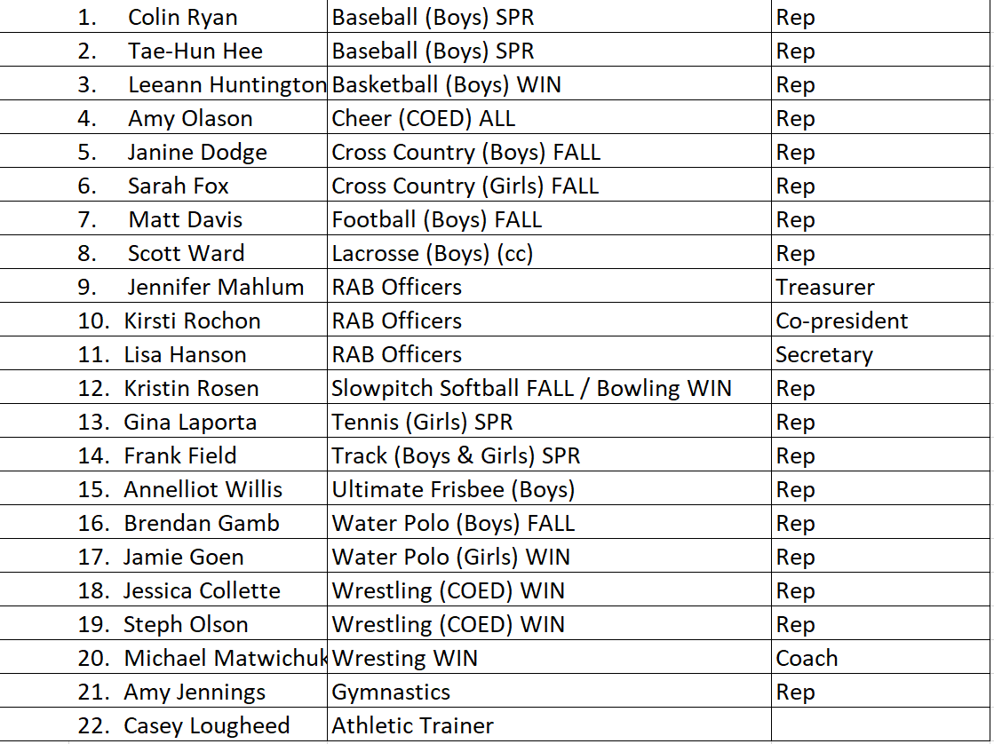
23. Meta Gpdse ? ?

