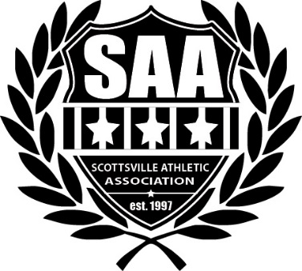

March 2021

Hello local business owner!
The Scottsville Athletic Association (SAA) is currently seeking sponsors for its 2021 season. SAA is a non-profit organization that provides opportunities for hundreds of area children annually to play soccer, baseball, softball and basketball in a safe and supportive team environment. SAA is a fully volunteer run organization, including more than 20 coaches – this is no small achievement for a small community! However, in order to provide these services for our youth at an affordable cost, we are dependent on sponsorships and donations. Given the COVID pandemic, we were unable to solicit sponsorships in 2020. With soccer, baseball, and softball about to kick off soon, we are aiming to bring on TEN new sponsors this year. Money collected through sponsorships, donations and fundraisers will help underwrite program costs that include (but are not limited to): uniforms, equipment, field maintenance, referee/umpire fees, insurance, and most significantly, to provide scholarships to families with financial hardship.

We are hopeful that your business might be able to support the mission of SAA with either a financial or in-kind donation. For your convenience we have attached a donation form to this letter though know we would be happy to customize a sponsorship program to your ability to support our programming.

Thank you for helping make our program a reality for the Scottsville community. Please do not hesitate to contact me with any questions you may have. We look forward to hearing from you!

Sincerely,

Rebecca Alquist
Sponsorship and Fundraising Coordinator
PHONE: 585.233.7276
scottsvilleaa@gmail.com
www.scottsvilleathletic.org

Donation Form

House Soccer Sponsorship: GOLD
$200
- Company name listed on our SAA website for 2021 season
- Company name (solo placement) on a House team jersey
- Team Photo Plaque

Baseball Sponsorship: GOLD
$200
- Company name listed on our SAA website for 2021 season
- Company name (solo placement) on a Baseball jersey
- Team Photo Plaque

House Soccer Sponsorship: SILVER
$100
- Company name listed on our SAA website for 2021 season
- Company name (in a group) on a House team jersey
- Team Photo Plaque

Baseball Sponsorship: SILVER
$100
- Company name listed on our SAA website for 2021 season
- Company name (in a group) on a Baseball jersey
- Team Photo Plaque

Social Media Spotlight
$50
- Unique company promotion to our social media followers, 2 postings
- Timing of your choice
- Includes traffic analytics

Friend of SAA Sponsorship
$20 | $50 | $75 | $150 | $300 | IN KIND

COMPANY OR BUSINESS NAME: ______

ADDRESS:

PHONE NUMBER:

CONTACT PERSON:

DESCRIPTION OF IN KIND ITEMS

SPONSORS MAY ALSO REMAIN ANONYMOUS

Please make checks payable to: SCOTTSVILLE ATHLETIC ASSOCIATION
MAIL CONTRIBUTIONS TO:

Scottsville Athletic Association
PO Box 183
Scottsville, NY 14546

