Please email LSRregistrar@gmail.com for membership corrections or questions.

- Go to https://memberships.sportsengine.com/org/lone-star-region-volleyball/affiliation/friendswood-challenge-elite-volleyball-club/get-membership
- Select Get Membership
- Select Child
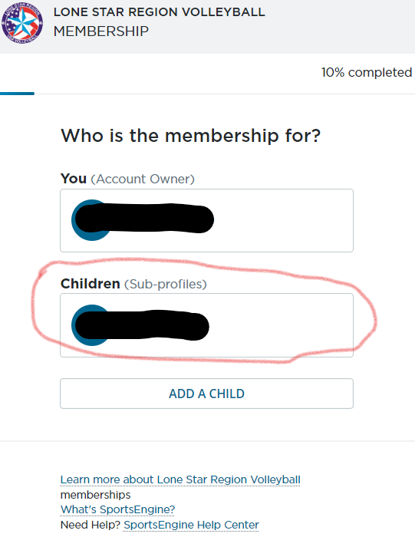

- Confirm and click Next
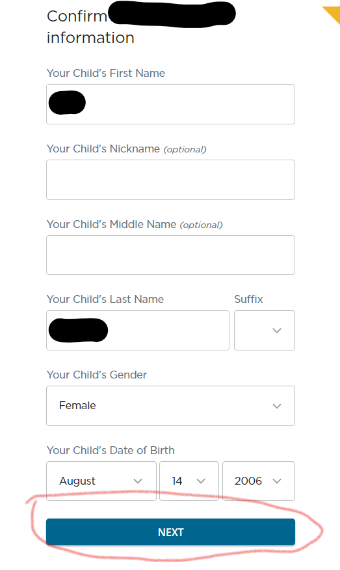
5. Confirm and click Next for guardian information
6.Select Player/Athlete and click Next
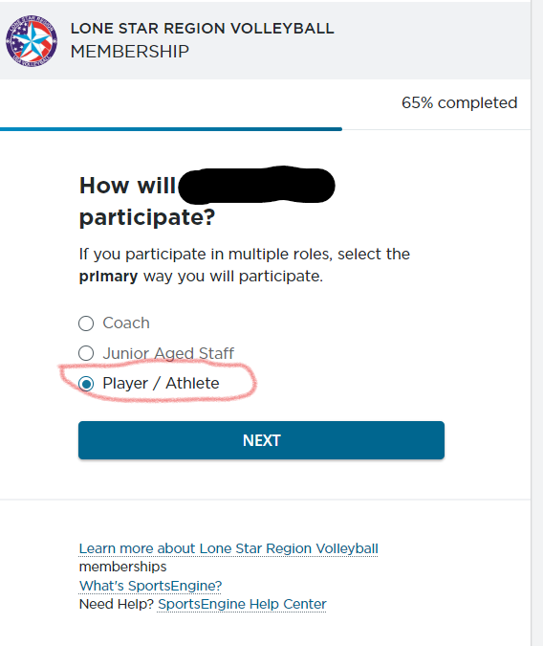

7. Select Lonestar Junior Player and click Next
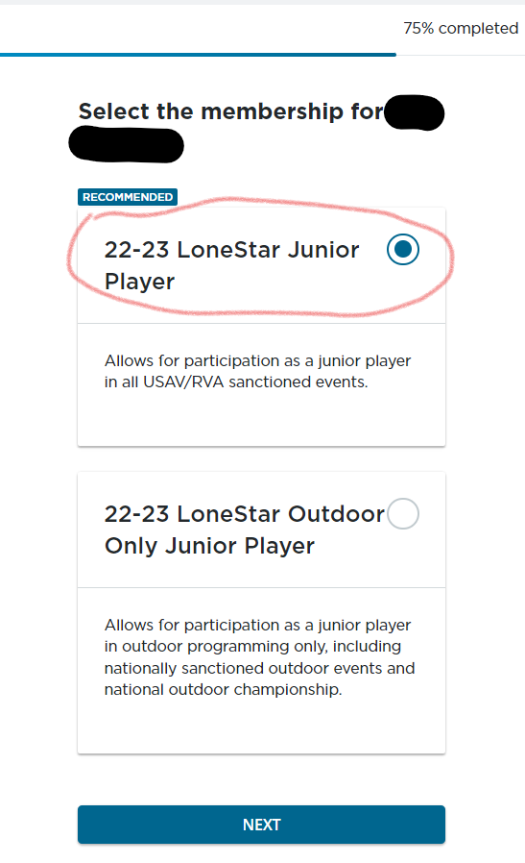

8. Click Next
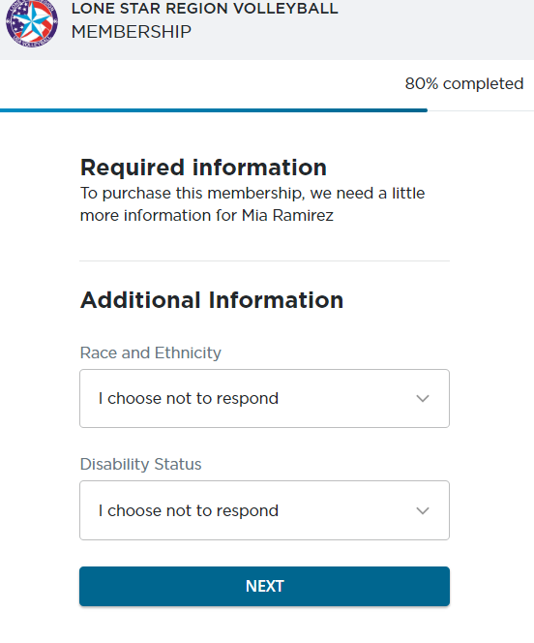
9. Click Continue with payment
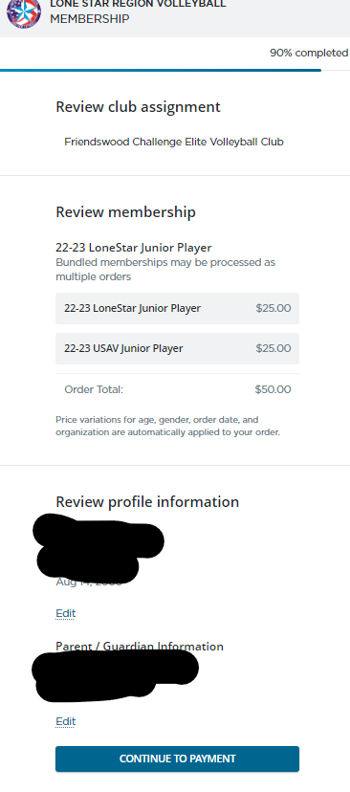
10. Click next on NCSA screen.
11. Proceed to Checkout
