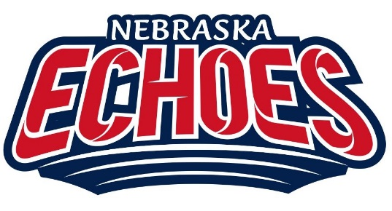
2026 Scholarship Application
GUIDELINES AND APPLICATION MATERIALS
The Echoes Fast Pitch Softball Organization of Papillion, Nebraska is honored to award two (2) scholarships in the amount of $1,500.00.
ELIGIBILITY INFORMATION AND GENERAL INFORMATION
- Applicant must be a current Echoes Fastpitch Softball Player in good standing.
- Applicants must be a 2026 graduating high school senior and eligible to enter college in the fall semester of 2026.
- The scholarship award will be paid directly to the applicant’s accredited college or university as a one-time payment of $1,500.00 upon proof of enrollment and class schedule. The scholarship is non-renewable. College and/or University is defined as “accredited” and can be a; Junior College, Community College, 4-Year College or University, or Online Degree program.
APPLICATION DEADLINE: April 15, 2026
Completed applications will be due April 15th, 2026, with selection completed by the Echoes Scholarship Committee no later than May 1st, 2026. The completed application must have a postmark designation of April 15, 2026.
APPLICATION PROCEDURES: (INCOMPLETE APPLICATIONS WILL BE DISQUALIFIED AND NOT UNDERGO REVIEW)
- All eligible candidates must complete and return all scholarship application pages except this cover sheet.
- Submit ACT/SAT Cumulative Score (proof document)
- Submit an official high school transcript in a sealed envelope and be sure to include official documentation of the grading scale used at your school.
- Submit one signed Letter of Recommendation (Echoes Coaches Not Eligible)
- Submit one 500 Word Character Essay (see paragraph #5 of Application form for topic)
- Send all application materials together in one package to:
Attn: Judy Larry
Echoes Scholarship Committee
12315 South 73rd Ave
Papillion, NE 68046

Additional applications are available on our website http://www.echoesfastpitch.com

