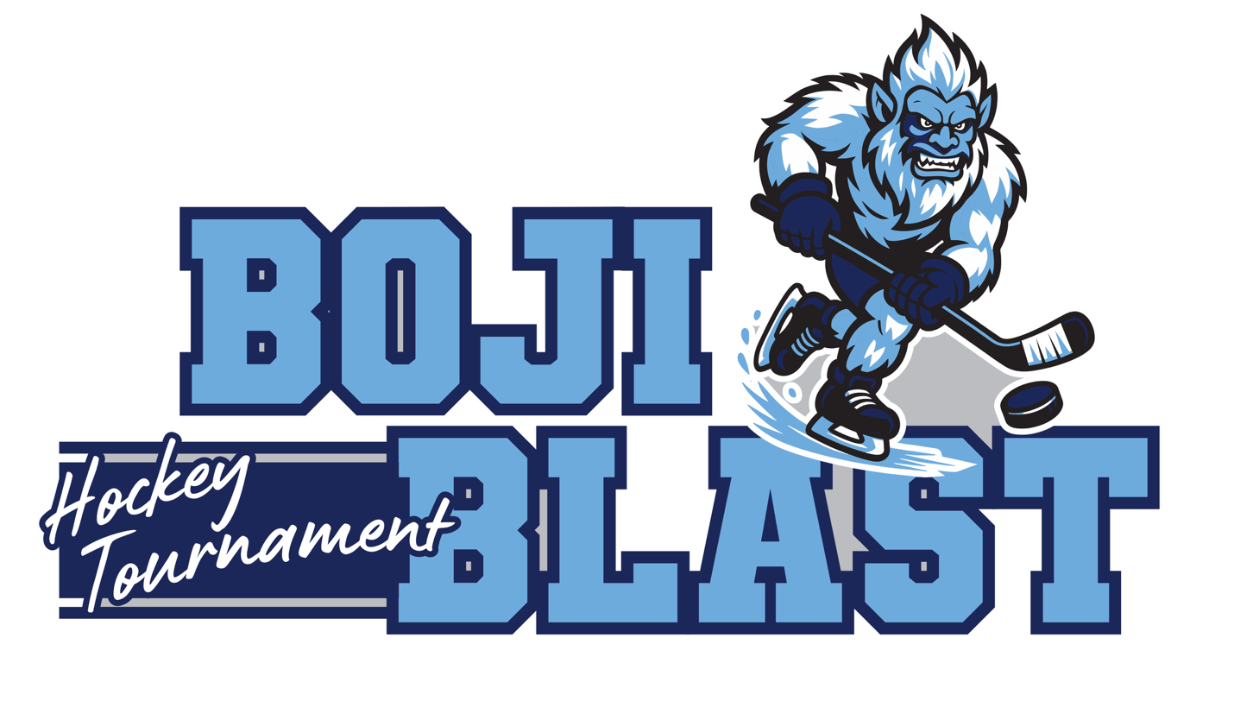

BOJI BLAST
TOURNAMENT RULES

- All games will be played under USA Hockey Rules. A current rules book will be available at the scorer’s table during each tournament game.
- All tournaments will have 2 USA Hockey registered referees of the correct level.
- Teams must check in with official stamped team roster at least one hour before the first game played.
- Coaches must be on roster, no more than 4 coaches allowed on the bench during a game.
- The top team in all brackets is considered the Home Team and will wear light colored jerseys. The Visiting team will wear dark colored jerseys. In the event a team does not have the correct jersey it will be handled at the time of the game.
- Game times will be:
    - 5 minute warm-up before each game
    - Squirts & 10U Girls will run 3 (12-minute) stop-periods, Peewee and Bantam will be 3 (15 minute) stop-periods
    - Penalties will be 1:30 for minor (2:00 for Bantams) and 5:00 for major
- Run time will take place if there is a six-goal lead. Stop time will be reinstated if the goal difference becomes four or less. In order to maintain rink scheduling, the 3rd period may go to run time with stoppage for injuries or penalties.
- A single 1-minute time-out will be permitted per team
- All players must be ready to play 30 minutes before the scheduled game time. If the tournament is running ahead of schedule, Tournament Directors may opt to begin a game ahead of schedule.
- Players need to be ready to hit the ice as soon as the referees have nets set and wave them onto the ice. Games times listed reflect the time of puck drop.
- Resurfacing of Ice will be done every 2 periods for Bantam level of play and at the end of every game for Squirts & Peewee’s (this format is subject to change to maintain scheduling).
- This is a zero tolerance facility. Unsportsmanlike conduct will not be tolerated. Any player, coach or fan exhibiting unsportsmanlike behavior will be ejected from the game and / or tournament by the officials, the Tournament Director and/or Designee and/or any member of the LAHA Board of Directors and Arena Staff.
- A game disqualification shall be automatically assessed when a player receives a fourth penalty during a single game. Enforcing this penalty is the joint responsibility of the referees, the score keeper, the coach, and the player. The official scorekeeper will notify the referee when a player has received their fourth penalty under this rule. The referee will then notify the head coach of the offending team, and that player shall immediately leave the game and go to their locker room.
- All players must wear approved helmets, facemasks, neck laceration guard, and mouth guards. No persons other than certified coaches or rostered players are allowed on the player bench. Any player not suited for the game must wear an approved helmet while on the player bench.
- NO spectators will be allowed on the ice at any time during the event for any reason (other than special tournament specified events such as The Hockey Mom Shootout in which a helmet must be worn)
- National Anthem will be played prior to the first game of the day.
- During pool play, ties will be allowed with points assigned as follows:
  - 2 points for a win
  - 1 point for a tie
  - 0 points for a loss

- There will be no ties during trophy play. If a tie exists at the end of regulation play, there will be a one minute rest period, followed by a five minute sudden death period without changing ends or resurfacing. If a tie still exists at the end of the overtime, each head coach will select three players for a shootout. If a tie still exists at the end the shootout, it will go to sudden death format with each team having equal number of chances. No player shall go twice unless all players have been utilized. All players are eligible for shootout unless currently serving a penalty.

- At the end of pool play if two teams have the same point standings, tie breakers to determine trophy play will be as follows:
  - Head to Head result
  - Fewest goals allowed
  - Goal Differential (Goals for minus goals against). Max differential per game is 6
  - Least number of penalties (minutes)
  - Coin Flip
- Lakes Area Hockey Association, Tournament Directors and all personnel connected with the tournament shall not be held liable for injuries or losses sustained during the tournament.
- NOTICE: Games will be played even in the event of bad weather. No rescheduling date will be made.
- Tournament Director reserves the right to modify this format if games fall behind schedule.
- In all other matters not covered above the Tournament Director’s Decisions will be final.

All games will be played at Lakes Ice Arena, 3800 Sunner Ave., Spirit Lake, IA 51360
Questions? Contact the Tournament Director
Lindsey Keonin 515-229-5845 ljkeonin@gmail.com
Mary Louise Marso 605-214-0854 quissell98@icloud.com

