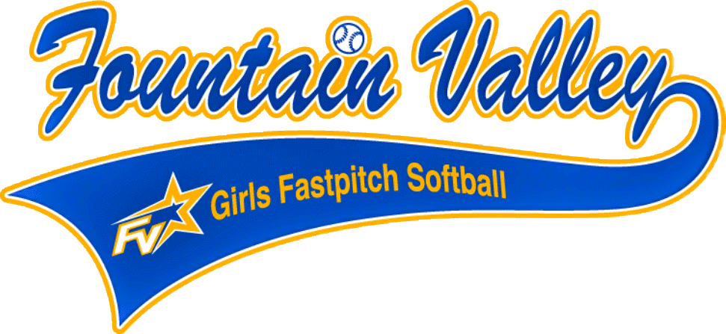

FVGFS MISSION STATEMENT:
FVGFS seeks to instill in the girls of the community ideals of good sportsmanship, honesty, loyalty, courage, and reverence so they will grow to be good clean healthy adults. This objective will be reached by supervised, competitive athletic games. The supervisors shall always bear in mind that the attainment of exceptional athletic skills or winning of games is secondary and that the molding of future citizens is of prime importance.

FVGFS TEAM PARENT:
There is a lot to cover over the season for the designated Team Parent and therefore it is strongly suggested that each team have a primary team parent and another parent or two who can assist so that responsibility can be shared.

The team parent is responsible for doing the following:

- TEAM ROSTER AND PHONE LIST: The coach or the Team Parent can compile the team’s roster and phone/email list for distribution. Establish to all player families early on how you plan to communicate and ensure you have all current contact information. You will need to create this list as soon as possible because you will use this list as a check list for many different events and responsibilities. Ensure proper spelling of player names to be used for banner and other important items. There are several free applications to maintain this information online for ease of access for the team. These services also have the added benefits of tracking games and practice schedules, and they have automated reminders, the ability to track all messages and sometimes, any collection of monies for Sprit wear, etc.
  - TeamSnap
  - Heja
  - Groupme
  - Spond

- EVENT COMMUNICATION: Holding team meetings and communicating with parents about all upcoming events via meetings, emails, handouts, or other means. Make a habit of checking the league website often for league updates. Encourage all player families to make a habit of checking the website. Website: www.fvsoftball.org.

- TEAM PARTIES: Lamppost Pizza will give us 3 coupons to be used throughout the season for 2 free pizzas per booked party for your team. You are not obligated to use the coupons, but they are provided. It is a very good idea to plan, call Lamppost ahead of time as they fill up fast.

- PICTURE DAY: Organizing the team for Picture Day. Notify players of picture date and time. Players should be in full uniform. Picture Day will be on in the AM/PM. Picture Day will start early, and specific team times will be released to the team moms when we get closer to the event. A picture package is included with registration. Shipping can have an extra cost, depending on the vendor. All extra pictures outside of the package provided by the league are a separate cost for each family.
- SPONSORSHIPS: Team parents collect Sponsorship Forms and monies from players and submit them to the Head Coach. The Head Coach will hand a check/business card and sponsorship form to the Treasurer. If your sponsorships are collected, 65% of the total goes to your team and 35% goes to the league for all Season Sponsorships. Each player’s family should make every attempt to obtain at least one sponsor. There is a tracking form on the league website under forms. Any monies received and processed through the league must be accounted for and tracked for tax purposes.

- TEAM BANNER (Optional): Creating or purchasing a team banner. Generally, team banners are displayed during each game on the fence near the team’s assigned dug out. The league does not pay for banners. Use any sponsorship money you collect or collect money from all player families to equally share the cost for the banner. Banners can range from approximately $50 - $150. There are several companies available to make banners for you or you can make your own if you prefer. Banners can also be used for Team Picture Day.

- TEAM PHOTOGRAPHER: Assign one or more parents to take pictures of the team at work and play. These photos can also be handy for your team’s end of season team party gifts. Start taking pictures early! Don’t forget to tag us on Instagram: fvgirlssoftball

- CHAPARONES: Ensuring that a female over the age of 18 and with an approved background check is present at all functions. This includes the dugout, at practice, and when escorting players to restrooms. The safety of our children is always a priority. All Chaperones need an USA Background Check. The form is located on the league website at http://www.fvsoftball.org/

Each team must have at least 4 parents complete background checks so they can be approved as Chaperones. If you plan on assisting the team or being on the field with the players – you must have a background check on file to do so. The more parents who do this, the better.

- SNACK BAR: Each registered player paid a snack bar fee at time of registration. This is a refundable fee if you choose to work at the Snack Bar during the Fall Ball Season. Sign-Up information will be sent. If you sign up to work at the snack bar, please make sure you are available to work the full hours. You may need to work separate days to complete your hours, this will depend on how long we can have the snack bar open each day/night. We ask that no kids are taken to the snack bar during working hours as it is a safety issue.

If you cannot make it and would like to send in a sibling (15y/o or older), family member or spouse to work your hours you will need to let the board know. You cannot have two people work on the same day for a player. If there is more than one sibling playing in the league parents will need to work the hours for each child. Please be advise there will be an additional fee if you do not show up for the day you signed up to work.
To receive a refund, you must work a minimum of 4 hours. If you do not want to receive your refund you do not need to sign up to work a shift.

- FIELD MAINTENANCE: Ensure a minimum of 2 parent volunteers from each team are assigned to help the coach with Field Maintenance. Setting up the fields and cleaning up before and after practices and games is the whole team’s responsibility.

- FIELD CLEAN UP REMINDERS: Each team is responsible for field clean up after use. Please note this also means practice field use. Please remind families to clean up the field and the stands before leaving all practices and games. (i.e., Remove any trash, sunflower seed shells and check for any forgotten equipment, sweatshirts, etc.) Please remember to leave the dugout clean for the next game. The last team leaving for the day must take the trash out before locking the dugout.

- DUG OUT REQUIREMENT: Only coaches, dugout parents, and players are allowed in the dugout. Parents, siblings, and friends are not allowed in the dugout during games. assisting in the dugout or assigning a Dugout Parent to keep order for players and assist the coaches with the lineup and equipment (bats, helmets, catcher’s gear) if necessary. Encourage girls to stay positive, cheer their teammates on, and have fun!
  - There must be one female in the dugout during all games. Make sure girls:
    - Remain in the dugout during the game and not off visiting family or friends between innings.
    - Have water for hydration.
    - There is a first aid kit in the dugout and ice available in case of injury.
    - Remind players and families there is NO FOOD in the dugout.
    - There should be no parents conversing with their players through the dugout fence during game time.

Dugout needs it’s a good idea to purchase dugout needs and divide the cost between the team or ask parents to purchase and donate. It really makes it convenient to have sunblock, rubber bands, band aides, tissue, and other little things that you can think of in one convenient place. This is not mandatory.

- SPIRIT WEAR, BOWS, SOCKS, LACES, HEADBANDS, ETC.: Organize spirit wear for your team if agreed upon by your player families. Spirit wear is on an individual basis. The league does not require or pay for spirit wear. It is not a requirement that all members of the team participate.

- APPRECIATION GIFTS: The league does not pay for Coaches/asst Coaches or team mom gifts. The families can raise or collect money to purchase gift cards, plaques, etc. to show appreciation.

- SNACK SCHEDULE: Creating a Snack Schedule for after games. It is a team preference that can be decided before the season begins. This schedule is not to be confused with the Snack Bar Schedule and it is not mandatory.

- TEAM SNACK: Ask each parent if their team is allergic to any foods and share with all families the item that should not be in the snack packs.

- COACH/LEAGUE EVALUATIONS: Coach evaluations are done through our online system. This is anonymous and used for training purposes.

