2024 CYBSA SPONSORS/ADVERTISEMENT
Cloquet Youth Baseball/Softball Association
PO Box 45
Cloquet, MN 55720

Your sponsorship is tax deductible, as we are a 501 (C) 3 organization.

FIELD BANNER- $200.00 FIELD BANNER ON OUTFIELD FENCE
(Banner on all 4 fields $650.00)

BRONZE SPONSOR- $300.00 JERSEY SPONSOR

SILVER SPONSOR- $450.00 JERSEY SPONSOR AND 4’ X 6’ BANNER

GOLD SPONSOR- $1,000.00 TEAM ENTRY IN GOLF OUTING/HOLE SPONSOR
JERSEY SPONSOR AND BANNER

Please email contact below with your sponsorship/advertisement with your intentions and then we can invoice your business.
Contact: Jason Eckenberg
cloquetbsa@gmail.com

Outfield Fence sign
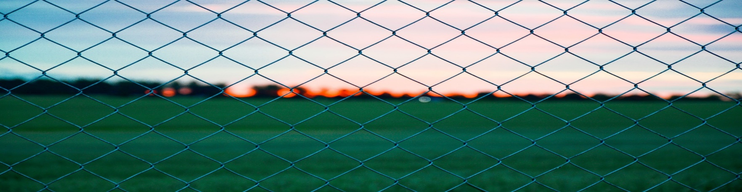









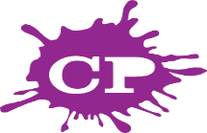
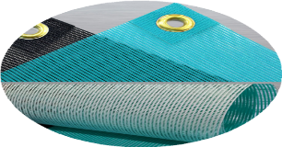

Community Printing
since 1979
PROMOTIONAL 1306 CLOQUET AVE, CLOQUET
COMMUNITYPRINTING.NET

CYBSA
Cloquet Youth Baseball/Softball Association
PO Box 45
Cloquet, Mn 55720

Please complete the entire form. Your sponsorship is tax deductible, as we are a 501 (c) 3 organization. Our federal tax ID # is 41-1727460

Company/Organization Name:

Contact Person:

Email:

Level of Sponsorship:

Please email: cloquetbsa@gmail.com with your intent.

Will need a Logo with form if a new sponsor interested in a banner sponsor to CYBSA unless on file with Community Printing

