MMYFC GCYFL 2026 CALENDAR
5/3: Cheer Uniform Fittings
5/27 & 5/28: Football Uniform Fittings
7/1: Sports Physicals Completion Date
7/8-7/9: Distribution Day (assigned day/time; pick up uniform & equipment)
7/13-7/17: Week 1 of Mandatory Camp (10 hours of conditioning) *cheer only MWF
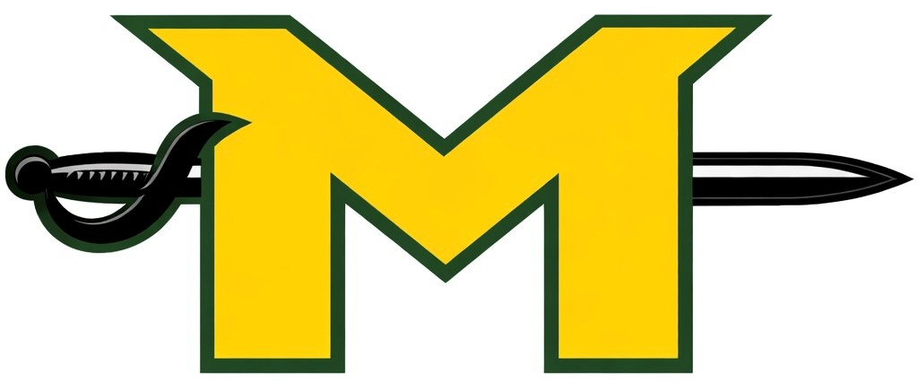
7/20-7/24: Week 2 of Mandatory Camp (Complete 20 hours required) *cheer only MWF
7/27: Regular/Full Practices Start
8/1: Mandatory Player Certification/Weigh-Ins (no late/early weigh-ins)
8/8: Football Jamboree (FB Scrimmages all divisions)
08/22: Week 1 (National Conference)
08/29: Week 1 (American Conference)
10/21: Mandatory Playoff Weigh-ins (no late/early weigh-ins)
10/24: First Round of Playoffs
11/7: American Conference Championship
11/14: National Conference Super Bowl
11/21: All Start Game

