GAME/Station: Defend the Net Front Game with 2 points
Play 3v3. Before they can shoot at their designated net, they must pass to one of their point players. The point player must pass to his/ her partner who can shoot or pass but must do so by two-touching the puck (one touch stops it, second touch moves it). Players who are defending must defend the players at the net front, not the point players. Attacking forwards should get to the net for tips and screens.
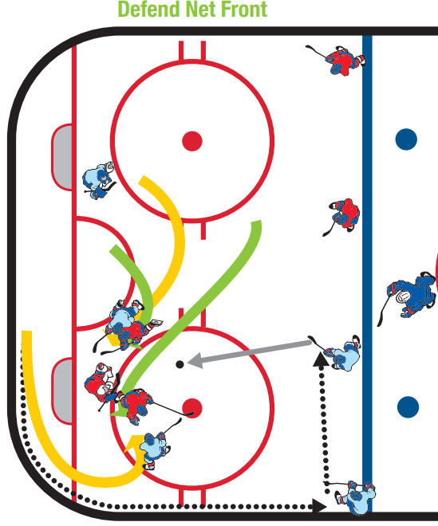

Station: 3v2 Keep Away (Neutrel Zone)
Play keep-away in a 3v2 setting in a small area. Emphasize moving to get open and gravitating toward the puck. If the team with 2 has possession, emphasize outnumbering the puck to win it back.
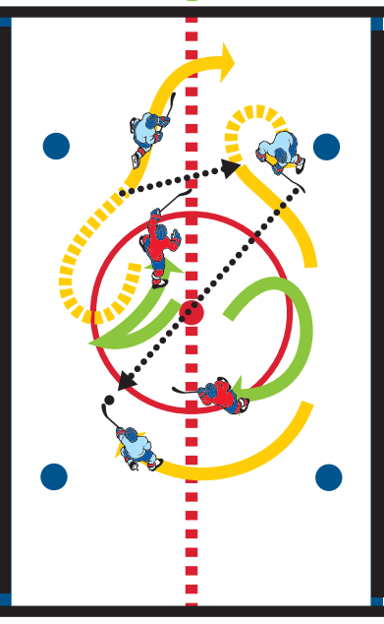
Station: High Roll Shooting (10mins)
D1 rims a puck to player F1 behind the net. F1 picks it off the runner properly with his/her stick and protects the puck and cuts back to the corner. F1 continues up the wall with the puck at which point D1 moves down the wall. F1 stays to the inside and exchanges it with D1. D1 carries it to the goal line extended and hits F1 in the high slot for a scoring attempt. Have players go at both positions, have a line for each positions as well.
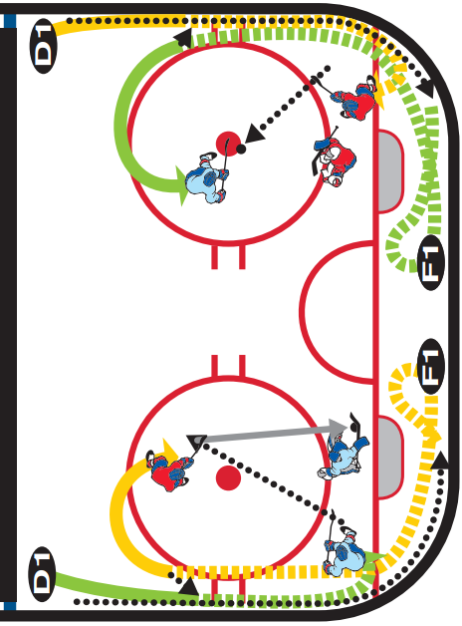
GAME/Station: Shark 1v1 to Progressive 2v2, 3v3 Down Low
F1 and D1 start with a shark 1v1 and play it until whistle blows. On whistle, F2 and D2 activate with a puck to make it 2v2. On next whistle, F3 and D3 activate to make it a 3v3 from tops of circles down. F3 starts with puck on wall and D3 containing him.
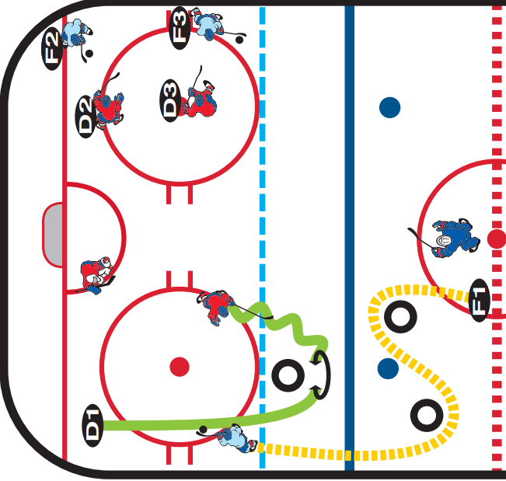

Game: Breakout/Forecheck Modified Regroup Game (10 minutes)
Play 3v3 cross-ice but before you can attack the opposition’s net, you must regroup with a player on your team who cannot go above the goal line. In addition, the regrouping players must come below the line that goes across the hash marks closest to their net to ensure good breakout habits/support. The regroup player may move anywhere below the goal line but cannot come above it. One of the attacking forwards must pressure the regroup player as if forechecking. Move to get open on the regroup and stay below the line.
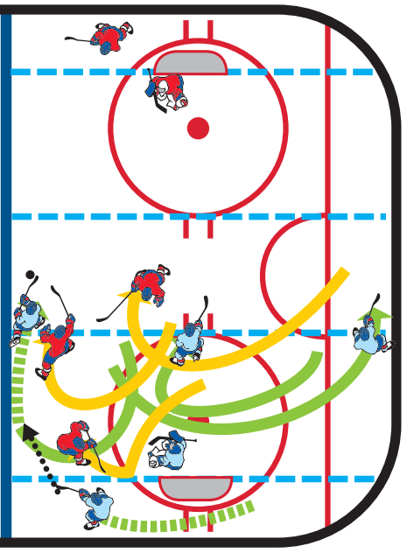

Station: Underhandle Shooting Progression
1st Progression – players skate around tires keeping the puck on their forehands the whole time and shooting it in stride when they clear the second tire.
2nd Progression – players skate around the tires keeping the puck on the forehands the whole time and they make a give-and-go with a player near the net after they clear the second tire. The passes should be either one-touched or catch-and-pass (DO NOT dust the puck off).
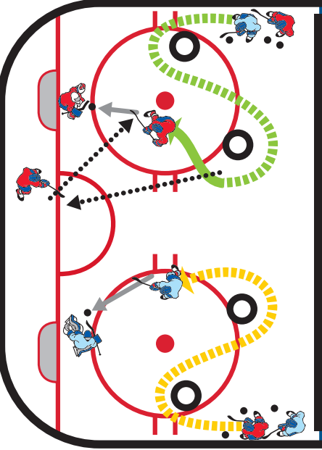

Station: Angle Through the Dot 1v1
The player in the middle of the ice skates toward the wall through the face-off dot. Once he/she hits the dot, the first player in line can take off and attack the net. The angler’s job is to try and eliminate the attacker’s progress toward the net with proper angling and body contact. After the drill is whistled dead by the coach, the attacker becomes the next angler (defender) and the drill runs continuously.
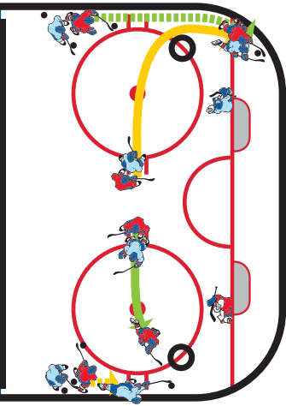
GAME: Regroup Game
Play 3v3 cross-ice, but before you can attack the opposition’s net, you must regroup with a player on your team who cannot go above the goal line. The regroup player may move anywhere below the goal line but cannot come above it. Move to get open on the regroup.
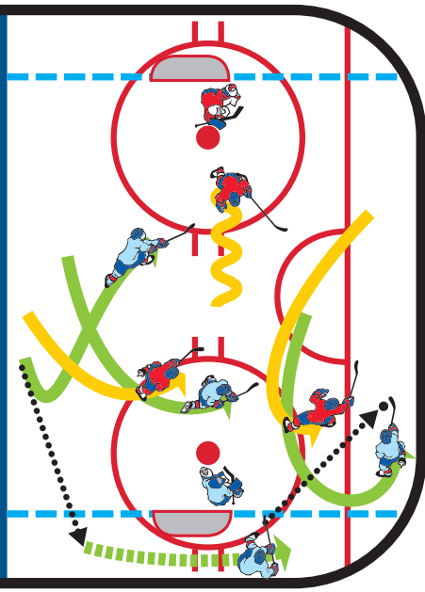
Station: Stop-and-Start Loose Puck Race
Players start at hash mark and sprint to blue line. They stop facing inside and sprint for a loose puck that coach leaves near the dot. Winner gets scoring chance.
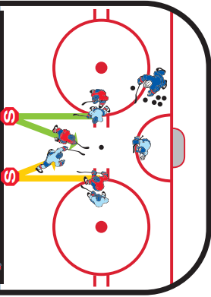

Station 3v1 Pit Game
Players compete to score in a 3v1 pit game, but one of the offensive players always has to be below the goal line. The offensive players can rotate so that the player below the goal line can change mid shift. Defensive player should just try to apply all-out pressure on the puck to make the offense make plays under duress.
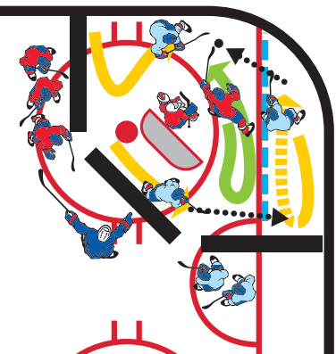
GAME: Pearl 4v2 One Net
Each team has a power play every other shift. Start off with 4 red vs 2 green. On the whistle, 2 new green join the play to make it 4 green. The 4 red players go for a change and 2 new red players come on making it a 4v2 for the green team. On every whistle the team with 4 changes and two new players from each team join the play. It will result in continuously flip flopping 4v2s. Keep score. Allow the defensive team to score points by making more than two consecutive passes within the zone (can use the goalie). If the defensive team clears the puck, they lose a point. Encourage the power-play team to attack the puck and retrieve it on a lost possession.
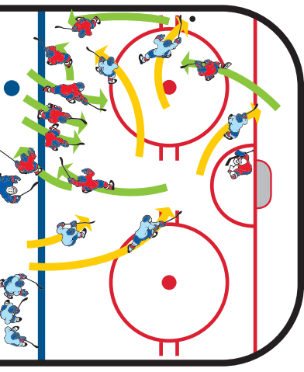
Station: Triple Regroup/Attack
Players regroup with own defenseman, then regroup with other defenseman, then regroup a third time with own defenseman. On third regroup they attack 2v1 with defenseman joining the rush to make it a 3v1. Wings post up on regroups and stay wide so they can attack with width and depth.

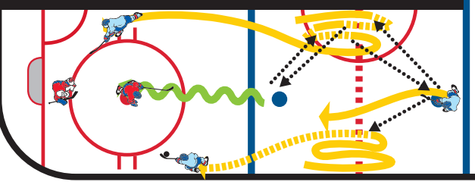

Station: Hit-the-Tire Passing Gam
Play 3v3. Offensive team scores by hitting the tire in the opposite circle. Offensive team cannot enter the offensive circle, but the defensive team is allowed in the defensive circle. Object is to move the puck quickly to open up passing/scoring lanes.
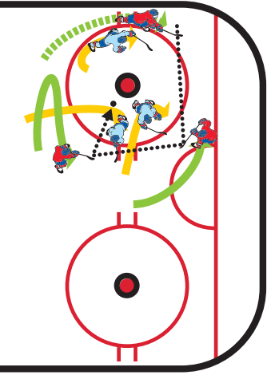

GAME: Power Play/Penalty Kill Game
Each half of the ice has a 4v2 power play. Two players on the power play must remain above the tops of the circles, but they don’t have to be the same two the whole time. Encourage switches, movement, etc., to get them to change places. The first power play that scores gets a point for their team. If the penalty kill players get the puck, they must try to maintain possession of it and play keep-away. Throwing the puck away is not allowed. Emphasize puck retrieval by the power play unit.
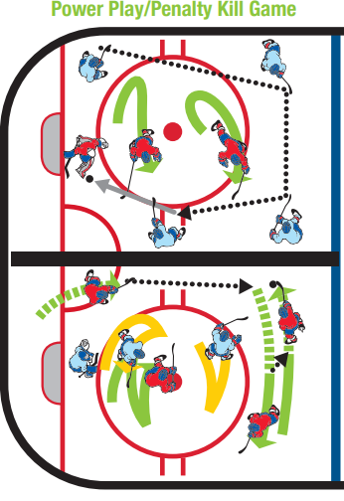
Station: 50/50 Takeover to 2v1 with Backchecker
Coach dumps a puck in and players battle for the 50/50 puck. The player that wins the puck skates toward the tire, completes a takeover with the player waiting and they attack 2v1. After a second, the next player in line backchecks to turn it into a 2v2. Play it out until either a goal is scored or the defending team skates the puck out.
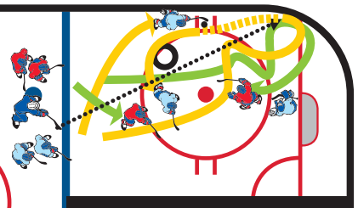

Game: Nobles Transition Game
Play 3v3 in each zone. One team is on offense, the other on defense. When the defending team steals the puck, they pass to their teammates who are waiting on the side boards. The 3 that just passed to their teammates leave the zone; the 3 that were on offense become defense; and the 3 that received the pass attack on offense.
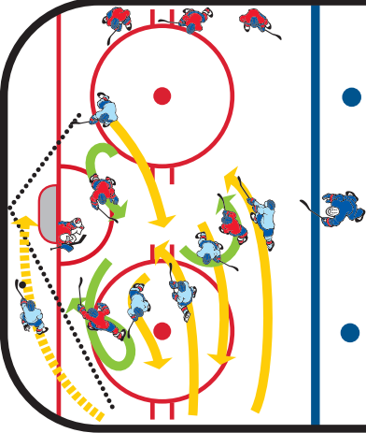
Station: Confined 2v2
Play 2v2 in a confined area. Designate which net each team shoots at. Focus on winning pucks and underhandling to get pucks to the net.
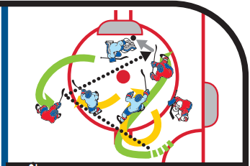

Station: 2v1 Puck Pursuit
Player O2 chips puck in. Player O backpedals, transitions, and retrieves puck. Player O wheels the net attempting to skate through the two tires (the gate) while X1 and X2 forecheck. X1 tries to shut down player O before the gate. X2 reads, reacts and pressures to create puck possession turnovers and 2v1 offensive attack opportunities.

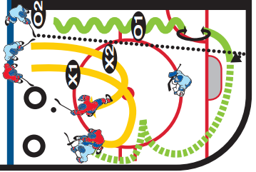
Station 1: Underhandling
Players skate a figure 8 pattern around cones, keeping the puck on their forehand. Pass puck off bumper and collect puck on forehand, push or pull around bumper executing a quick-release shot. Follow for rebound. Can progress to same as above but players skate a Russian figure 8 pattern (always facing the goalie).
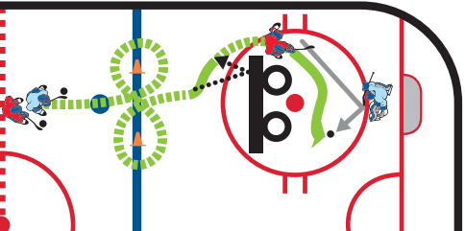

Station: Bumper Scissor
Set up 2 lines. Players scissor in front of both bumpers, exchanging puck possession away from the bumper on each overlap. As players round the last bumper, they can shoot the puck or pass to their teammate crashing net for a rebound or redirection. Progression – allow players to sell the fake and maintain possession.

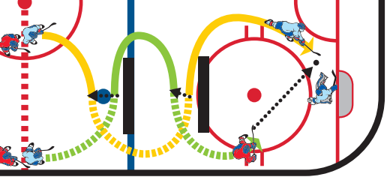

Station: Blue Line Reps
1st Progression – player X chips puck into corner, skates to retrieve puck, shoulder checks, surrounds puck when retrieving, skates behind net and escapes back toward corner. After escape, player X passes to player O at the blue line, who pushes or pulls the puck around the stick for a quick shot. Player X who made the pass looks to go to the net for a screen/tip.
2nd Progression – player O chips second puck on net, goalie plays puck behind net and O retrieves, escapes, and passes to X at the blue line for second shot.
Additional Progressions – 1) blue line player can fake shot, and pull/push to the other side for quick shot. 2) add a second X at blue line and D-to-D pass.
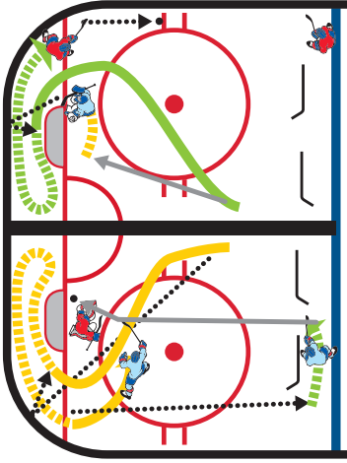
Game/Station: Continuous Corner 1v1 and 2v1
Defensive player works on angling in tight spaces steering forward, closing gap, and stick-on-puck, while offensive player tries to get to net to score. Offensive player gets a new puck if he/she scores. If defensive player steals puck, must pass puck to offensive player in opposite corner. 1v1 must stay in their half of zone; defensive player cannot attack until offensive player receives pass. Continuous drill. Progression – add second offensive player and work on creating offense, moving toward puck, takeovers. Defensive player works on keeping stick in passing lanes and body position.
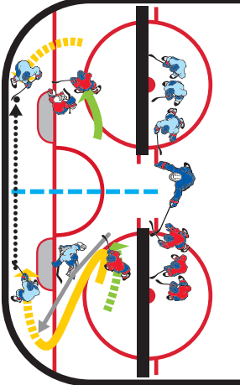

Station: Czech Agility Shooting
Player1 pulls puck across blue line and passes back to player 2 in line, player 1 pivots to outside and gets pass back from player 2. Player 1 now passes to player 3 for a quick give-and-go. Player 1 one times it on net. 1 becomes 3, 3 goes to line, 2 becomes 1.
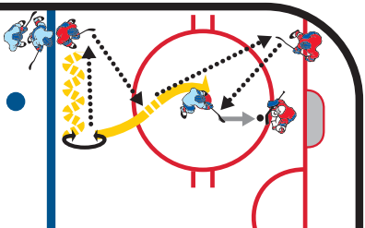

Station: 2v2 Clear Below the Goal Line
Play 2v2 in a tight area and before they can go on offense, they must take the puck below the goal line. On every change of possession, the puck goes below the goal line to promote switches on coverage and identification.
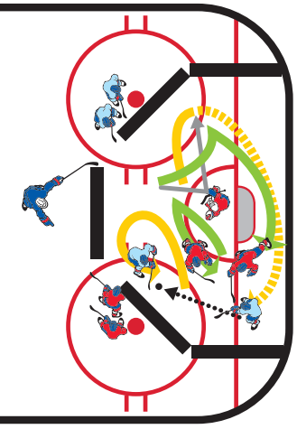
GAME Big Box 3v3 Game:
Play at both ends. Use center red line to divide the ice. The big box acts as a barrier that players must negotiate with skating and puck support skills. Encourage 3v3 play with pace and transition. The game will force offensive players away from the puck to skate hard to join the rush on the opposite side of the box. Coach players to attack with urgency when turnovers occur.
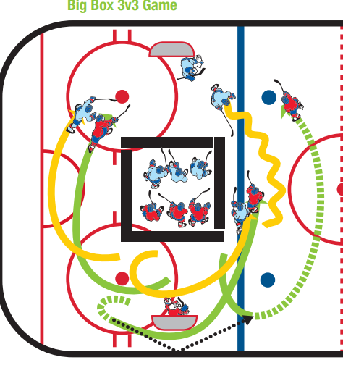

GAME Face-Off Competition/Live Action
Play 5v5 in zone starting with a face-off. Teams earn points in the following manner: • Face-off possession = 1 point • Shot on net = 1 point • Goal = 2 points • Skating puck out of zone for defenders = 1 point • Blocked shot = 1 point

Game: BETWEEN THE CIRCLES 3-ON-2
Place the net in its regular crease area. Place three offensive players between the circles and two defensemen. The offensive players try to score with quick puck movement while the defenders try to stop them. After a goal or a puck clearing, the coach passes a new puck to the offensive players. Change players after five pucks have been used.
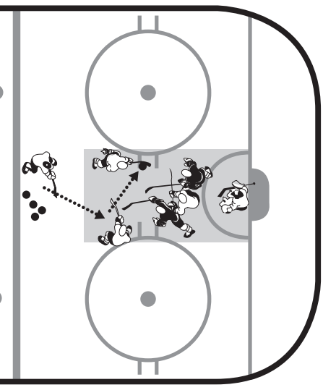
Game: HIGH/LOW 2-ON-2 TIP-INS
Divide the players into two teams and place one player per team at the blue line. Using two nets, players play a 2-on-2 in front. When the top player has the puck, they wait for a teammate to get in front for a tip-in. Goals only count if they are tipped in. After each goal, the team that scores keeps possession of the puck. Players hustle from side to side playing offense or defense depending which point player has the puck. Change every 40 seconds.
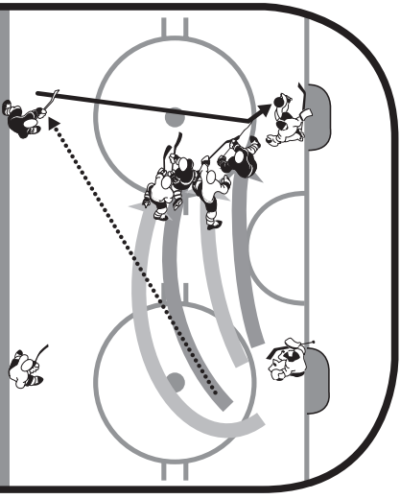

Game: 3v3 Neutral Zone Game
Play 3v3 within the neutral zone. Any time a goal is scored, the goalie covers a puck, or the puck leaves the zone, the coach on that end passes to a player on his/her side to start a transition play.
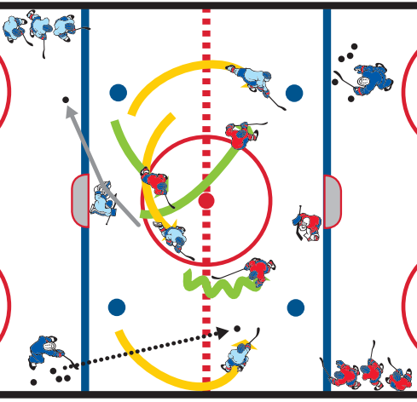

Station: Tika Taka Passing
Player 1 passes to player 2, who opens up around the tire and passes to player 1 who has skated to the middle tire. They perform a give and-go and player 2 passes to player 3. 1 becomes 2, 3 becomes 1 and drill is continuous.
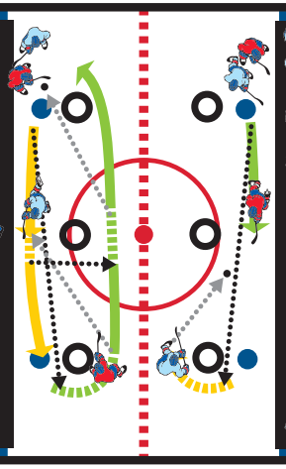
Station: 50/50 to 2v1 with Backchecker
Coach dumps a puck in and players battle for the 50/50 puck. The player that wins the puck passes back to teammate and they attack 2v1. After a second, the next player in line for the other team backchecks to turn it into a 2v2. Play it out until either a goal is scored or the defending team skates the puck out.
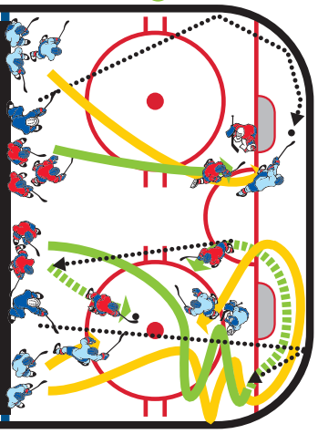

GAME: Royal Road 3v2
Players compete 3v2 from the tops of the circles down. Before they can attempt to score, they must make a pass over the drawn center line which signifies the Royal Road.
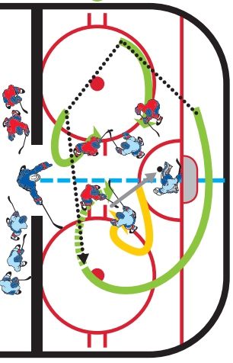

GAME: 3v2 Middle Lane Drive:
When coach says go, the center passes to a wing (before the blue line) who drives down the wall. The center drives the middle lane to the net while the far wing buys time and becomes the trailer. While this is happening, the opposing team has two players gap up to the red line and play it as a 3v2. On the whistle, the 3v2 starts from the opposing side.

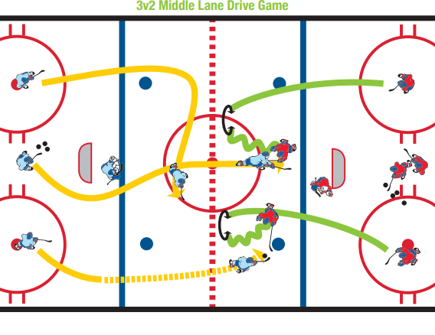

GAME: Live Action 3v1 D Activate
Purpose: To create a live-action situation for your team that teaches your defensemen to defend a rush, shut down the opponent and kick-start an offensive attack from the defensive zone. For the forwards, this drill teaches back-side pressure, funneling into the defensive zone and launching an offensive rush off a live break-out.

Drill Structure: Drill begins with D1 breaking puck out to O1 and O2. These three players attack 3v1 versus D2. Once the puck passes the red line, X1 and X2 backcheck the rush into the zone. Hopefully these backcheckers can apply back-side pressure to the 3v1. IMPORTANT: D1 falls out of the play after the initial attack is made. So D1 has one chance to make a play off the rush. Once this opportunity passes, D1 falls out and returns to the line. Because this D falls out, we now have a 2v3 favoring the defensive team. The puck stays live off the rush. D2 must break out puck to X1 and X2. Once this first breakout pass is executed, O1and O2 fall out of play and let the 3v1 continue to opposite end of the ice. D3 accepts new rush in the NZ.

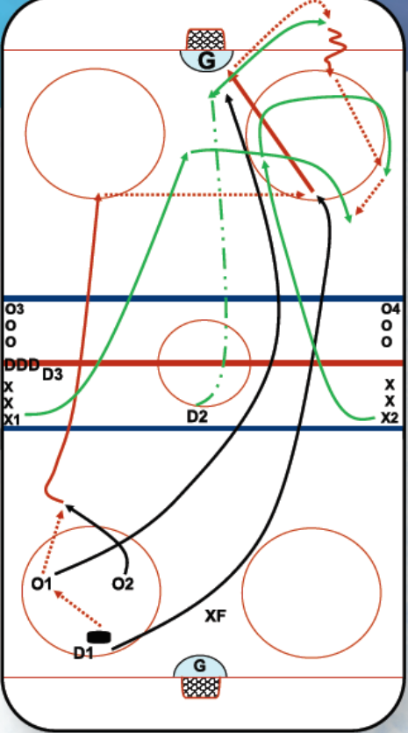
Coaching Points: This is live action. Players must be attentive in line, active and ready to go. This drill is great for young defensemen in the sense that you can encourage them to defend a 3v1 rush, and then play live in the defensive zone. The next aspect for D is to achieve shut down or reach the puck first to create a break-out play. Once this happens, encourage the defending defensemen to change roles from defense to offense and to be aggressive with their skating to join the rush and read the rush so they become a dangerous option on the attack. For the forwards, teach strong back-side pressure, techniques for funneling into defensive zone and then supporting the puck for a break-out pass to create a 3v1 rush.

Comments: Emphasize two-way play. Drill should have high tempo and execution. If the attacking team scores off the rush, coach should throw another puck to the offense in the zone and let play continue.
GAME: Offense-Defense-Out with a Goalie Twist
Purpose: To create an ultra-high tempo in attacking the offensive net while giving players goal-scoring opportunities. Also, this drill creates a 1v1 battle situation, awarding the defensive players an opportunity to create quick transition with breakout passes. The twist on this drill is encouraging the goaltender to make the breakout pass when the opportunity arises. This allows goalies to refine their puck-handling skills.
Note: Both the defensive player and goalie can initiate transition. Once the offensive player loses the puck, that offensive player becomes the defensive player through a hard back-check, working on back-side pressure against the breakaway. If a goal is scored, coach should reward the goal-scorer by giving him or her the next puck (you-make-it, you-take-it style).

Drill Structure: Place two nets cross-ice. Use a chalk marker to draw two parallel lines from the extended goal line to blue line creating a mini neutral zone. This area is important for the offensive player anticipating a head-man pass from their teammate in the defensive zone (who may be the goalie). Drill begins with one player on breakaway and one player backchecking. Once the attacking player passes the neutral zone, a new defending player slides into the NZ to receive a breakout pass. Drill is continuous.

Drill Rotation: Offense (breakaway and 1v1 play) > Backcheck to Defense > Breakout Team > Out of Drill

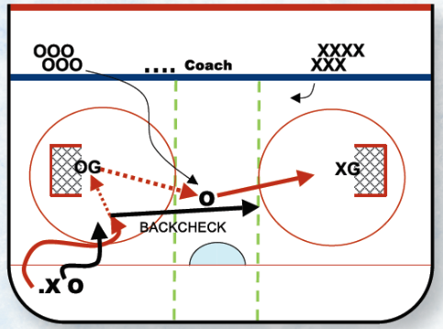
Coaching Points: Essentially this is a 1v1 battle drill with quick action. Players waiting to enter the drill must be ready to jump in the NZ and support the puck or create a good passing lane for their teammates. Encourage the player in the NZ to be moving, with stick on ice, and creating passing lanes. Also, encourage this player to attack the net immediately once puck is on his or her stick. Encourage the defender to play tenacious defense and create turnovers with stick-on-stick play while keeping body between the offensive player and net. Note: Both defensive player and goalie can make breakout pass. This transition pass should happen frequently and fast. Once offensive player loses the puck, teach the proper backcheck skills of moving feet, stick on ice and filling middle lane back to net. This drill is great to teach roles away from the puck. Watch your players to see how quickly they can change roles from attacker to defender.
ANGLING

Station: Open Ice Angling
X begins with the puck and makes a pass to O, who starts at the blue line against the boards. O takes off, skates around the cone and attacks down the wall. X skates around the cone near the dot and then angles O into the corner. X uses timing, stick-on-puck and skating skills to close and pin.

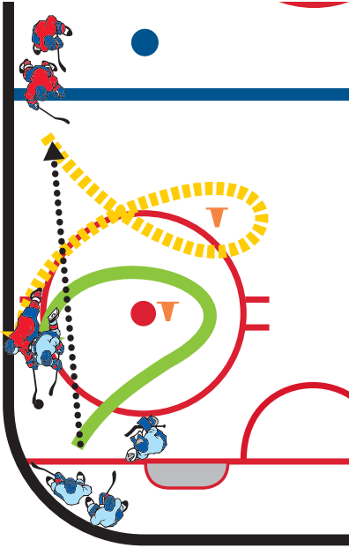

Station: Angling Up and Down the Wall
Player X skates clockwise around the cone, trying to gain the blue line. Player O skates around the near cone clockwise at an angle to steer Player X into the boards and take possession of the puck.

Station: Gap Up and Angle
O sprints to touch the goal line and then gaps up ice angling X outside of the Grade-A shooting and scoring area. Player X skates up ice around a cone with the puck when Player O initiates start of drill and tries to get a shot off or drives to the net for a scoring opportunity.

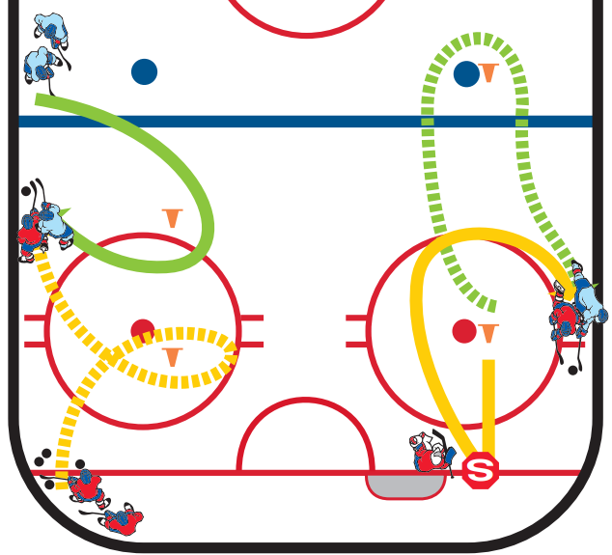

Station: Angling Drill
Coach shoots a puck on goalie and player picks it up then wheels the net and drives toward the opposing net. The opposing player must go through both circles and angle the other player out of the play.

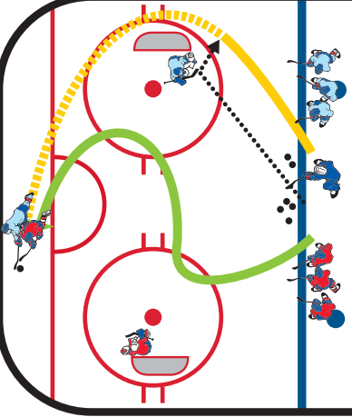

GOALTENDING

The 14U goaltender should be proficient in stance, depth, stickhandling, lateral standing movement technique and fundamental save techniques. All fundamentals must be practiced on a daily basis in order to develop consistent goalies. At this age, every practice should begin with goalies doing one movement drill and one fundamental save drill.

Add these concepts to drills with all players as well as to goaltender-specific drills.

MOVEMENT
• Focus on effective lateral movement while standing. This begins with being square to the puck when it is passed from dot to dot or all the way through the house.
• Goalies can t-push or shuffle. Focus on getting into position with one push without sliding.
• This will be difficult, so adjust the location of the shooter to challenge the goalie without encouraging bad habits.

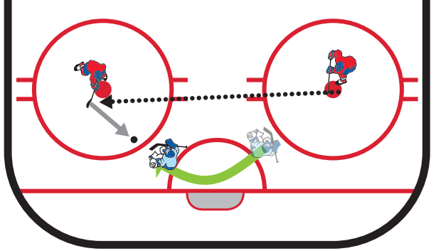

POSITIONING
Introduce the concept of the reverse horizontal vertical (RHV). This pre-shot position is used when a play originates from below the goal line and there is an immediate threat of a wrap or jam play. This position can be over-used, so it’s important for coaches to recognize it. This is NOT a default recovery position when pucks go below the goal line.

Seal the post. Practice the transition both in and out. Beware of goalies who simply stay in this position. Make sure they get back to their feet whenever possible.

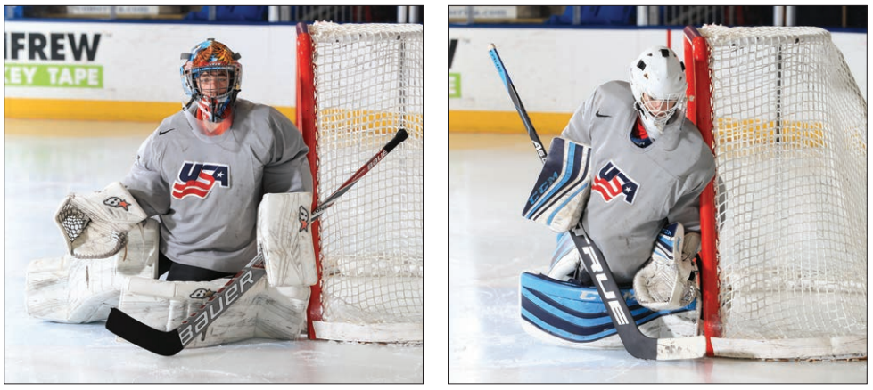

SHOT LOCATION
• Make sure the goalies are seeing shots from various locations.

